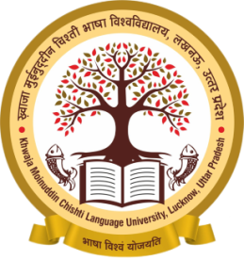
MAJOR ACTIVITIES OF WOMEN STUDY CENTER
Coordinator: Dr. Nalini Misra
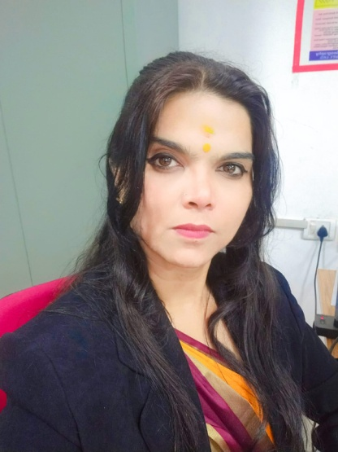

Women Study Center is established by the then Hon’ble Vice Chancellor Prof. Anil Kumar Shukla on 27th April, 2021. Dr. Nalini Misra is the founder Coordinator of the Centre. Women Study Center is constantly striving for the upliftment of women, especially women in rural areas, to strengthen their educational, family, professional, social, economic and physical aspects. The activities for welfare of women are organized inside and outside the campus on regular basis from time to time. The main programmes completed are as follows:

- On the occasion of International Women's Day, Dr. Nalini Mishra organized and staged three street plays consecutively on women-centric subjects in Mahila Samriddhi Mahotsav celebrated in Raj Bhawan by the students on March 8, 9 and 10, 2021, which received appreciation.

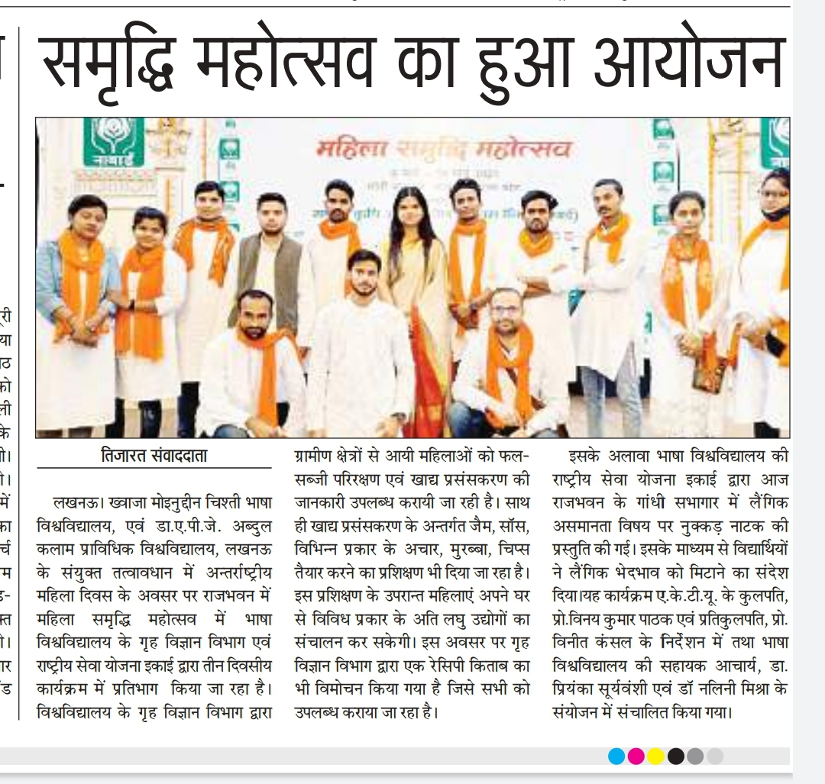
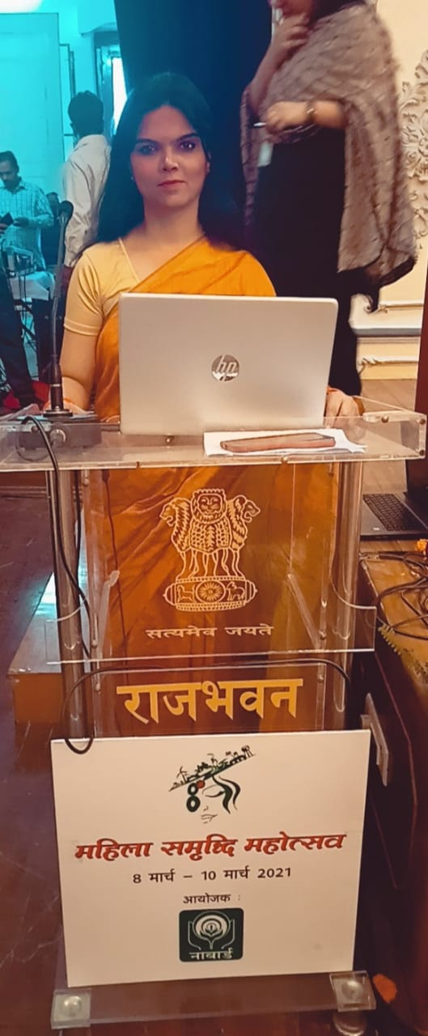
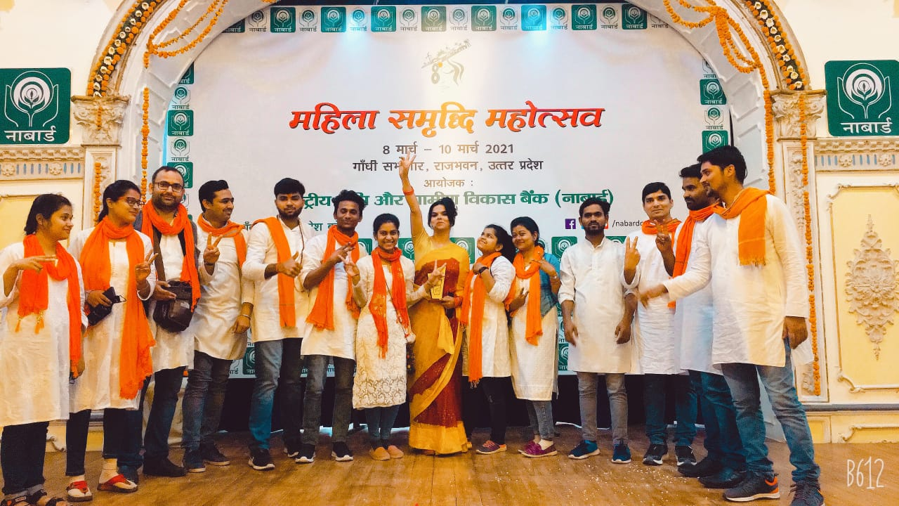
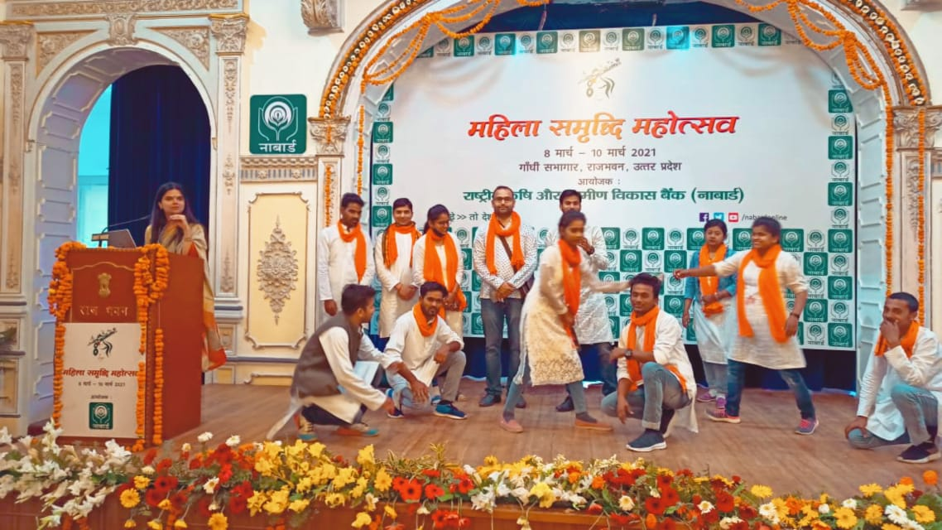

- In the month of May and June 2021, during the Covid pandemic times, women especially those belonging to rural areas were made aware about immunity boosting foods, importance of Covid vaccination, etc. through regular awareness programme run by Women Study Centre.

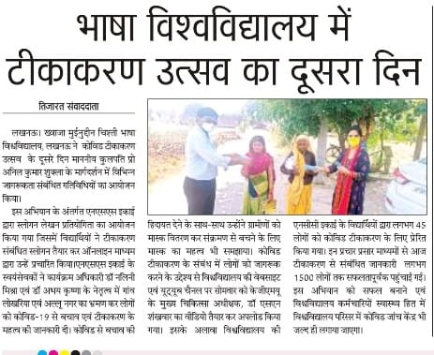

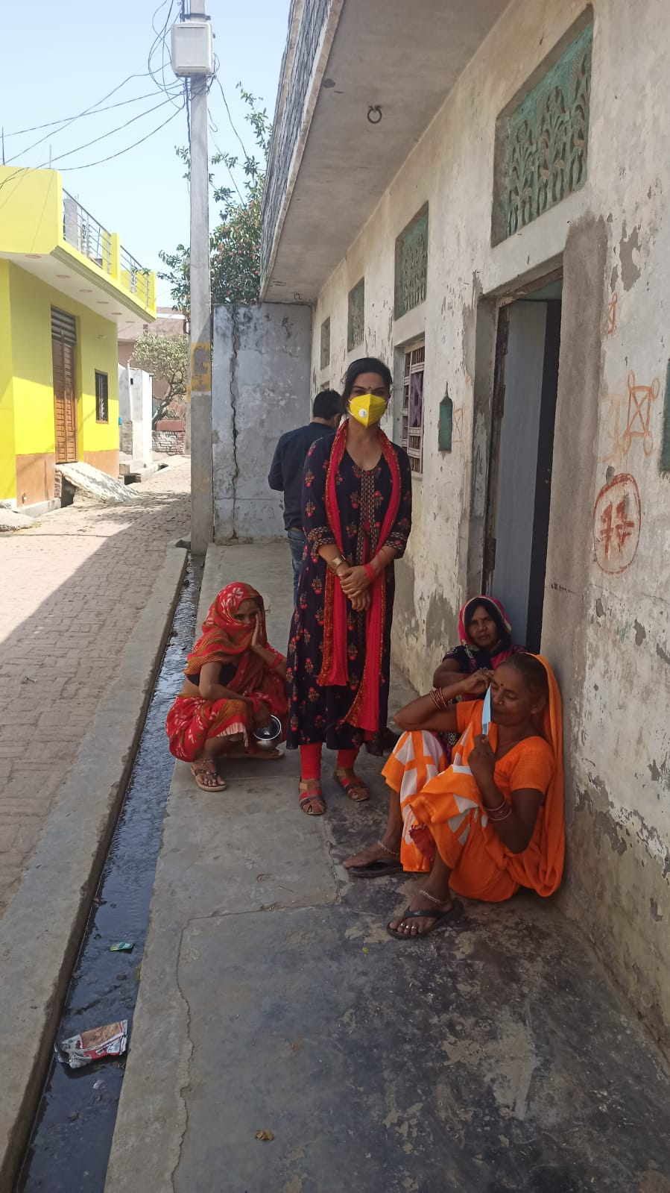

- On World Environment Day, June 5, 2021, tree plantation was done inside and outside the campus. The women were also given information related to importance of environment development and cleanliness for lives.

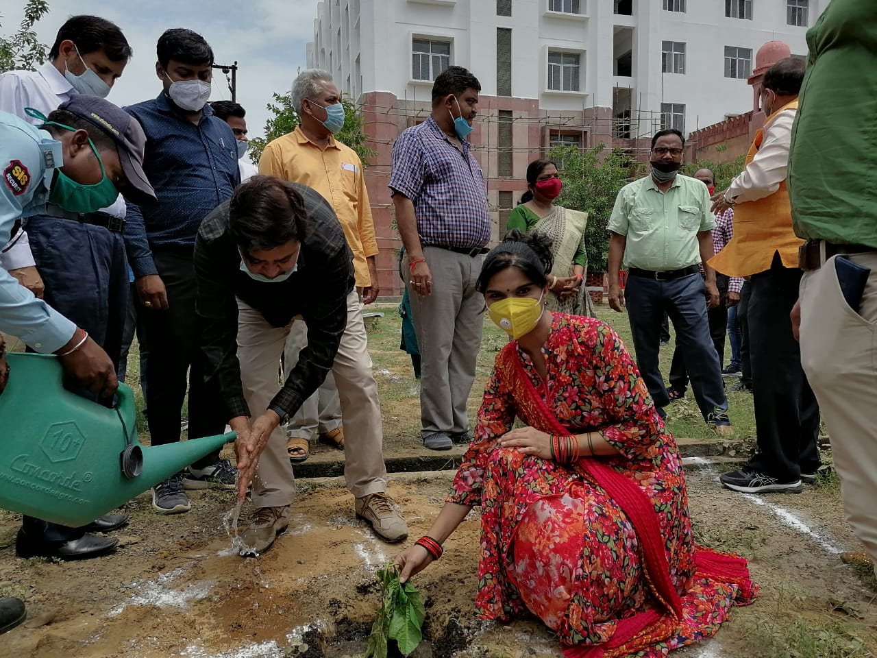
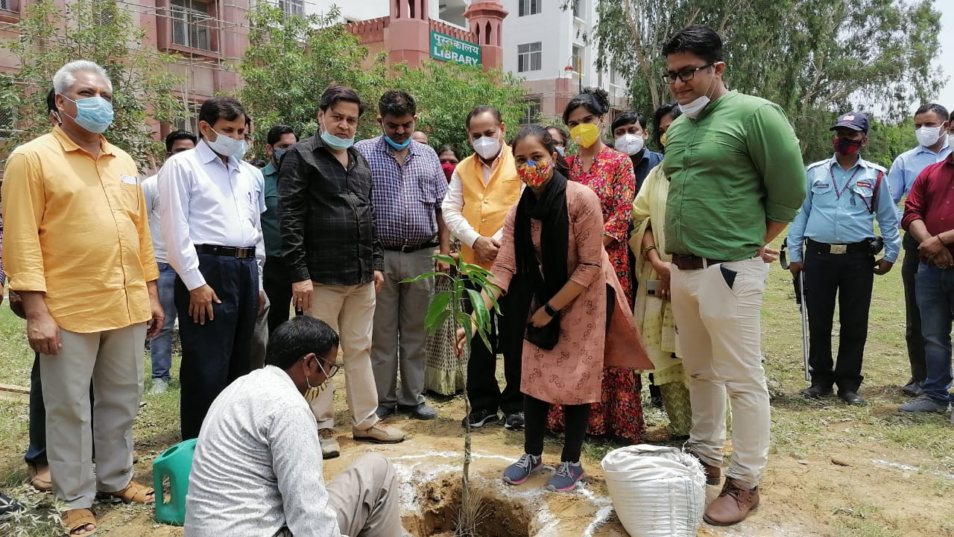

- On 09th June, 2021, Covid and health check-up camps were organized in adopted villages in which check-ups were done and related medicines were distributed to the people. Nutrition related counseling of women was also done for immunity boosting so that they may better take care of their family and themselves.
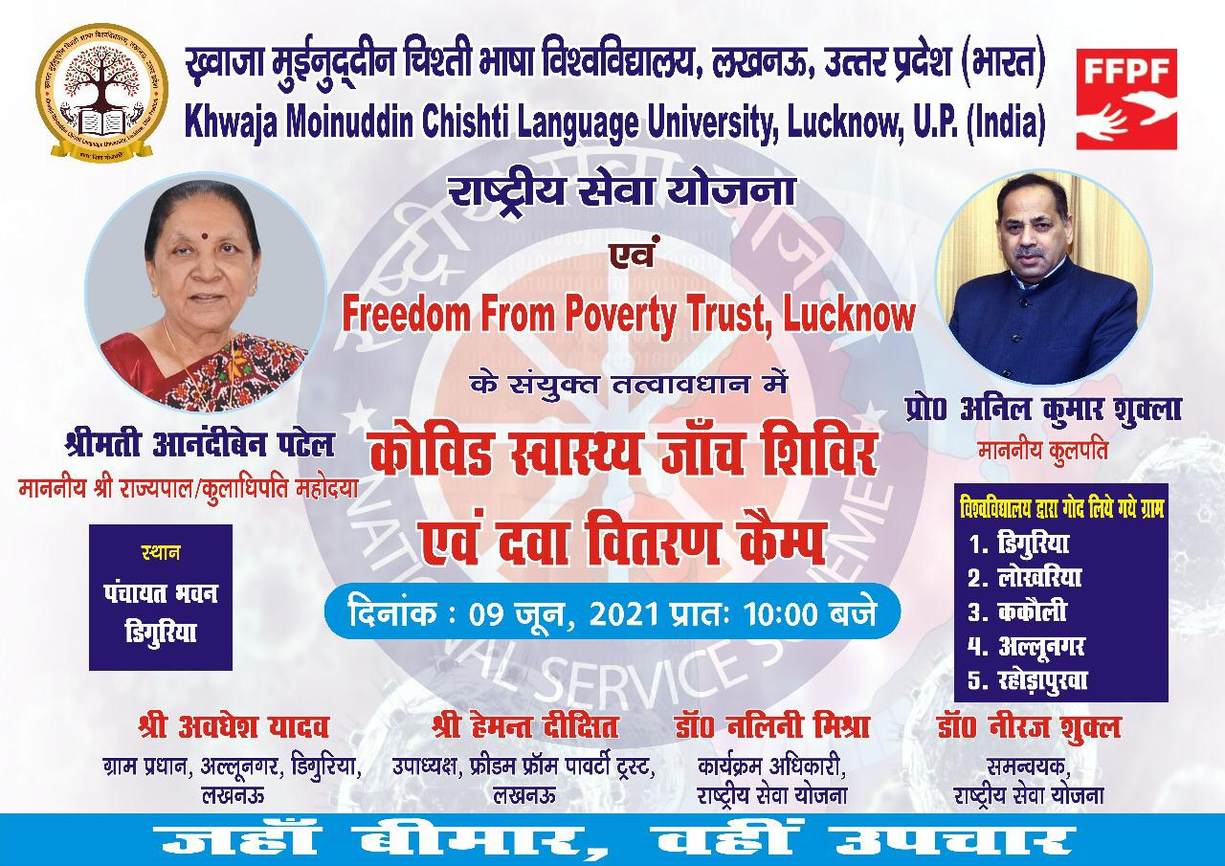

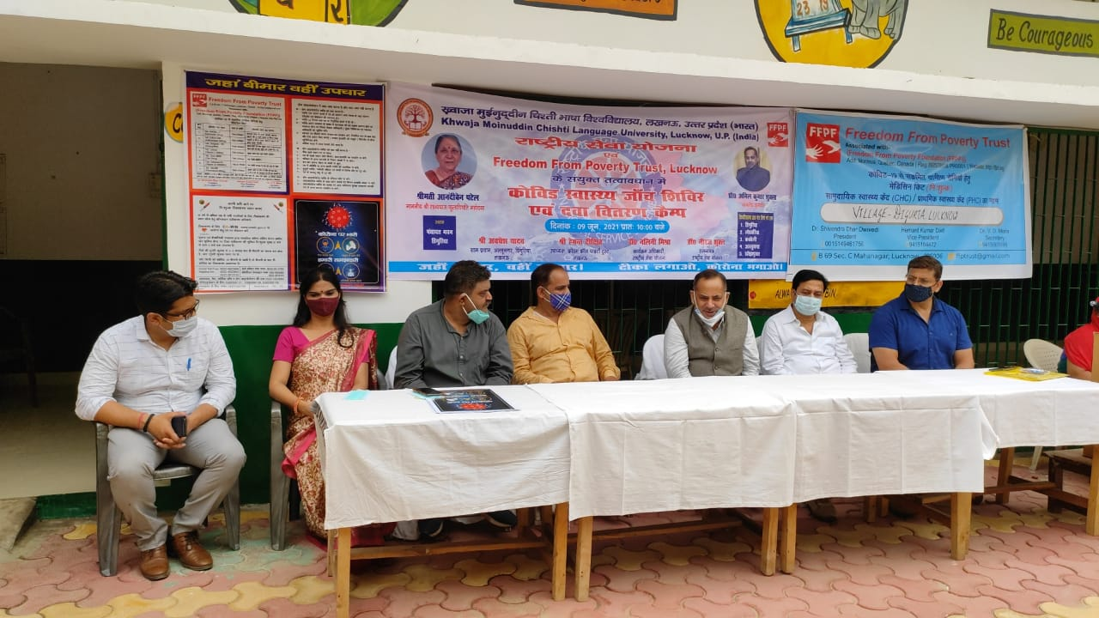
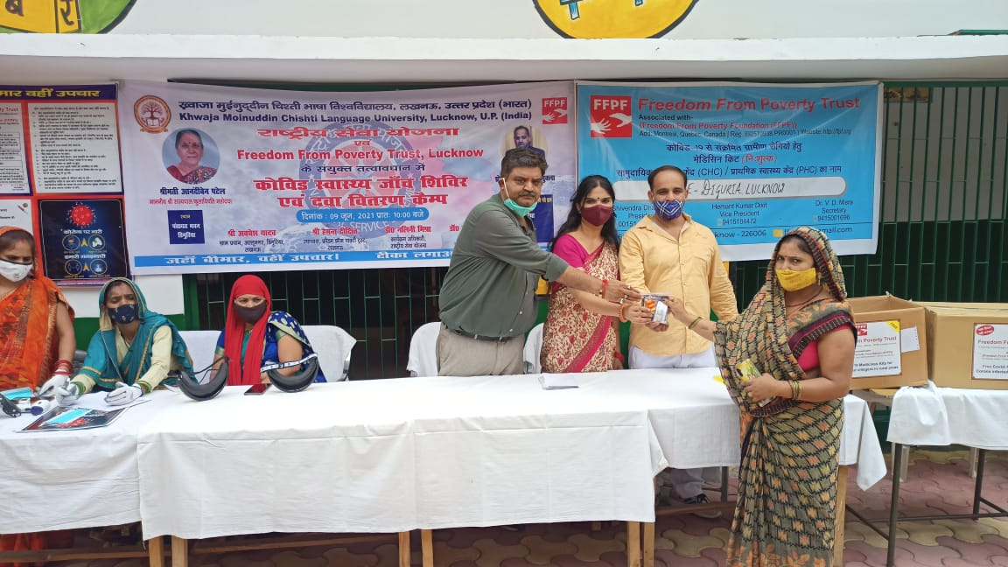
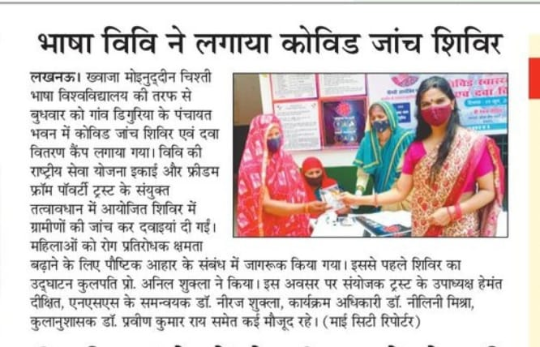

- Self- help groups of women have been made in the villages, which are contacted on regular basis. They are given counseling including financial counseling, and shown way for solution of their problems.
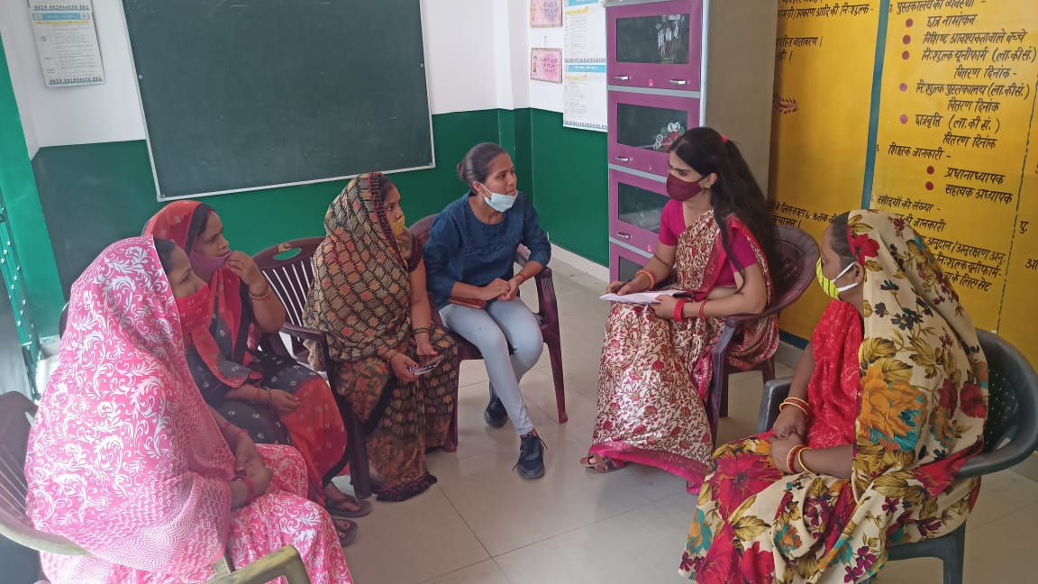

- Yoga camps and self-defense training (martial arts training) camps are organized for women by the Girls' Health Club in the campus every Saturday, in which an average of 70-75 women participates in all the camps. The beneficiaries are the women both from the society and from the campus.
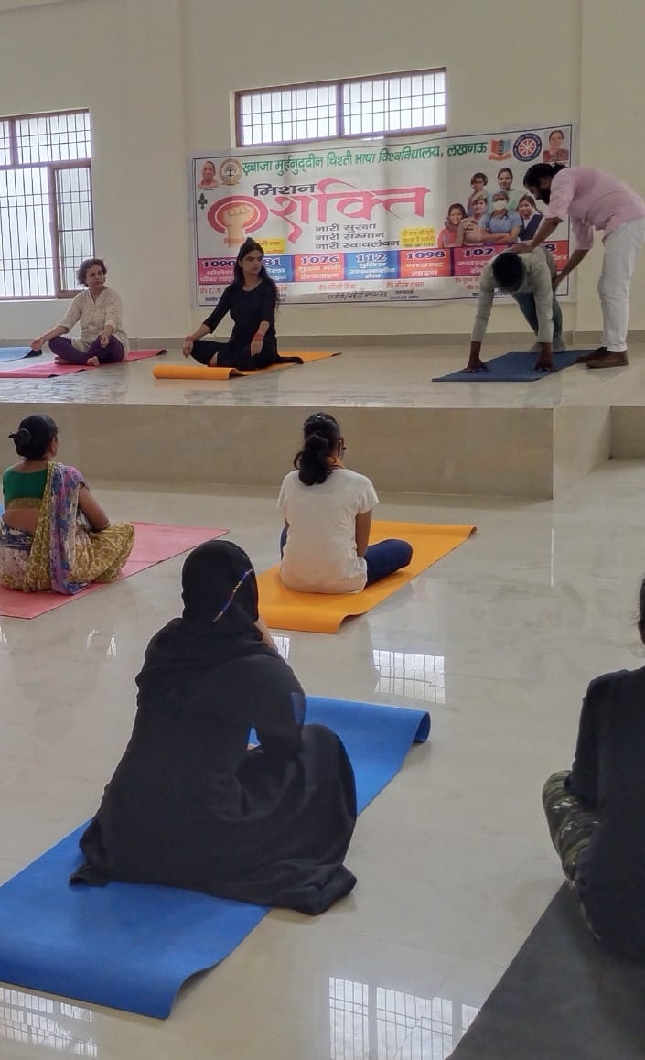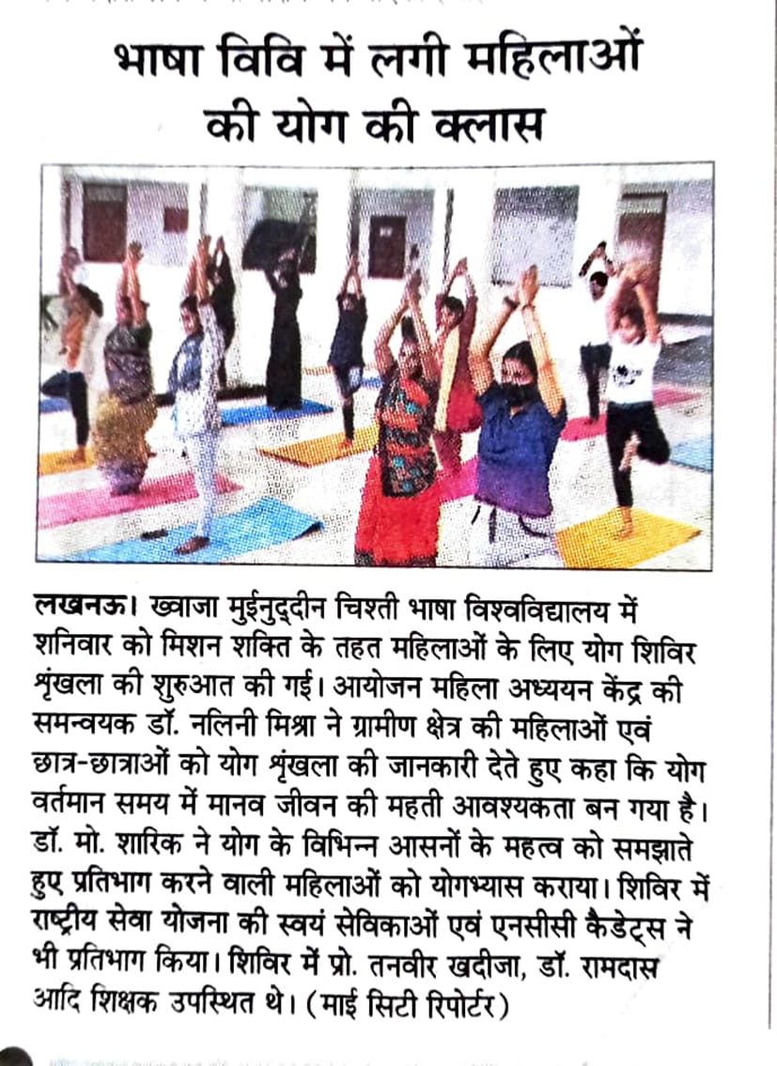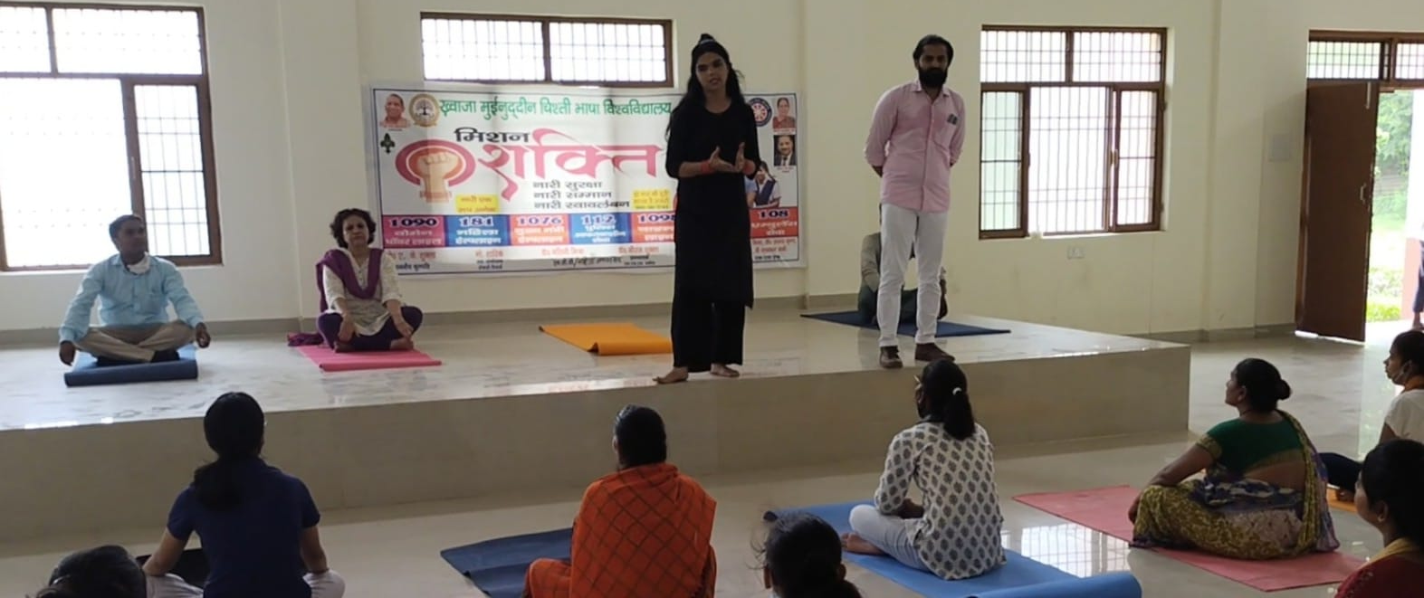
- On 24th September, 2021, under the guidance of Hon'ble Vice Chancellor Prof. Anil Kumar Shukla, a Blood donation camp was organized by Women's Study Center. Health checkup of girls was also done. Counseling was also provided to women and girl students in case of any health issue.
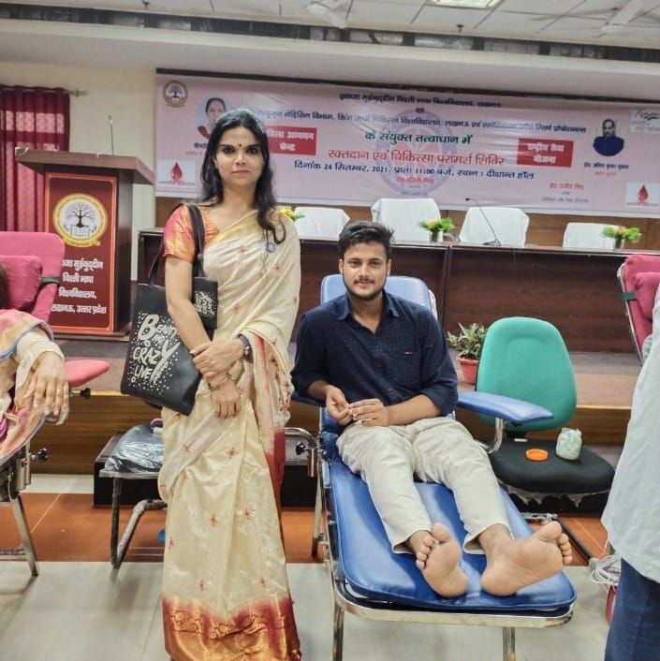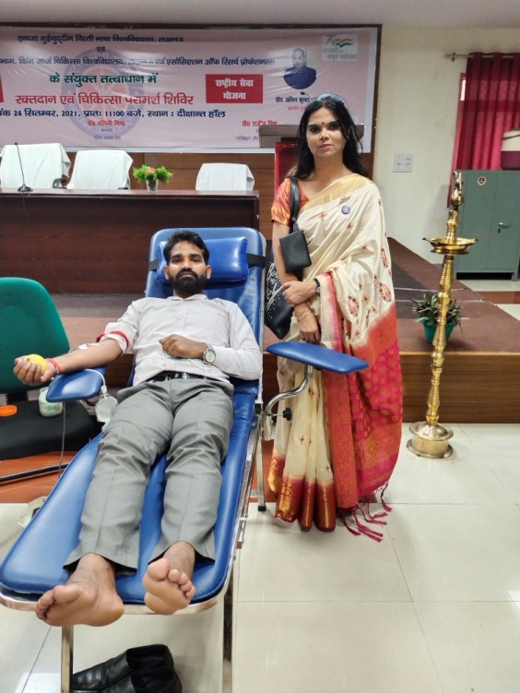

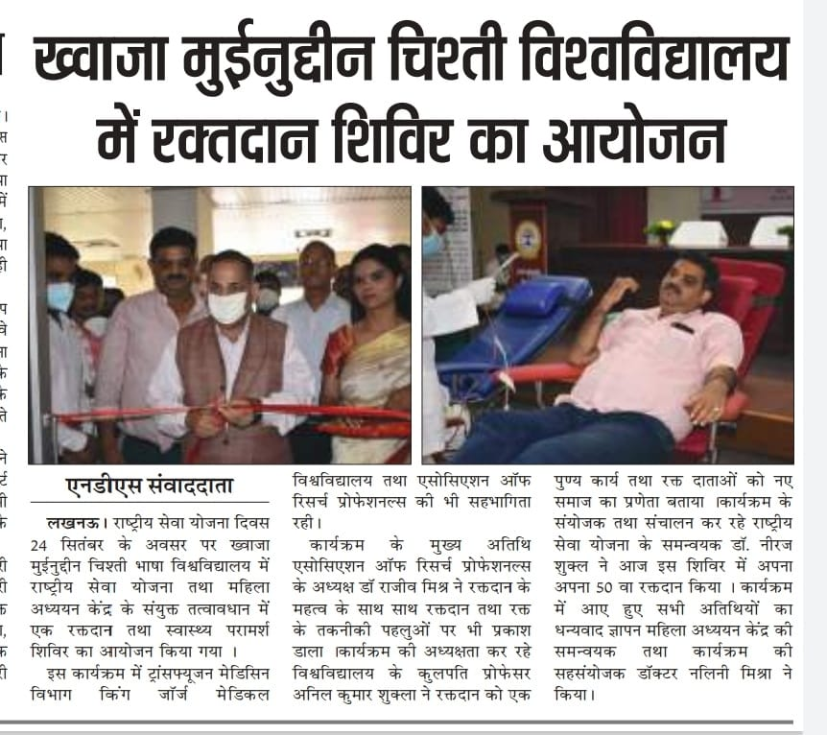
- An awareness campaign was conducted by the Center for Women's Studies on the Azaadi ka Amrit Mahotsav to develop the spirit of leadership in women. The women living in the adopted villages were told about the women who created history and had contributed in the freedom struggle, so that the girls and women take inspiration and work for the development and progress of themselves, their family and nation.
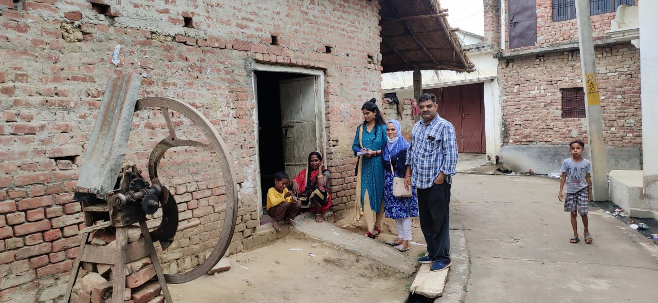

- Health and nutrition related information is regularly given to pregnant women in the adopted and nearby villages of University.
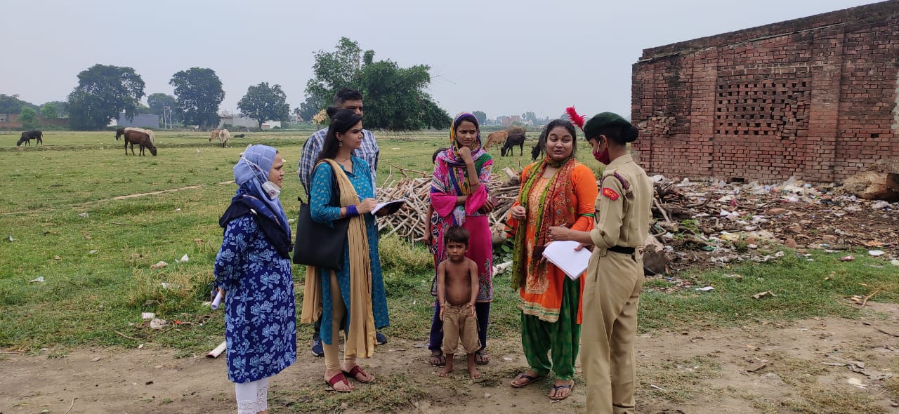
- Courses related to Garbh Sanskar and Women's Studies have also been included in the curriculum of the various departments of the University.
- Social campaigns related to cleanliness are also being run from time to time in the villages adopted by the University, in which women living in rural areas are being made aware of the various Government schemes available for them through hich they can be benefitted.
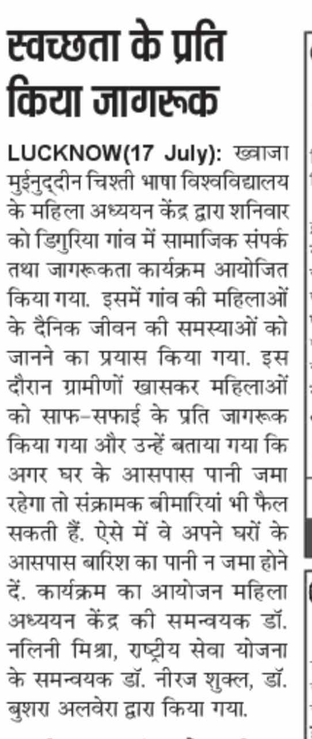
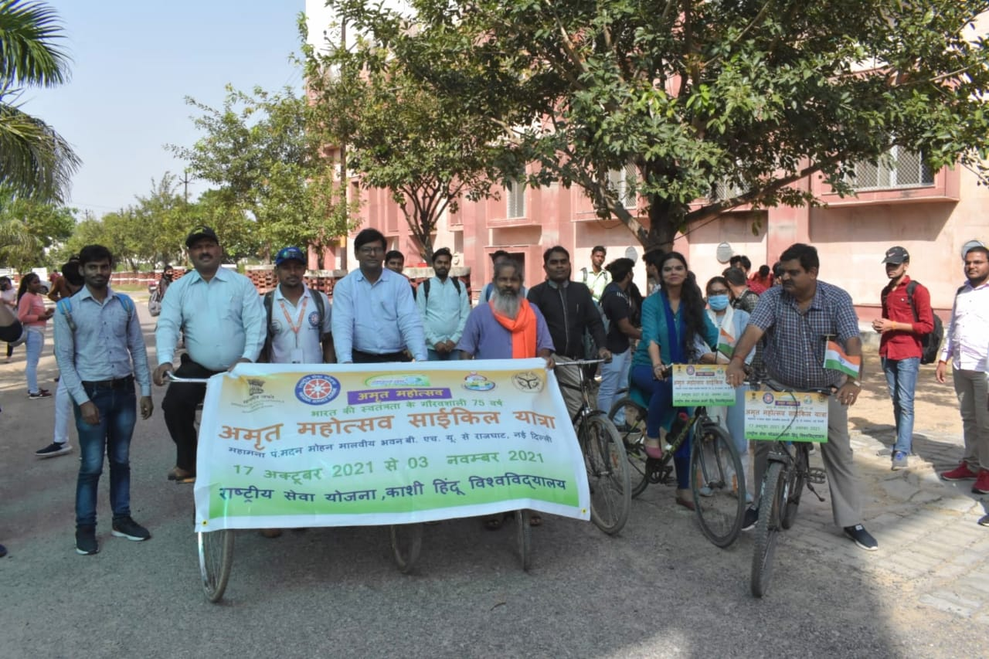
- Women's Study Centre is committed to the success of the objectives of Mission Shakti and works are being done for the upliftment of women through awareness activities and programmes.
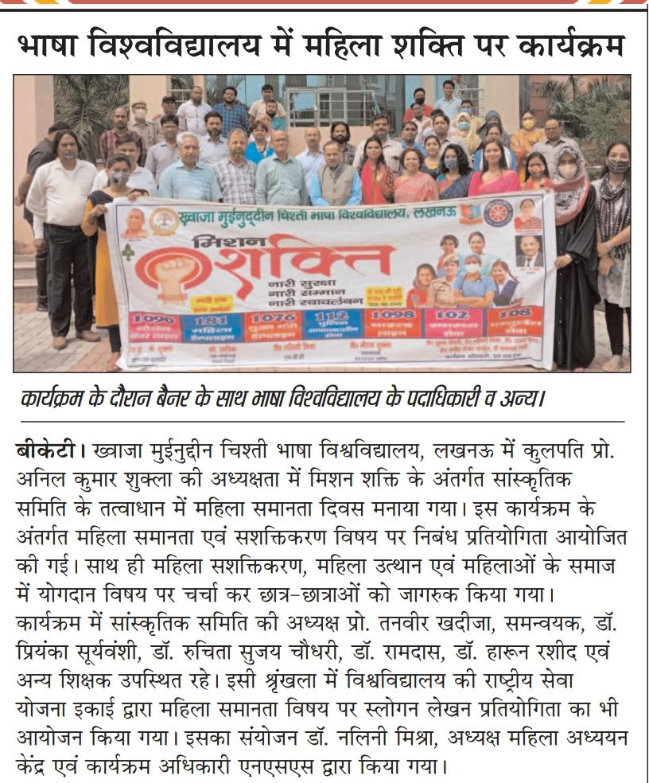

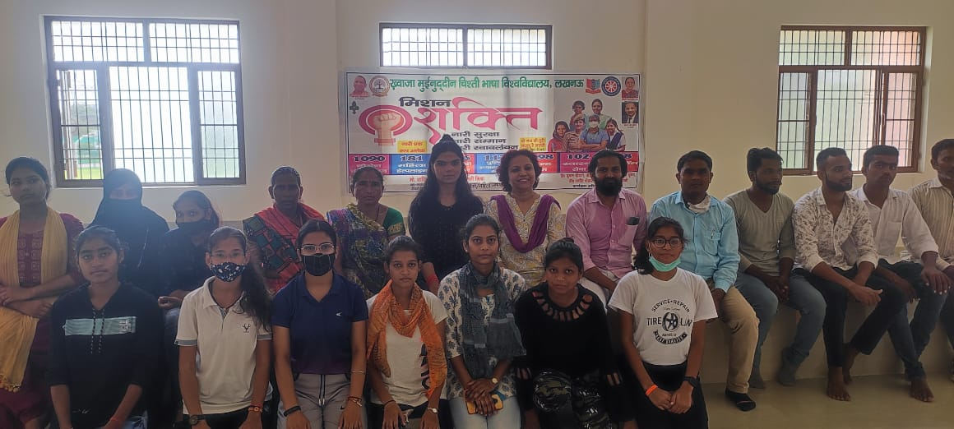

- E-posters and video messages on various social topics have also been circulated through social media from time to time. Awareness among women is also spread through rally, poster competition, slogan competition and discussion medium.
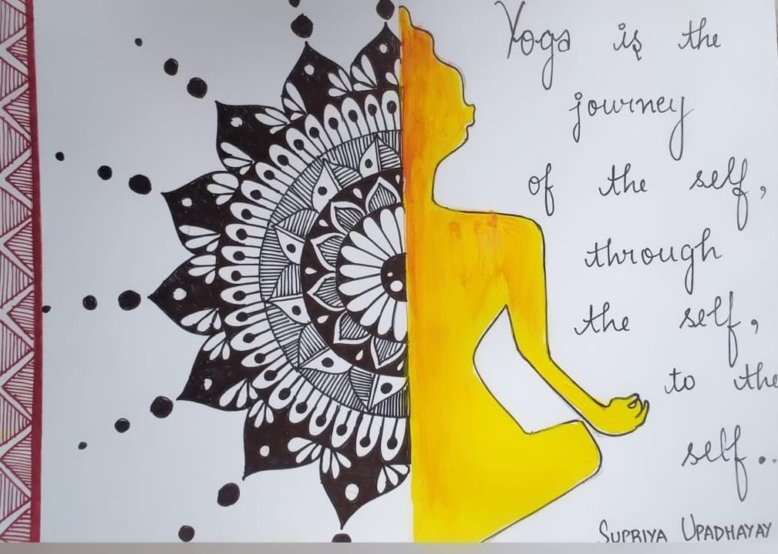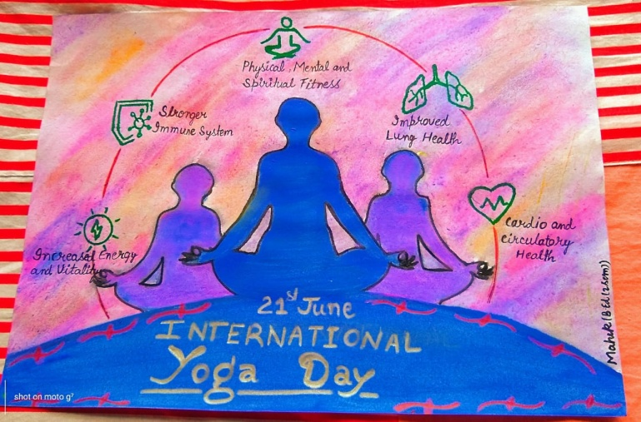
- World Health Awareness Day was celebrated on 7th April, 2022 in which the Women Study Centre organized an interactive session with women living in rural areas to give knowledge about healthy lifestyle and its benefits for health.
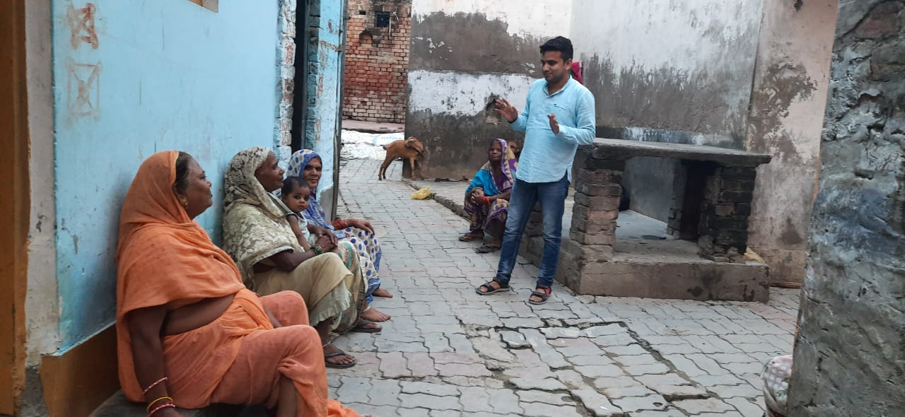
- World Voice Day was celebrated on 16th April, 2022 to raise awareness among women about the importance of preventing voice difficulties as words are an important medium of communication to the world and integral part in the of personality.
- International Day of Families was celebrated on 15th May, 2022 to highlight the important aspects related to family such as health, education, gender equality, rights for children and social inclusion.
- A rally on Road Safety Drive was done on 20th May, 2022 in which the women were made aware of the traffic rules and Road safety oath was also given to them.
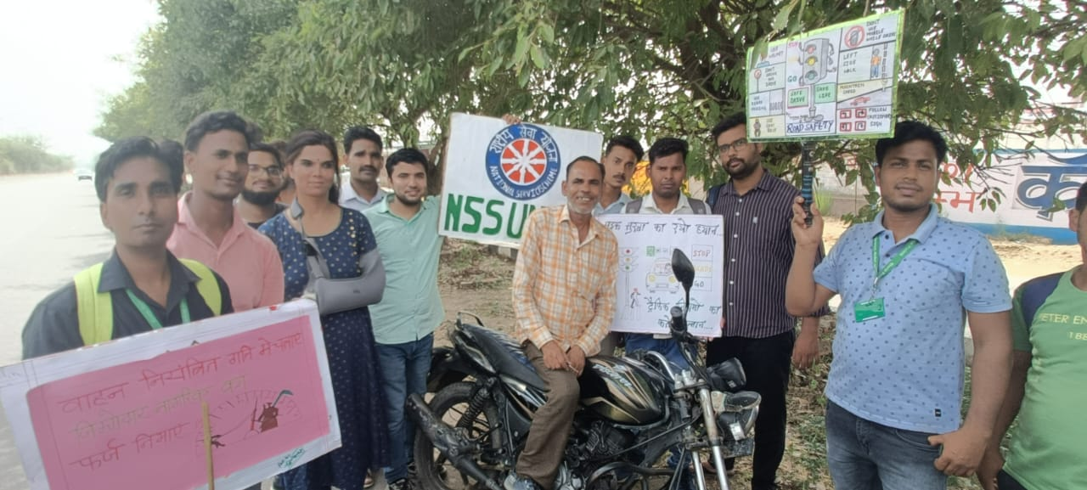
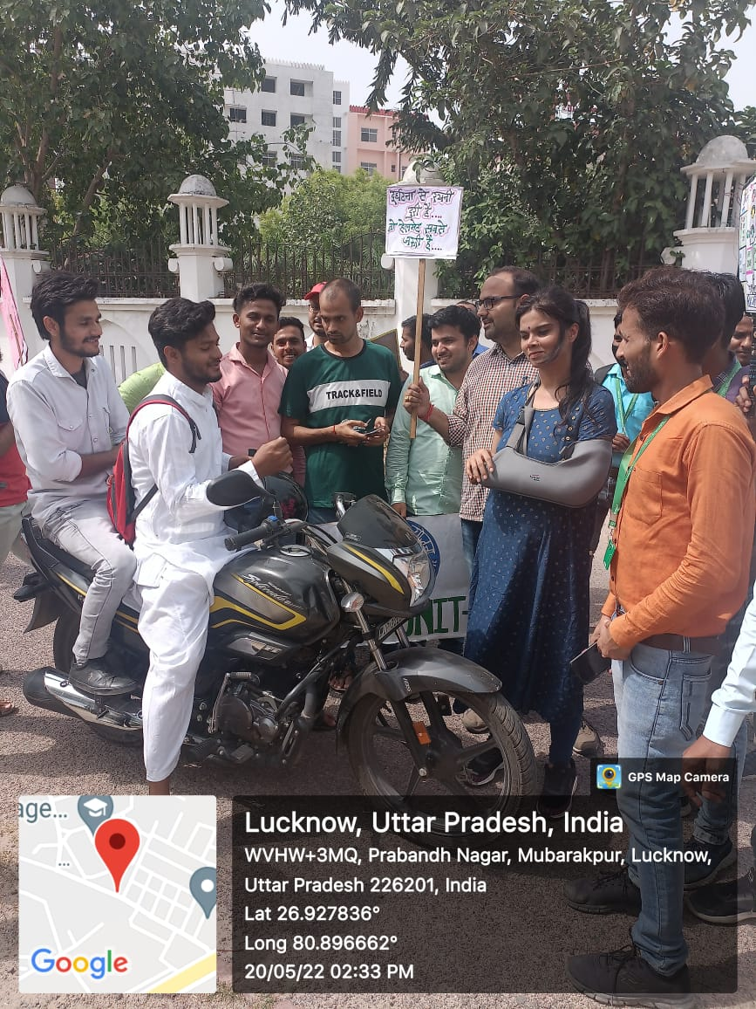
- A Road Safety Awareness Workshop was organized in the University under the leadership of Hon’ble Vice-Chancellor Prof. N.B. Singh.on 30th May, 2022 in which R.T.O., (Lucknow) and A.C.P. (Traffic) were the Special Guests and the Chief Guests. The girl students and female staff of the University were given special attention for making them aware of the Traffic Rules.
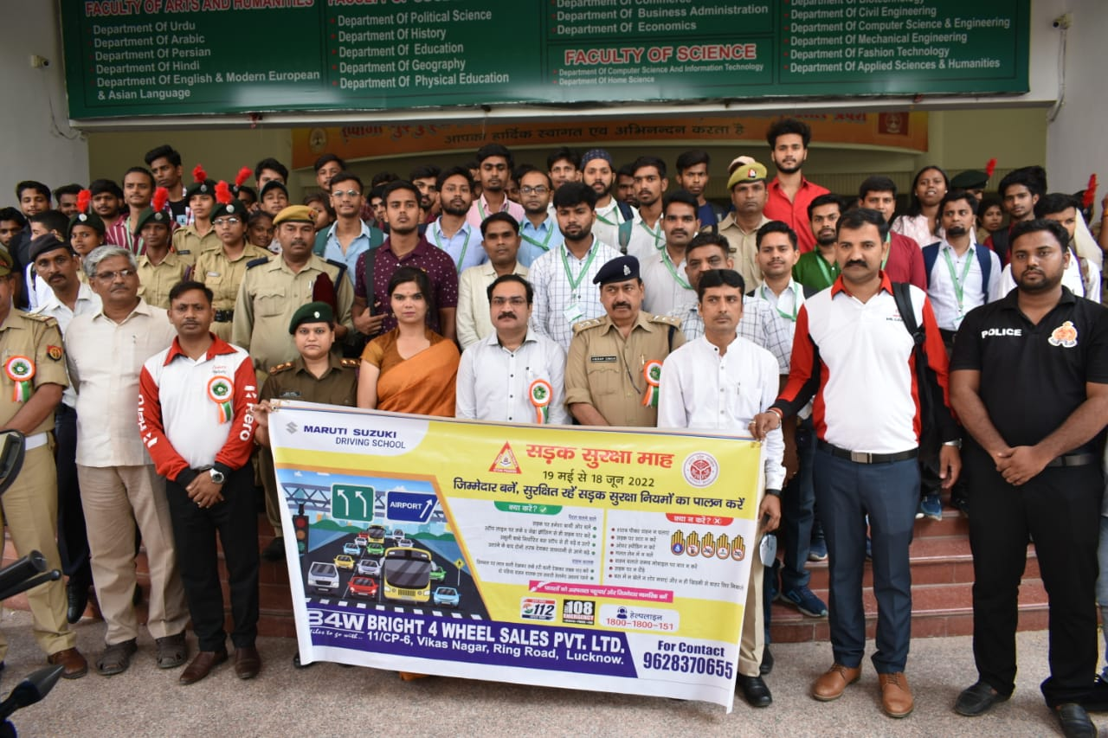
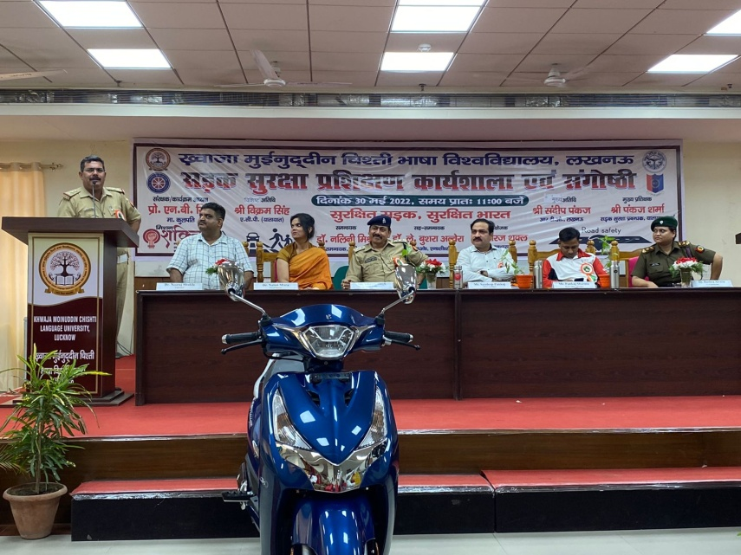
- A plantation drive was organized on World Environment Day, 5th June 2022 in the University in which fruit giving trees were planted. Also, a special lecture on “Effect of Environment on the Health of Women” was also organized.
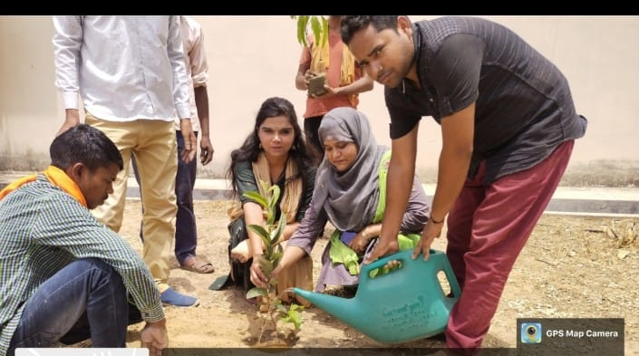
- Plantation Drive was carried on on 5th July, 6th July and 7th July, 2022 in the University under the leadership and guidance of Hon’ble Vice-Chancellor Prof. N.B. Singh.
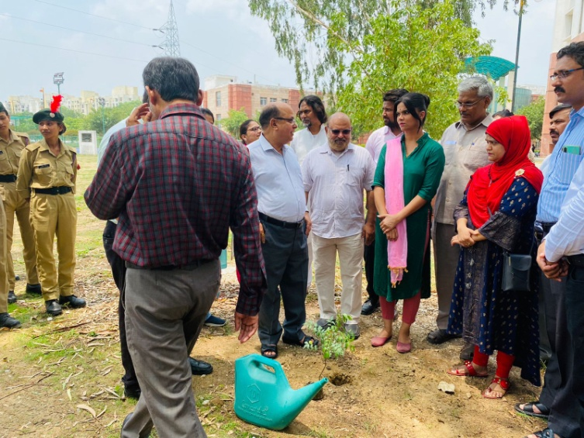

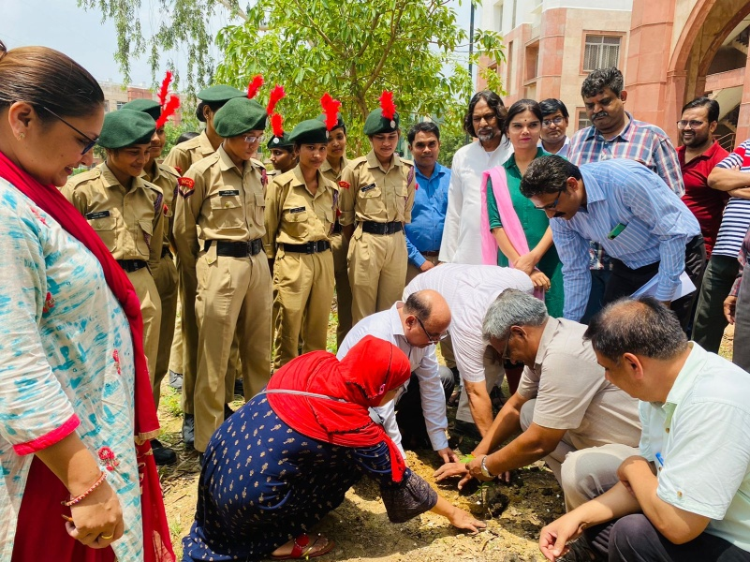

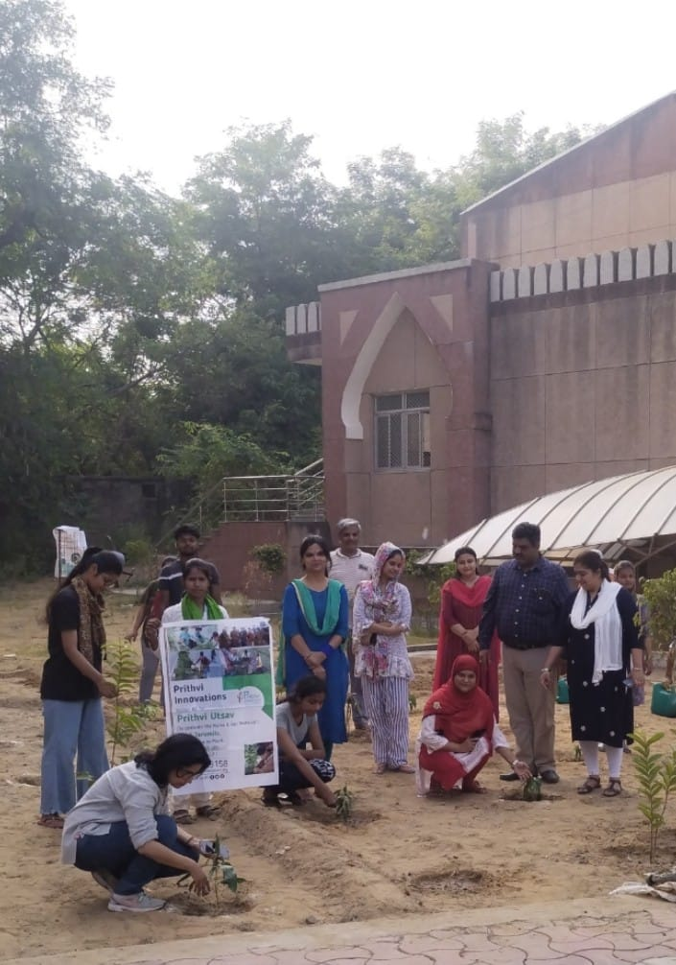
- A counseling Session is organized on weekly basis for Gender Equality where the women get interactive session for freely discussing their issues under the theme “CHUPPI TODO KHULKAR BOLO”
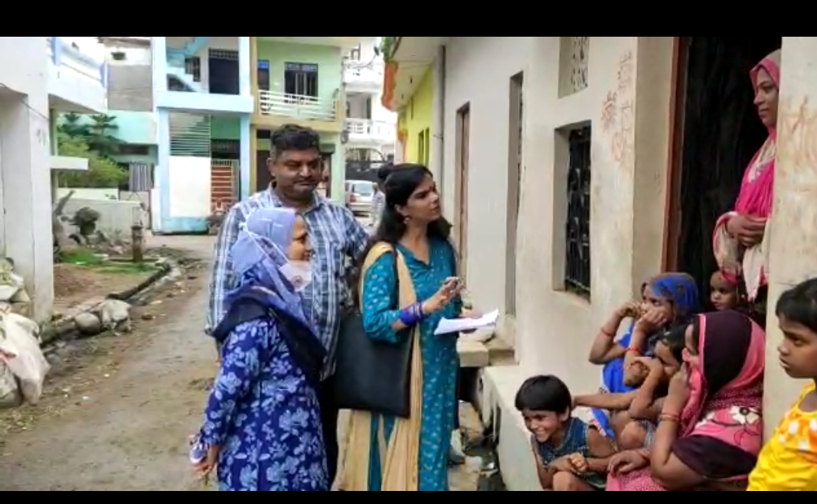
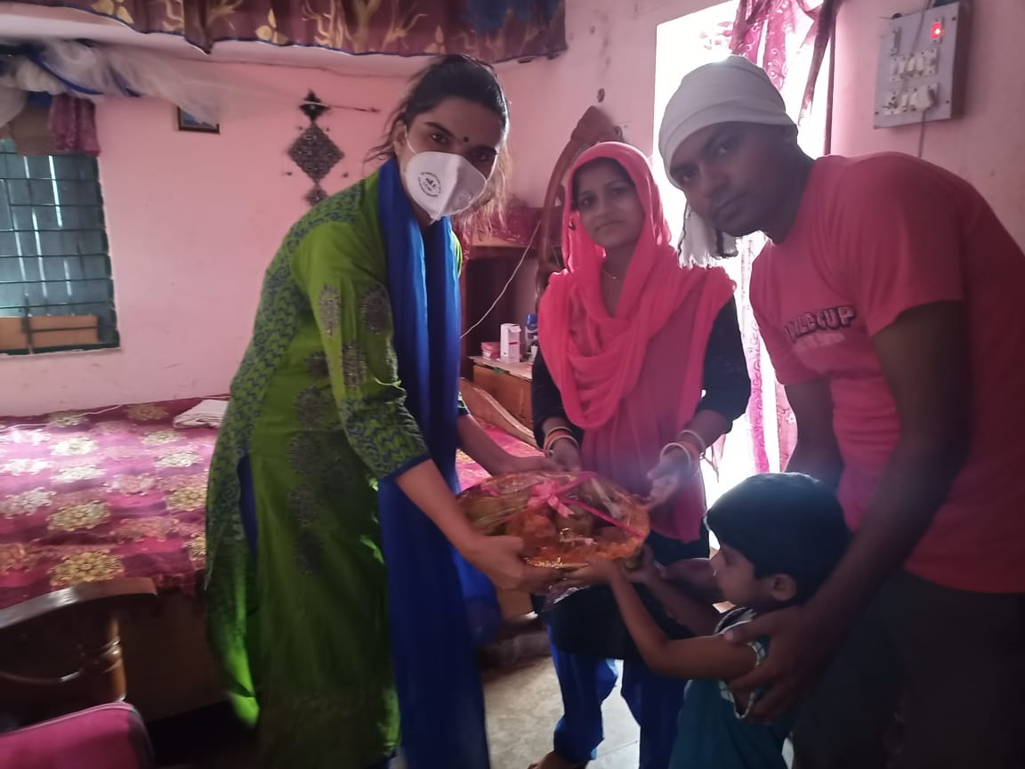
- An awareness workshop on “Cervical Cancer and HPV Vaccination was organized under the guidance of Hon’ble Vice-Chancellor Prof. N.B. Singh.on 13th June, 2022 in the University in collaboration with Dr. Ram Manohar Lohia Institute of Medical Sciences, Lucknow.
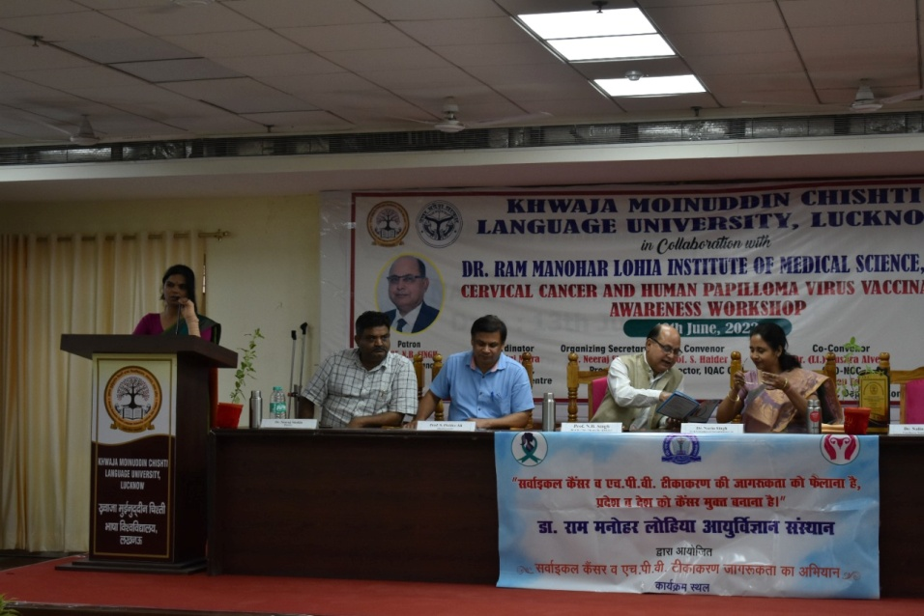
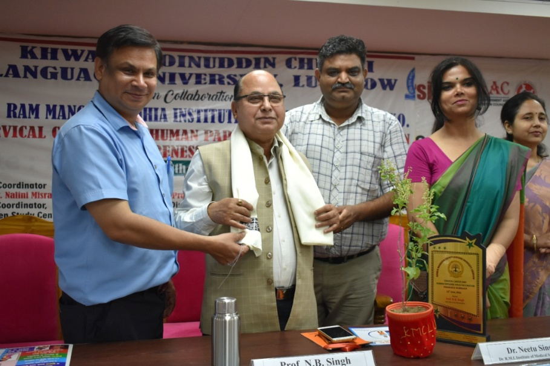
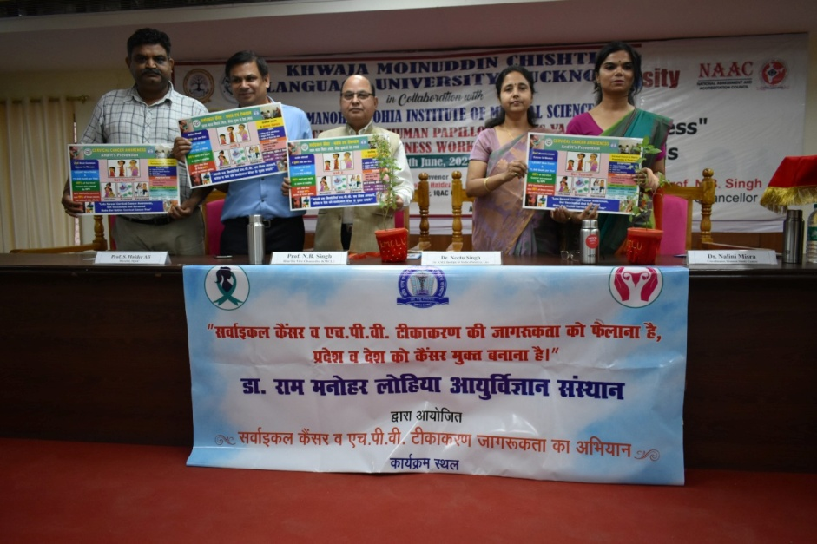
- Yoga Amrit Mahotsav Programme was organized from 14th June, 2022 to 20th June, 2022 in which the importance of Yoga for health was explained through lectures, exercises and workshops to women.
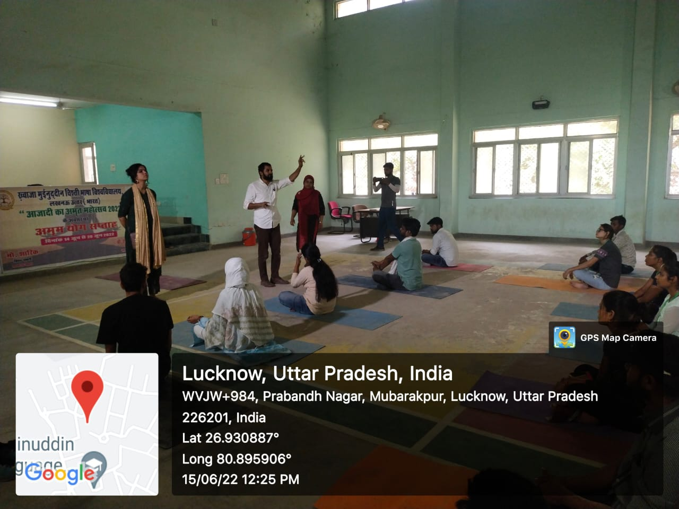

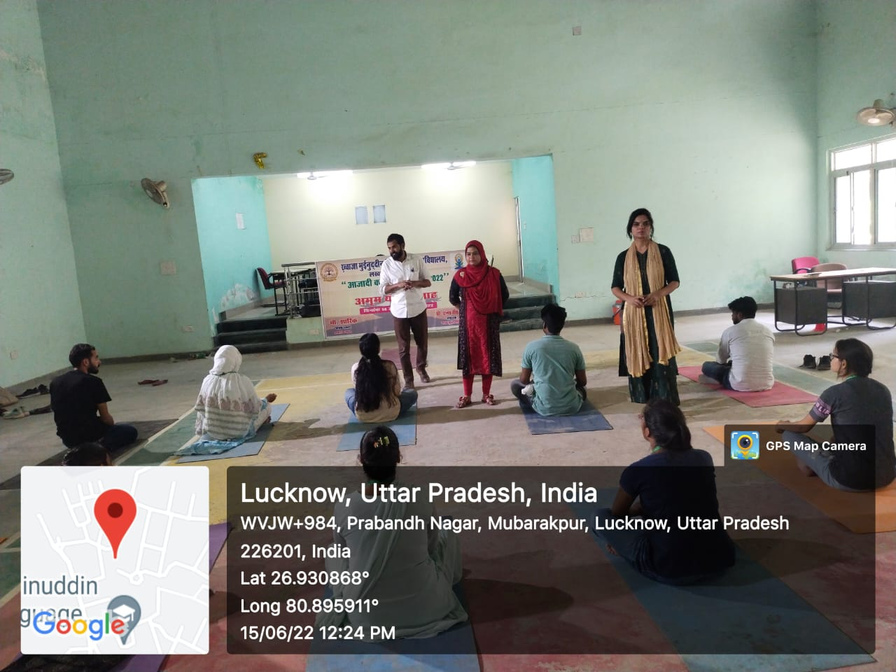
- A plantation Drive was carried out in Girls Hostel of the University in collaboration with Ehsaas, Lucknow( an N.G.O.) on 21st June, 2022 in which 500 fruit bearing trees were planted.
