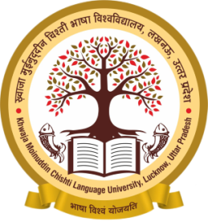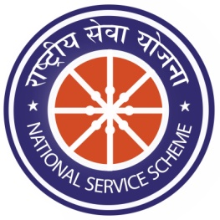
Major Activities done by N.S.S. Unit I
Programme Officer: Dr. Nalini Misra
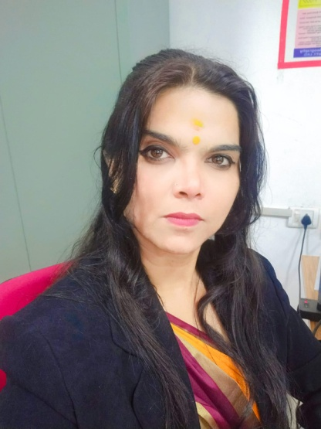
The National Service Scheme (NSS) is a Central Sector Scheme of Government of India, Ministry of Youth Affairs & Sports. The sole aim of the NSS is to provide hands on experience to students in delivering community service. NSS Unit I in Khwaja Moinuddin Chishti Language University, Lucknow is running under the supervision of NSS Programme Officer Dr. Nalini Misra. NSS Unit I has adopted a village Lokharia which is located in the vicinity of the University. The details of the activities performed by NSS Unit I under the supervision of Dr. Nalini Misra are as follows:
- Tuberculosis Eradication Awareness Programme:
Organized on 13th September, 2019. The awareness was spread in the villages in the vicinity of University to reduce the incidence of and mortality due to TB.
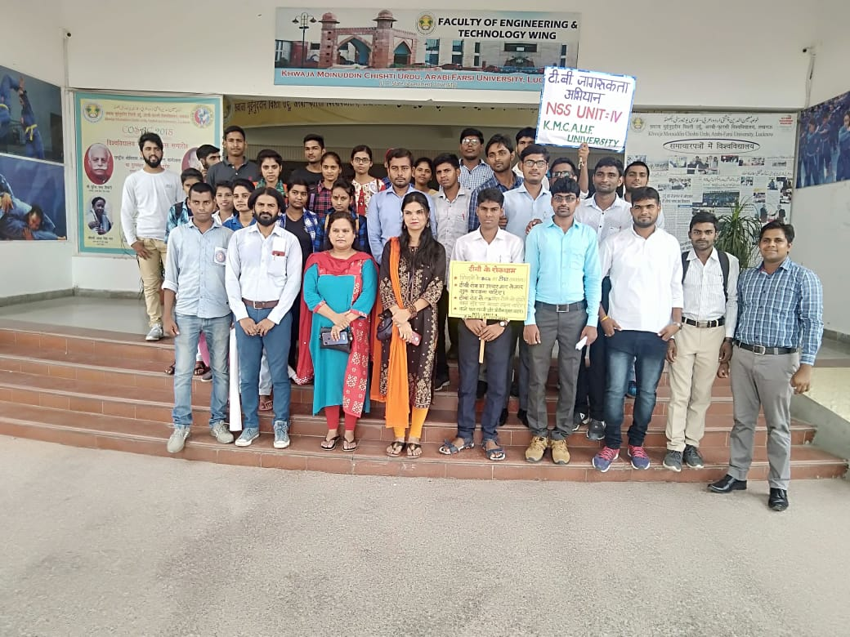

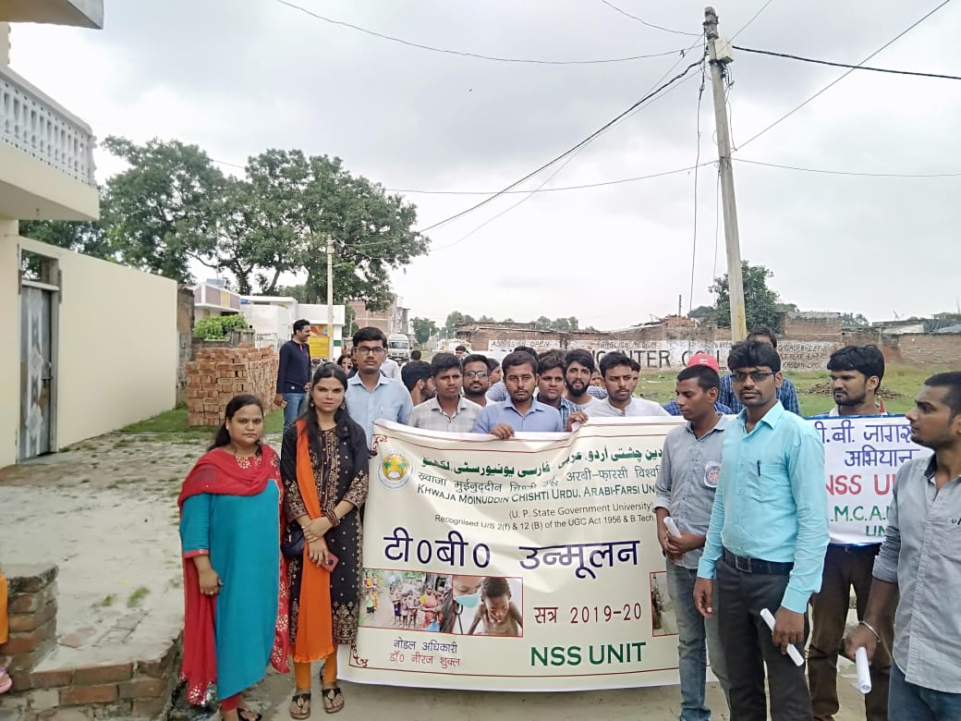
- 06 children affected with Tuberculosis were adopted by N.S.S. Units. Good care of the children was taken regarding food and medicines by the Programme Officers. All the children recovered, achieved good health and are now leading a normal life.

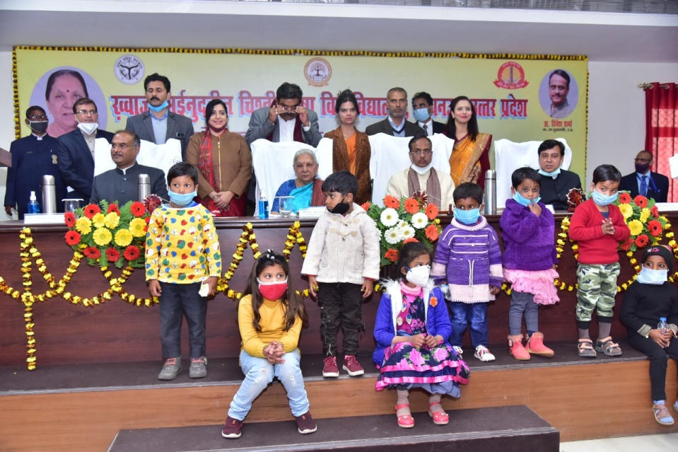
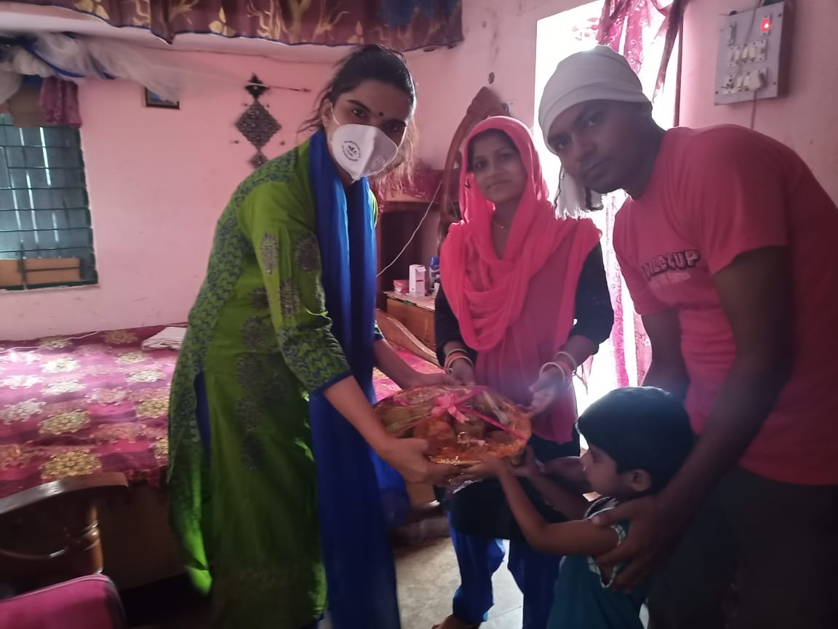

- Traffic Awareness Programme was organized on 17/01/2020. Road safety awareness is a useful way by which people become aware of road safety and traffic rules. Road safety awareness is a useful way by which people become aware of road safety and traffic rules. An awareness drive was organized in the nearby areas of University to make people aware of the traffic rules. Signature Activity was also performed in which the people took resolution of following traffic rules. Poster making Activity was done in the campus for creating awareness among volunteers so that they may spread the message in society.
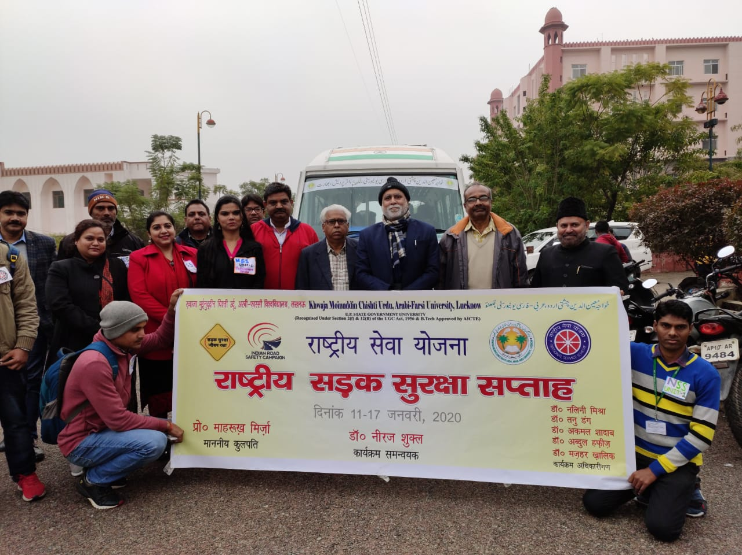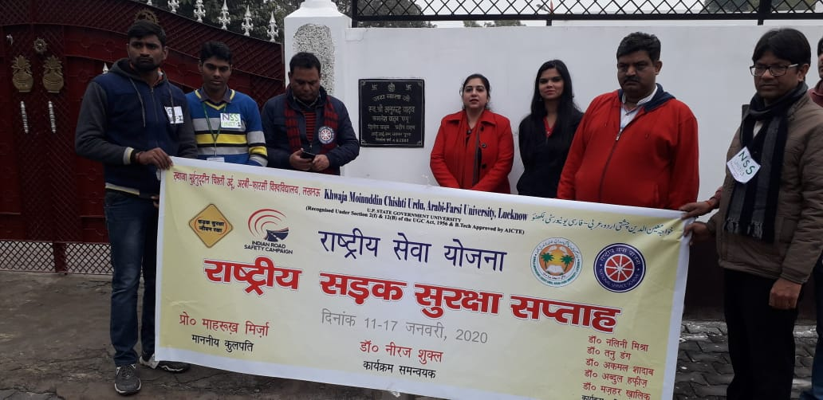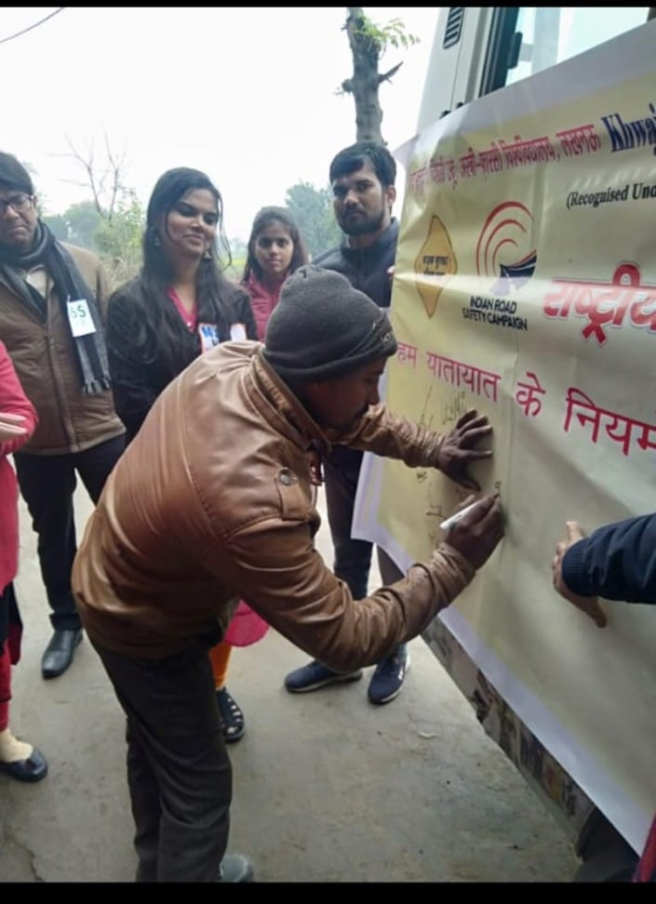
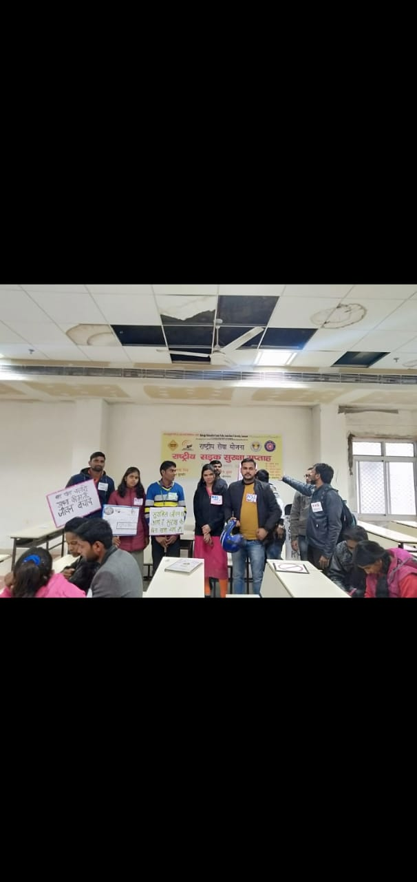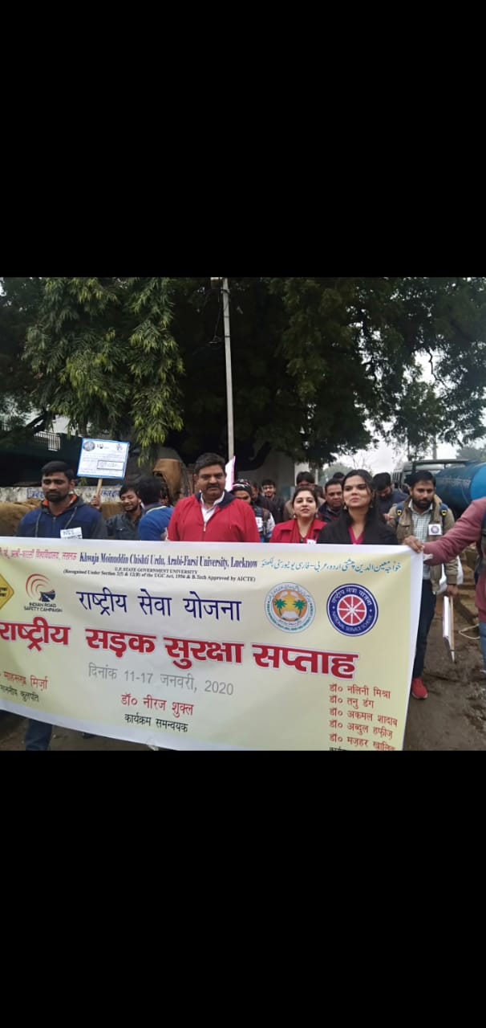

- Fit India Awareness Programme was organized on 18/01/2020. Fit India movement is a nationwide movement in India that encourages people to stay healthy and fit by incorporating physical activities and sports into their daily lives. A cycle rally was done to increase awareness about Fit India Movement among masses.
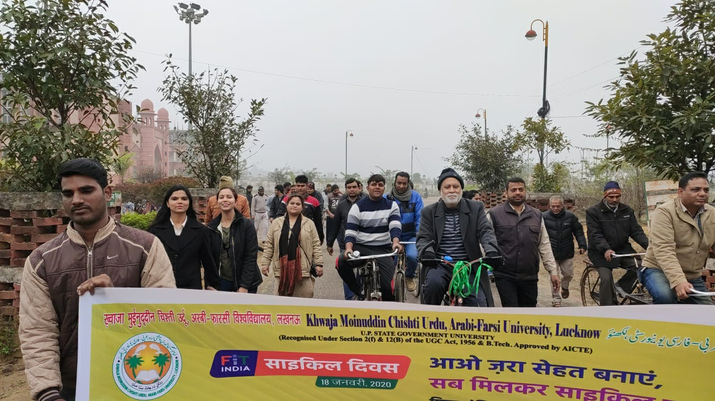
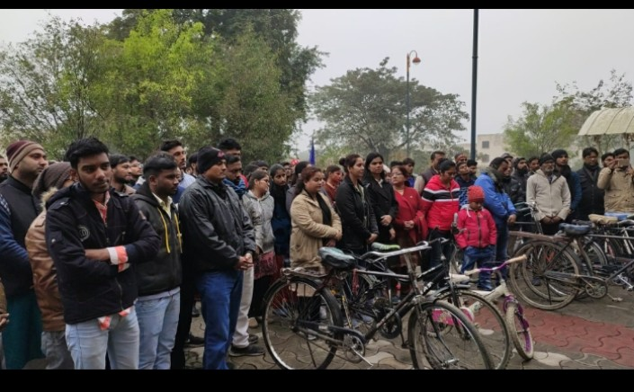
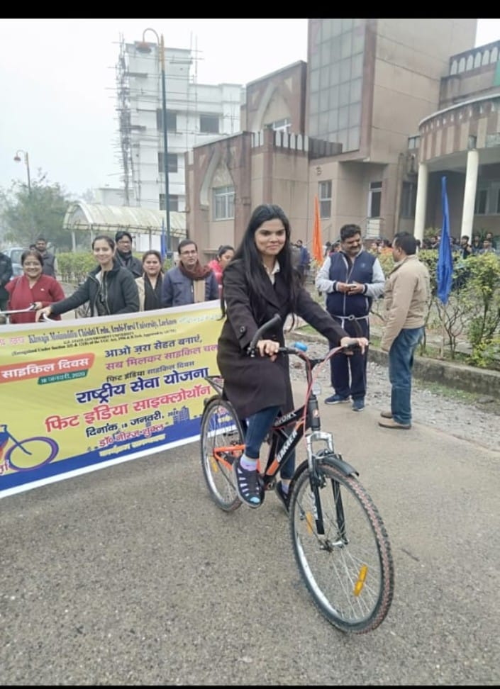
- Girls Rights Awareness Programme and Voters Awareness Programme was organized on 24/01/2020 and 25/01/2022
A Workshop on National Girl Child Day and National Voters Day was organized in the University. A poster writing Activity was also carried out in the University for creating awareness among people. A rally was also done on 25th January, 2022 for creating awareness in the society on the mentioned theme.
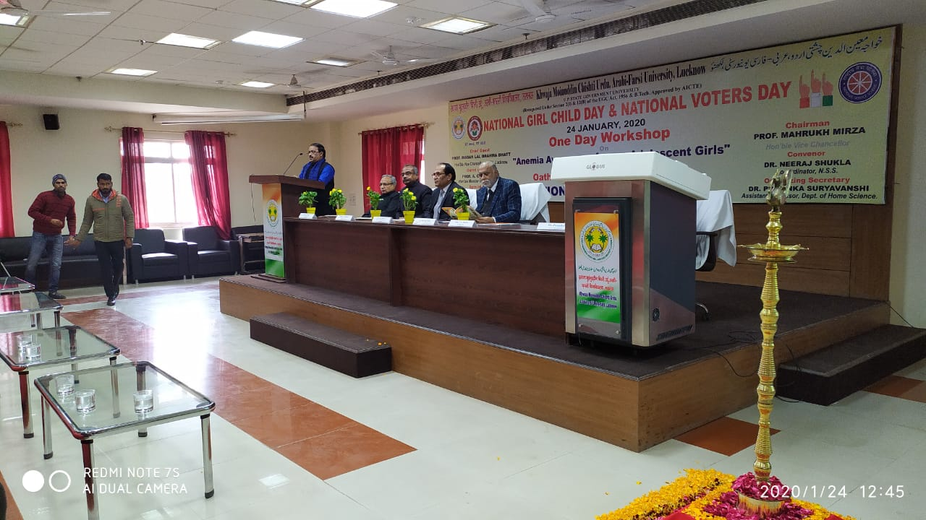
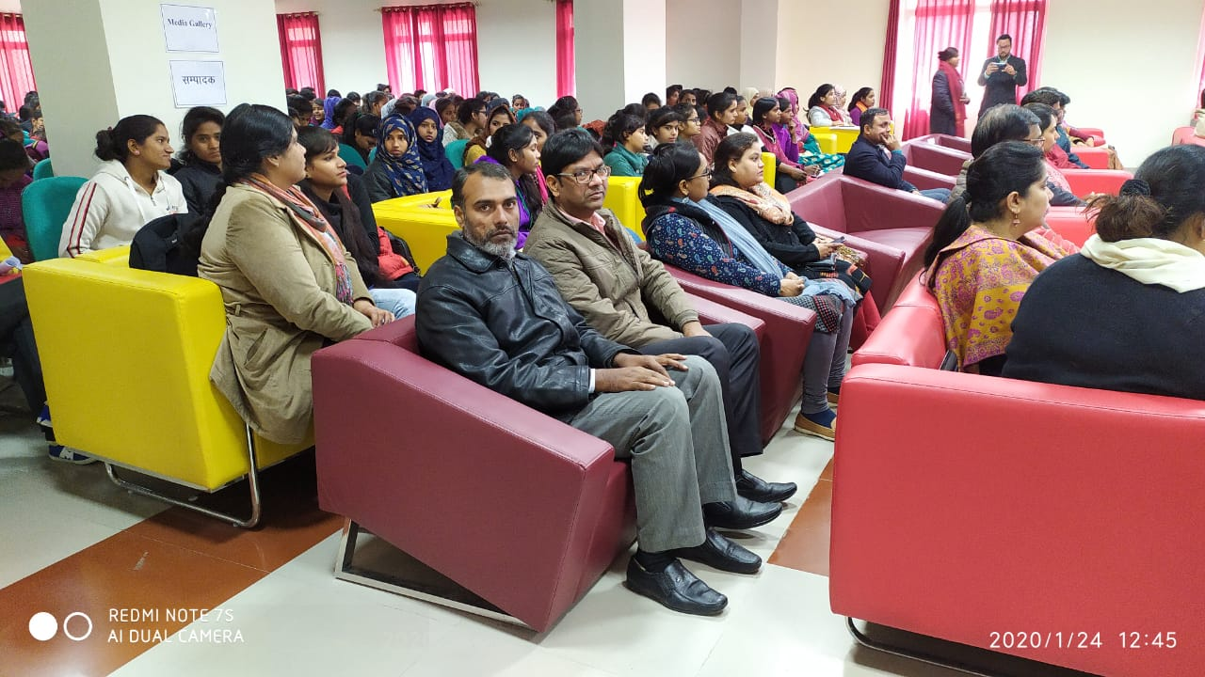
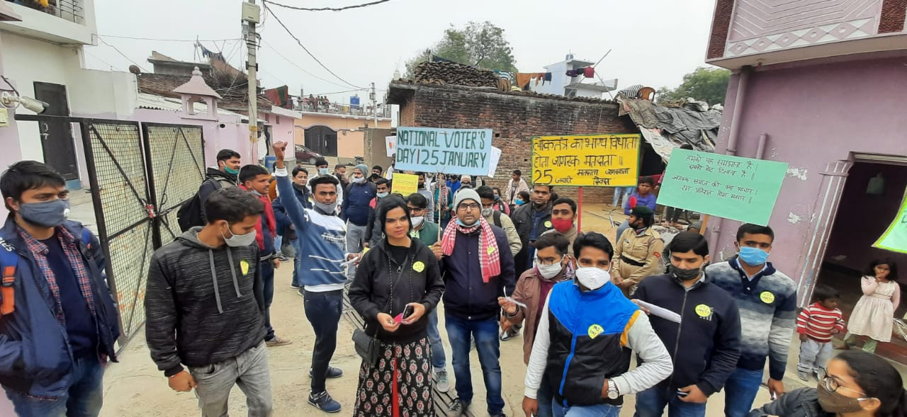
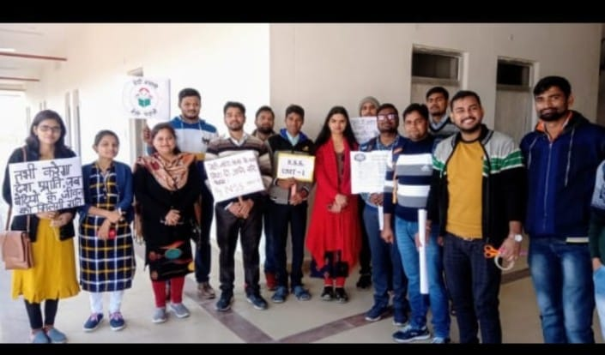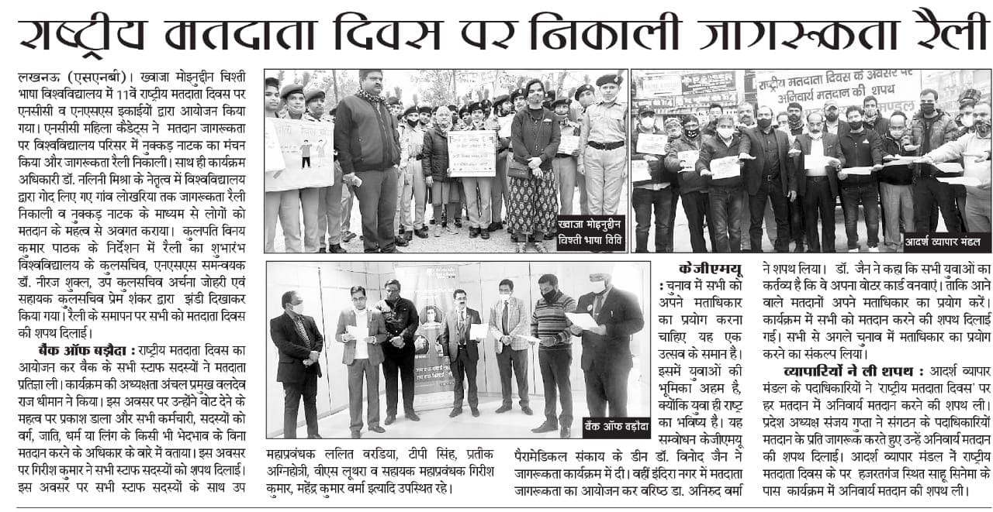
- Cleanliness Awareness Programme was organized on 28/01/2020 in which importance of Green Environment and clean habits on life were kept as theme.
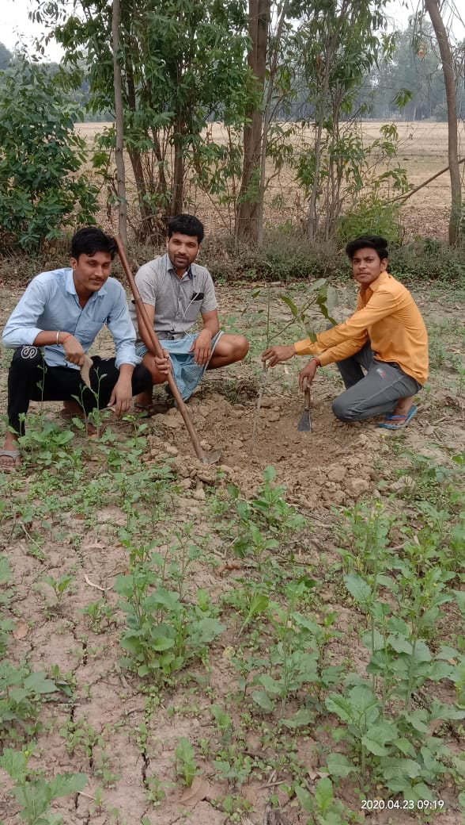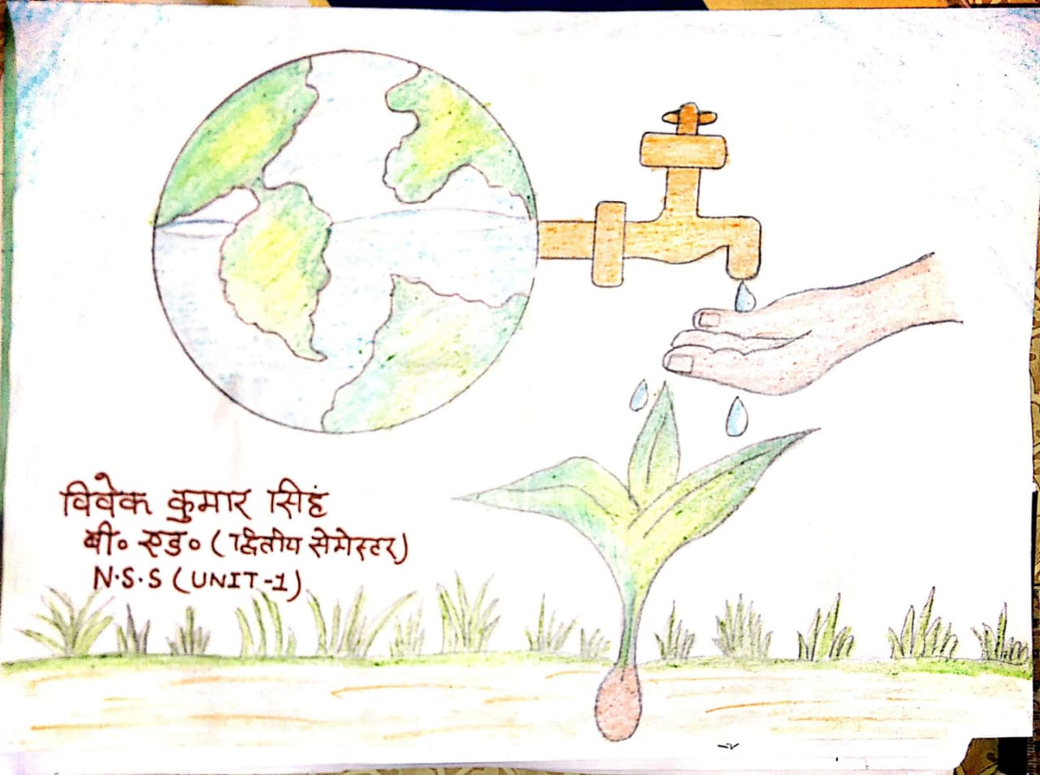

- An Essay Competition was organized on “Save Water Save Life” on 29th January, 2020 on the occasion of Ganga Yatra in the University for creating awareness about saving natural resource water.
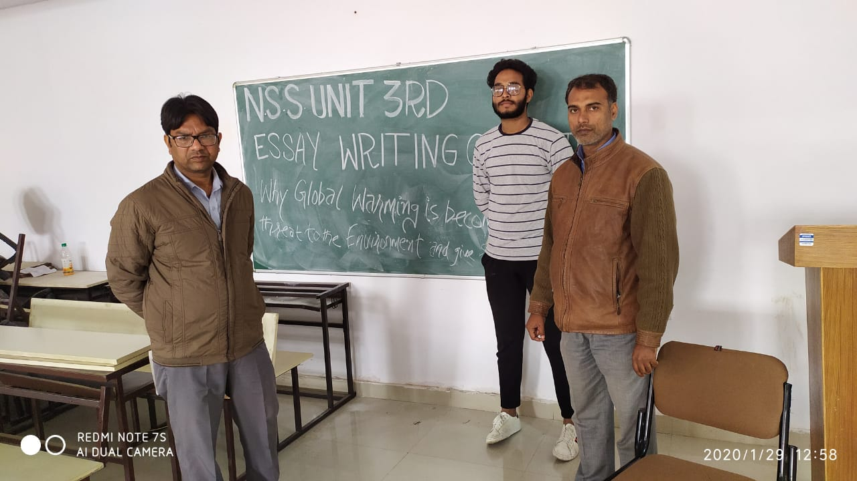

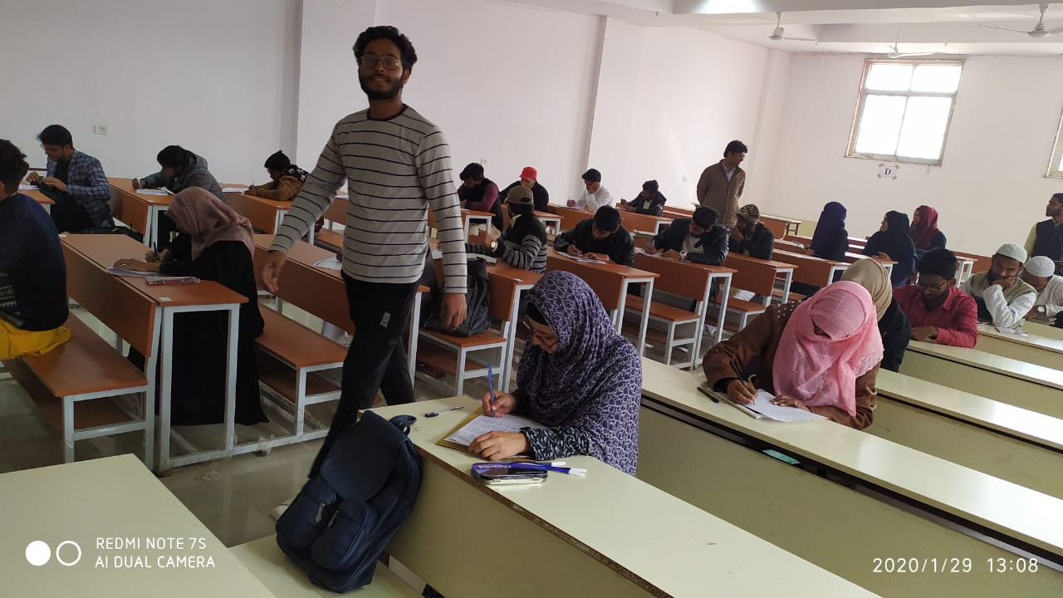

- Covid-19 Awareness Programmes were conducted during Covid times in which webinars, online activities and Special lectures were organized in online mode from March 2020 to August 2020. Food to the needy families was also distributed by the NSS Volunteers.
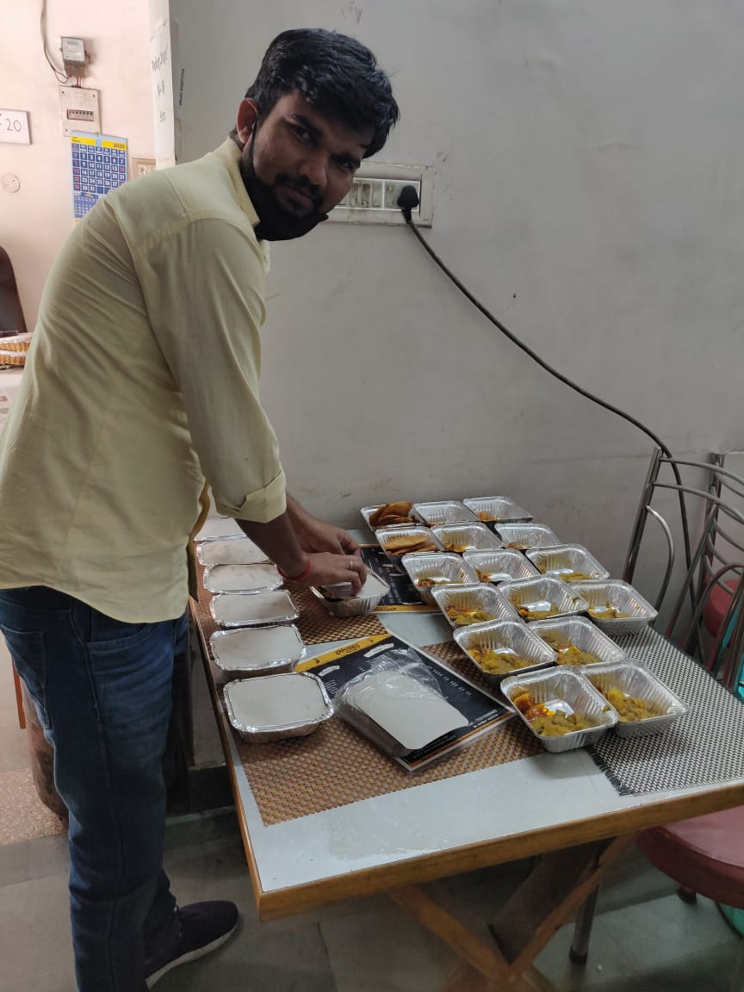

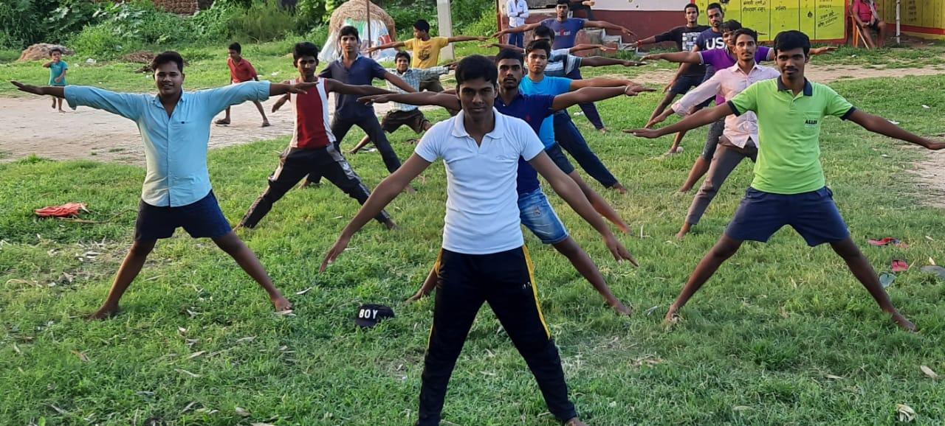

- Fit India Movement Awareness Programme (15/08/2020 –02/10/2020): Yoga Awareness was given through webinars, and yoga exercices workshops by the volunteers.
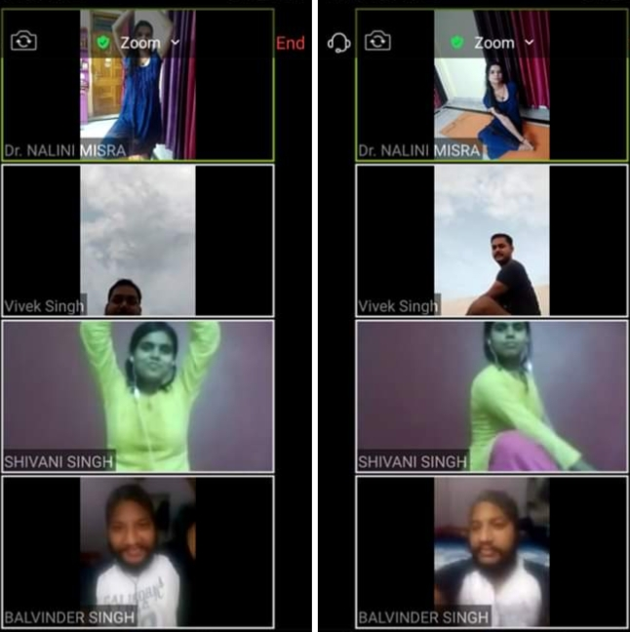
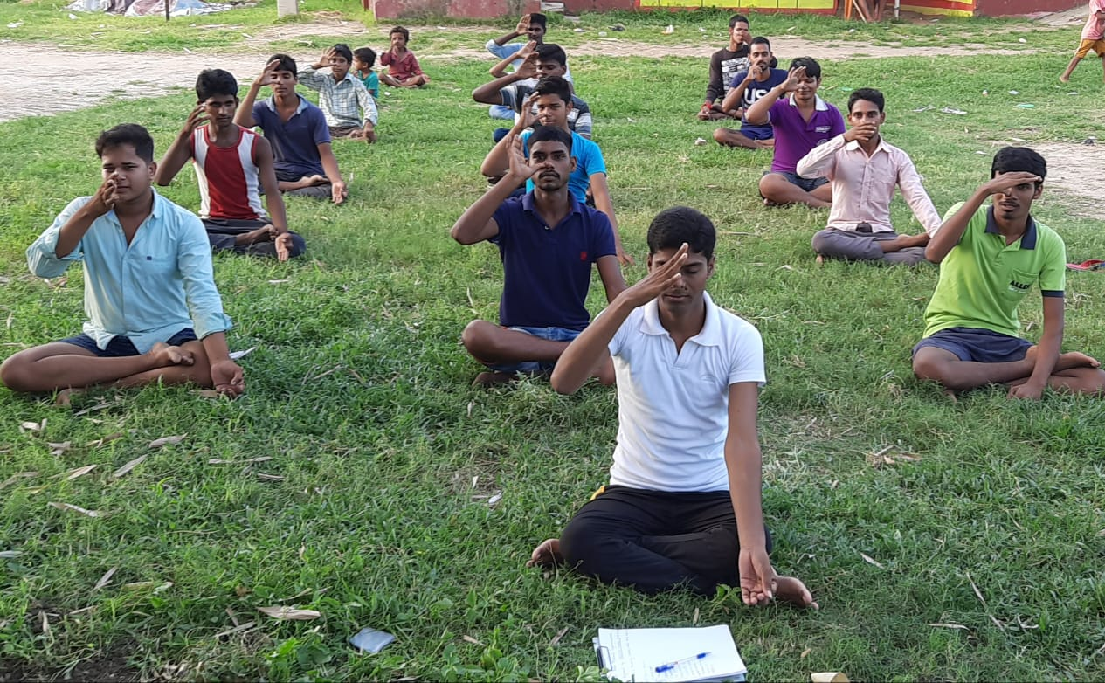

- Plantation Drive is carried out on 5th day every month in the University and outside the campus.

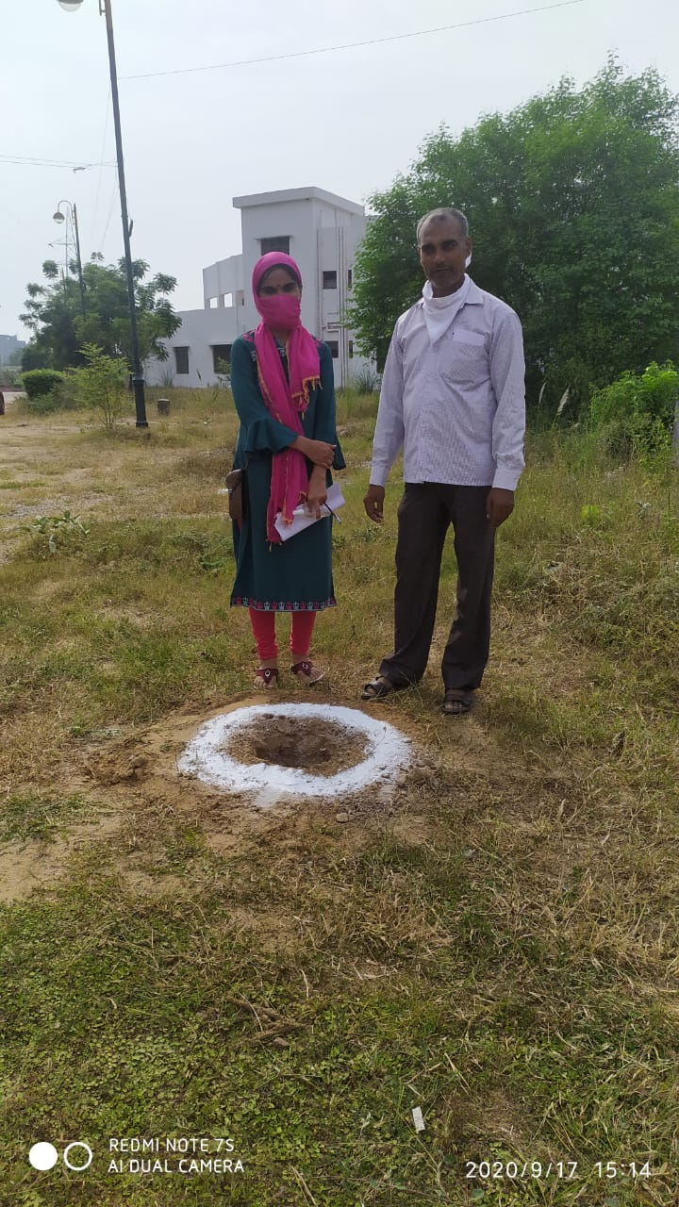
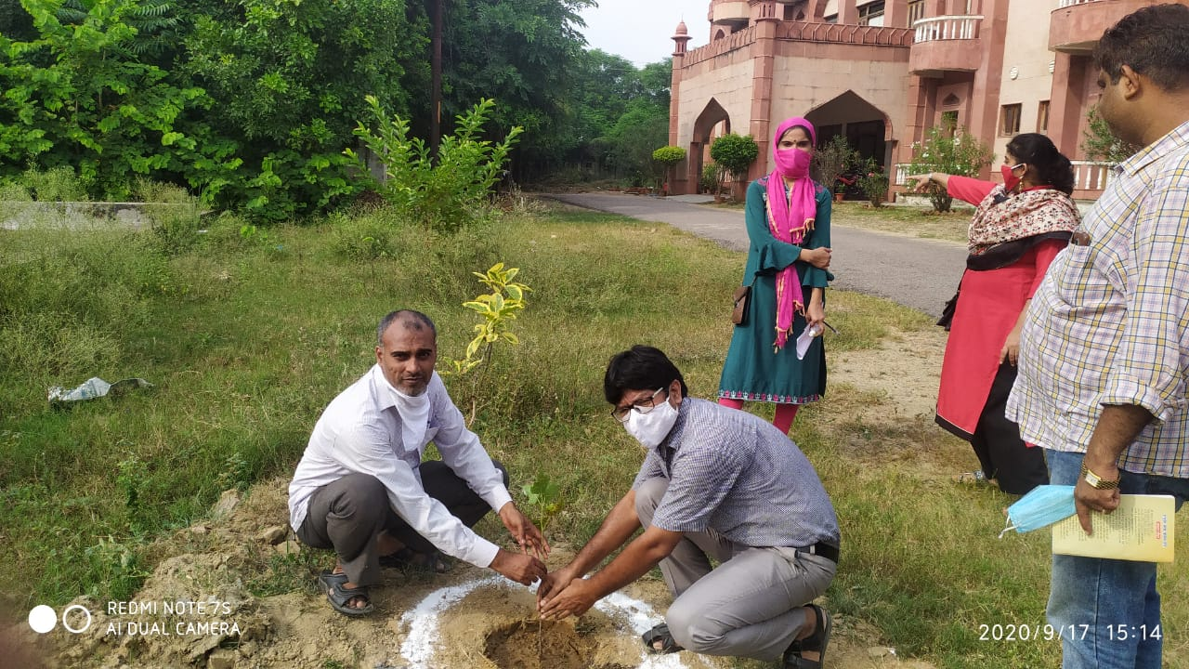
- During the time of Covid pandemic in the month of May and June 2021, Covid awareness programmes were conducted in which activities like mask distribution, food items distribution, awareness about immunity booster diet, cleanliness, etc. were performed.
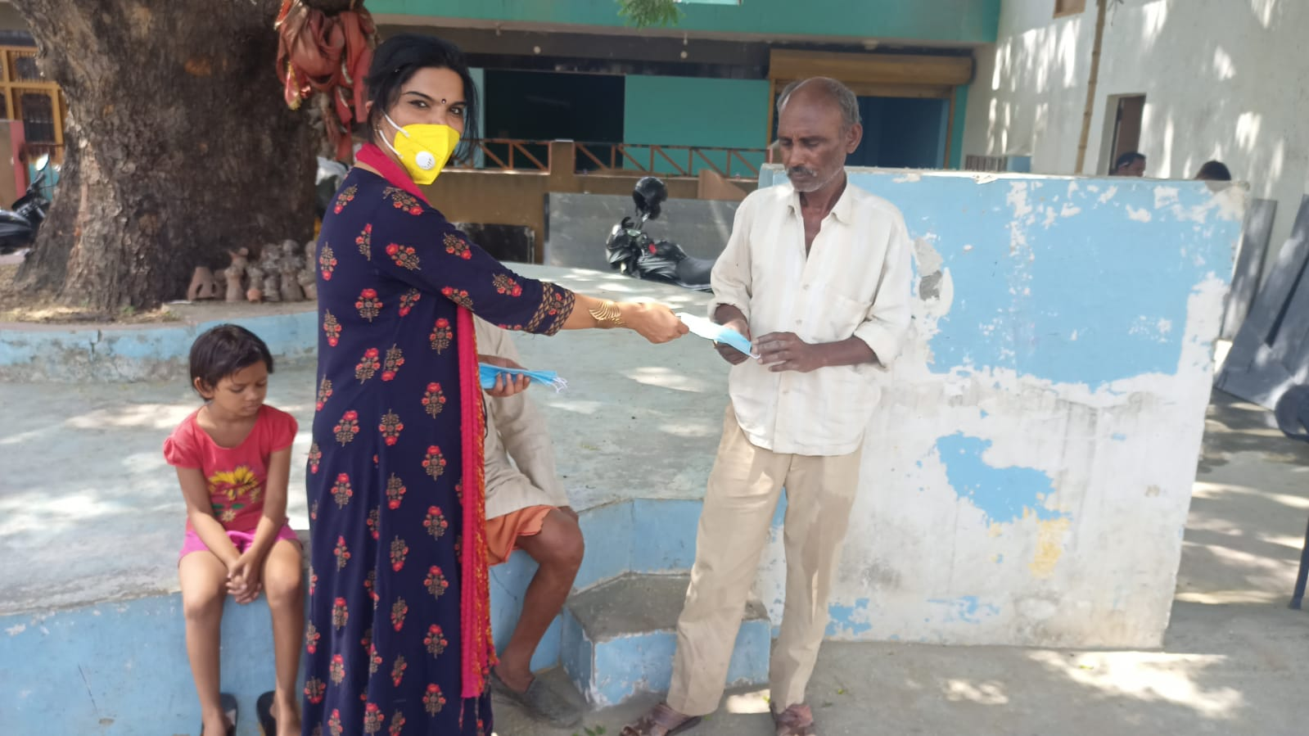
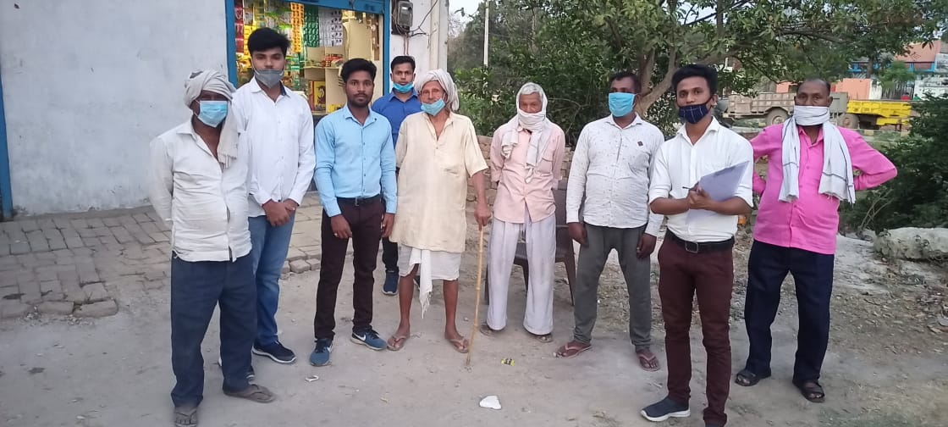
- Every year, World Environment Day is celebrated by National Service Scheme Unit I on 5th June. This year also tree plantation was done in the University campus and adopted villages outside the campus.

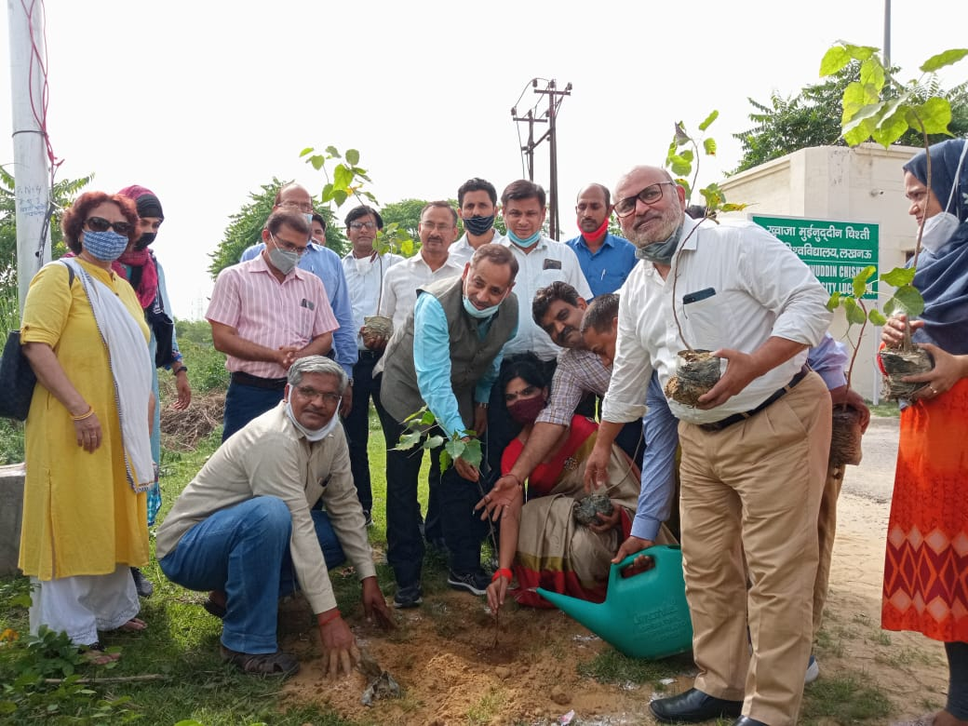

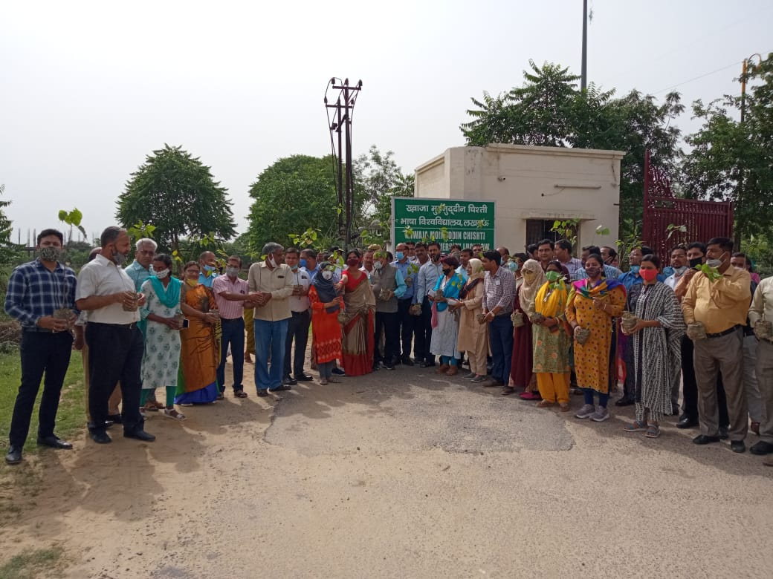

- On June 09, 2021, Covid testing camp was organized in the nearby villages of University in which medicines related to Covid were also distributed.
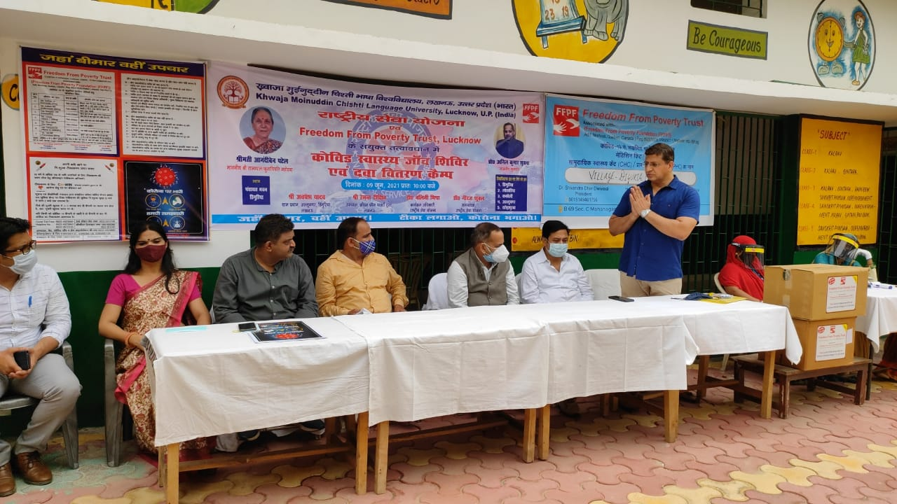

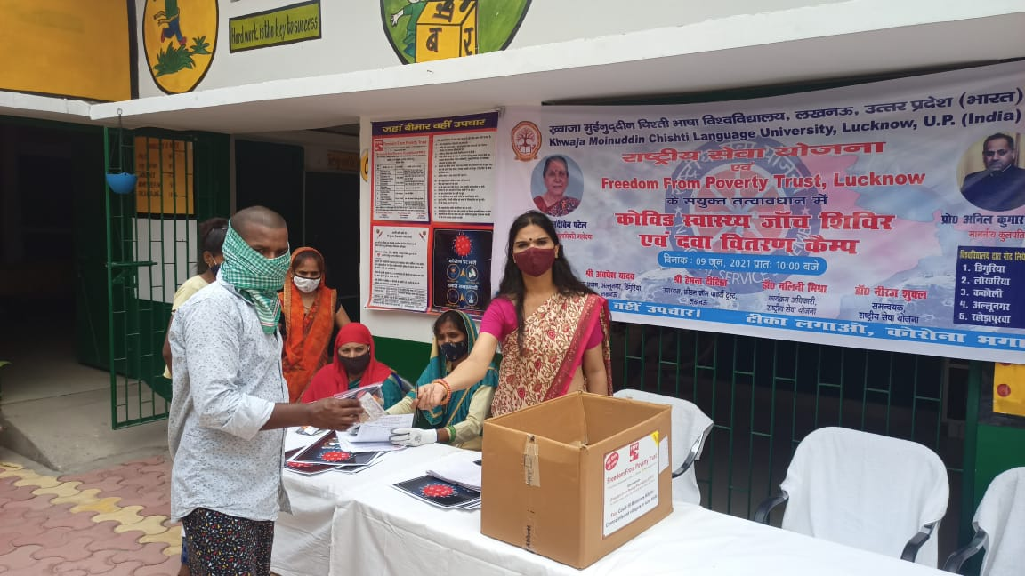

- On 24.09.2021, Blood donation camp was organized by NSS Unit I in which teachers and students contributed in the success of the camp.
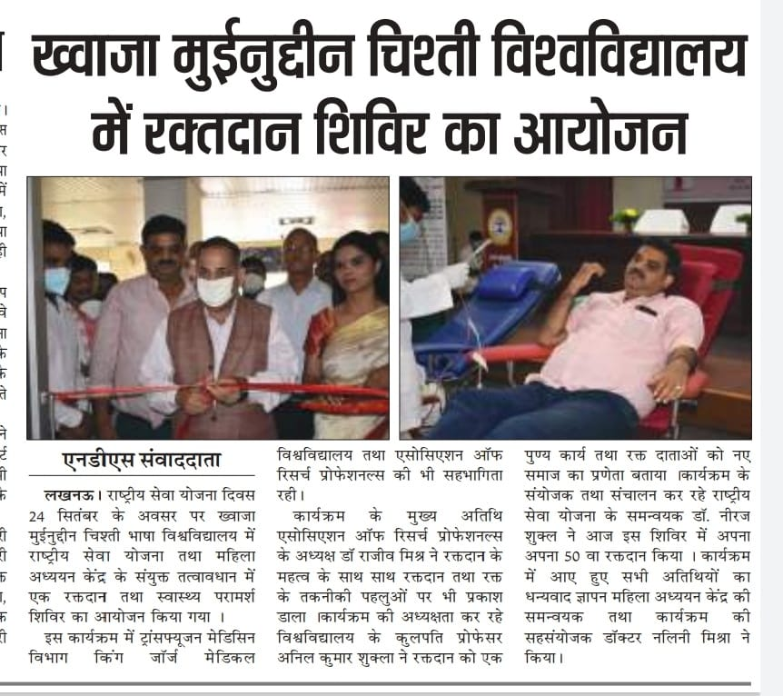

- National Service Scheme Unit 1 made an important contribution in the Azaadi ka Amrit Mahotsav in which the volunteers of Unit 1 participated in the Amrit Mahotsav Cycle Yatra (October 17, 2021 to November 03, 2021). Programme Officer Dr. Nalini Misra volunteered with other students for a cycle rally from University to Kakori where the students were shown places of historical importance and were told about the contribution of freedom fighters in the independence of nation. Dr. Neeraj Shukla made a special contribution in the success of the programme.
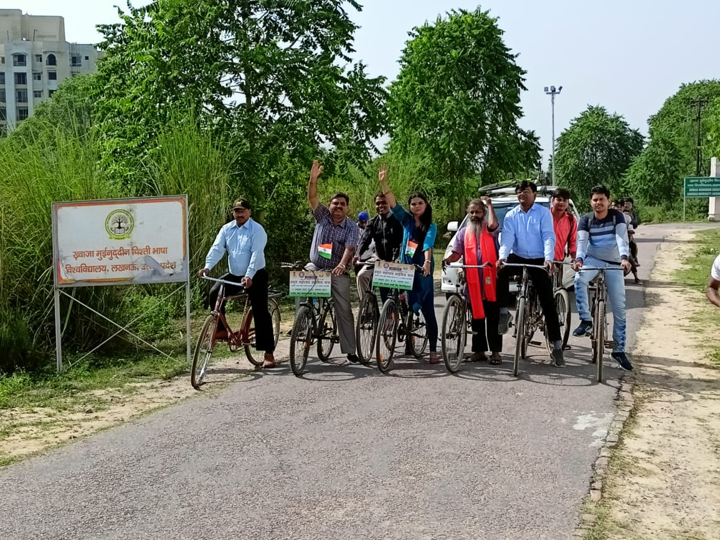

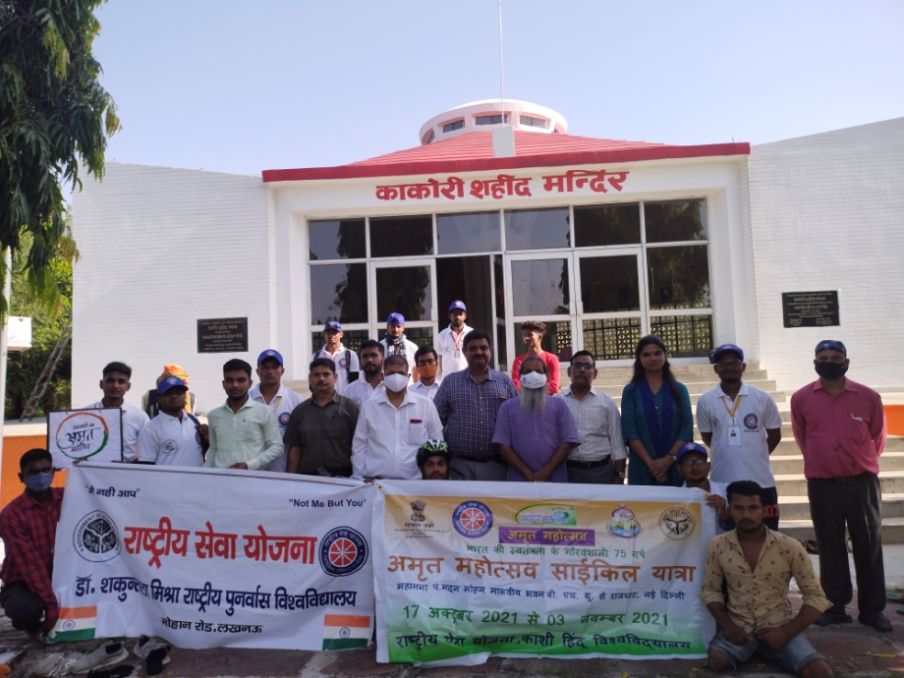
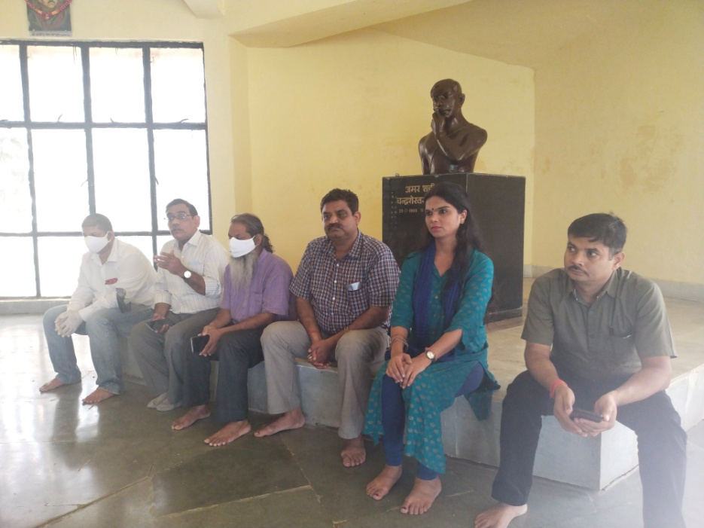
- In villages adopted by University, social campaigns related to cleanliness are run from time to time by volunteers and awareness is given about government schemes to people.
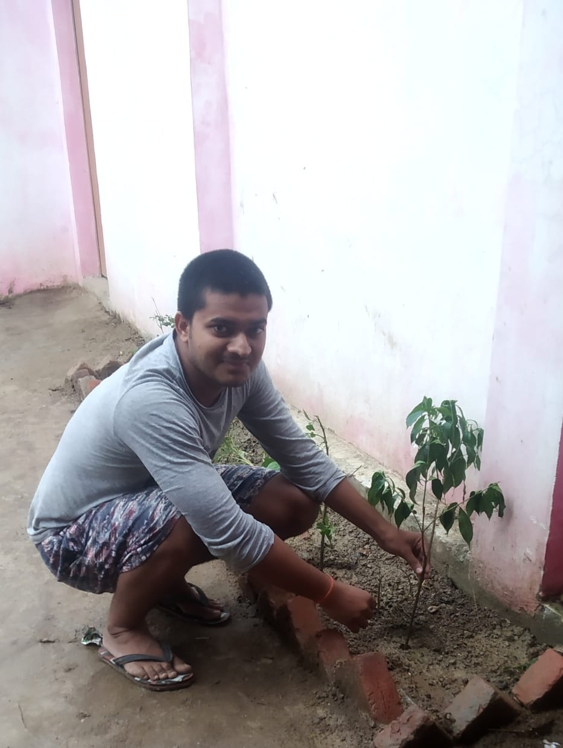
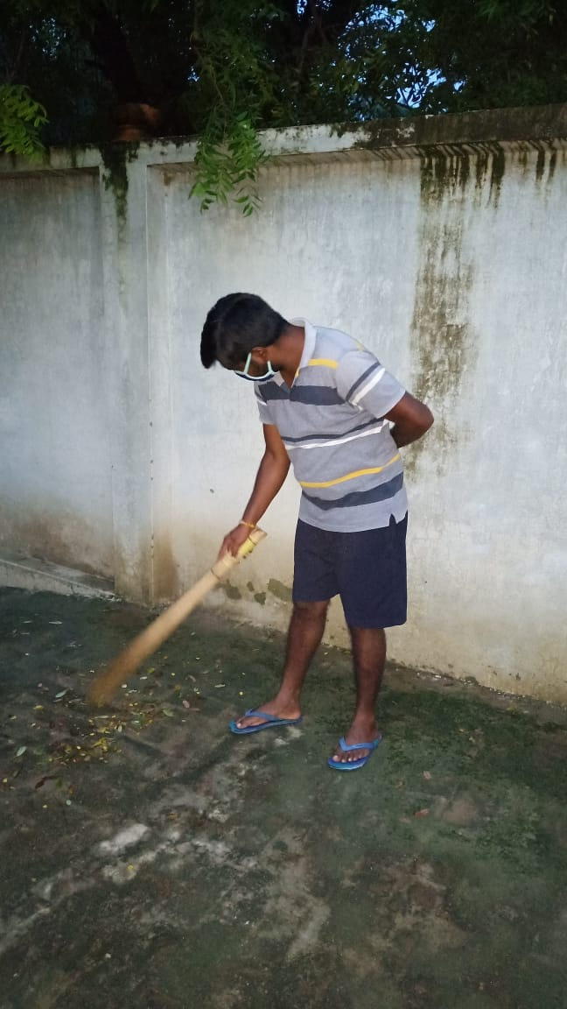
- Awareness campaigns are done by volunteers from time to time on various social issues through rallies, poster activity, poetry activity, slogans writing etc. and these are also disseminated through social media.
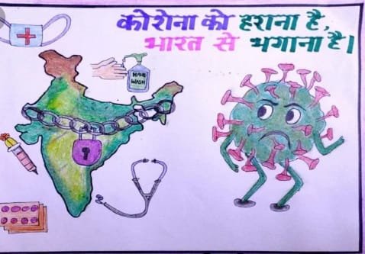
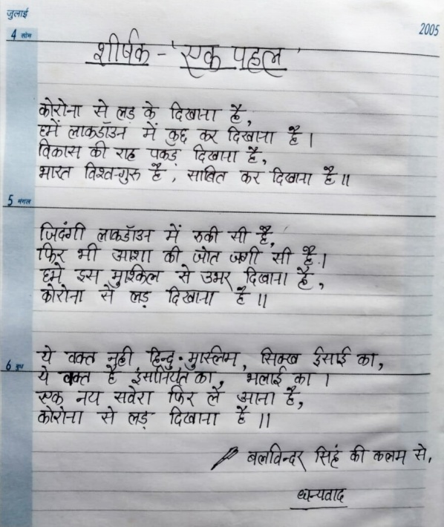

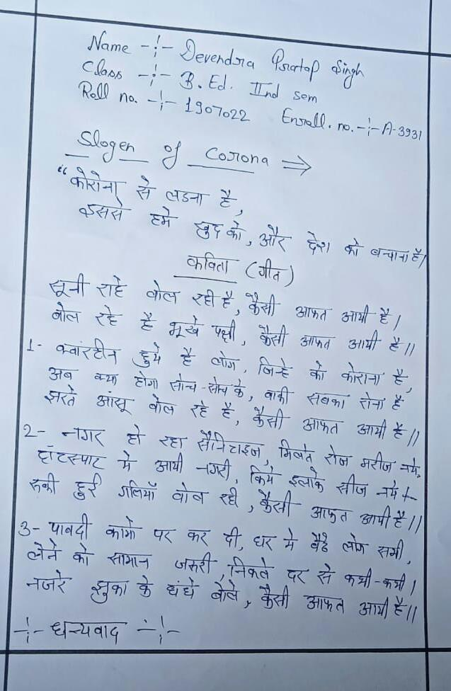

- On 27th November, 2021. poster competition was organized by Unit 1 in the University in the Road Safety Week, in which students and girls participated enthusiastically.
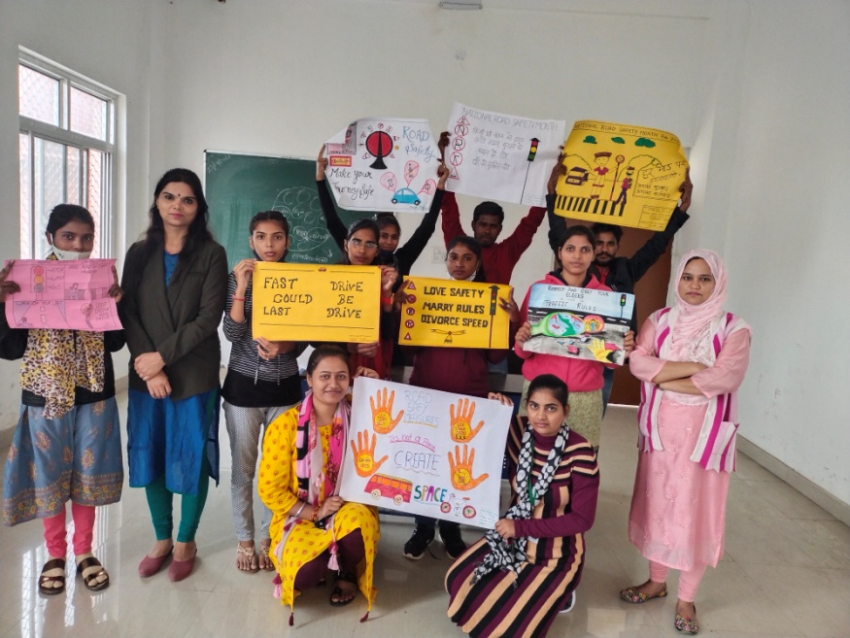

- 7 Day NSS Camp was organized in Village Lokharia (Village adopted by NSS Unit I) from 24th March, 2022 to 30th March, 2022. Rallies, Awareness Programmes, Activiies, etc. were done regularly in the village on the following themes:

Day 1 (24/03/2022): Awareness about Malnutrition and Drug Abuse
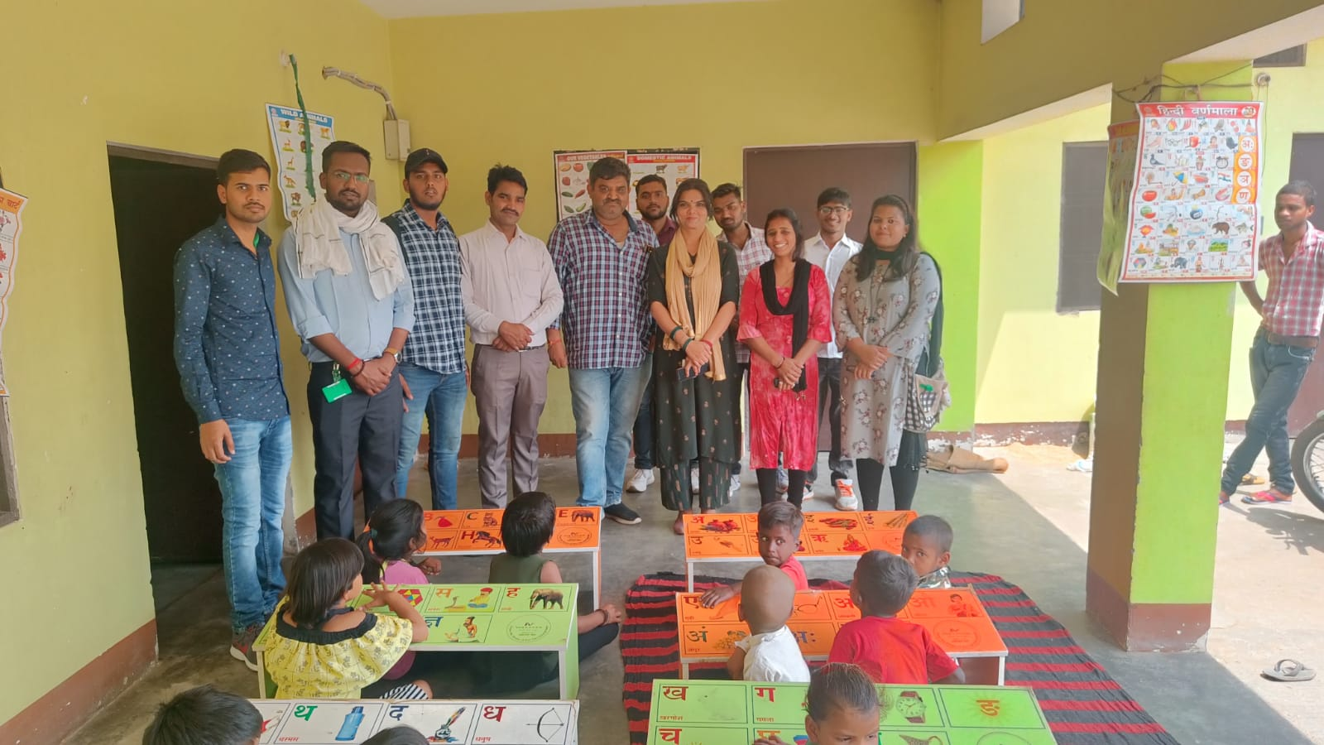
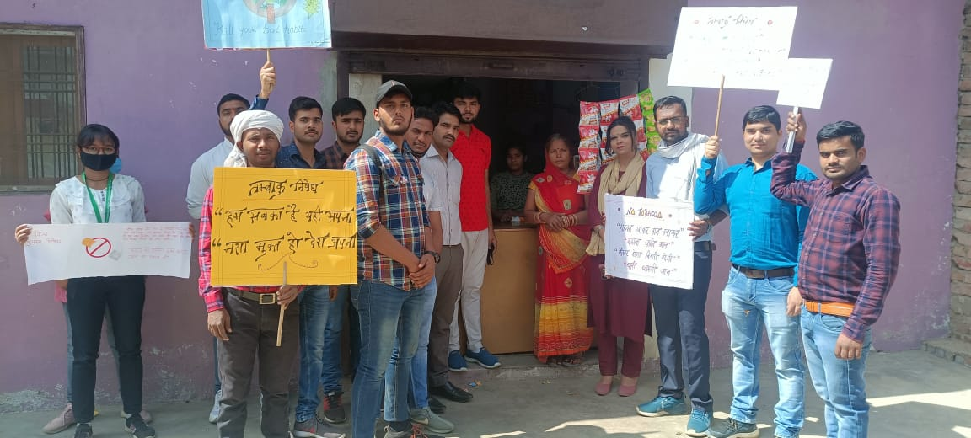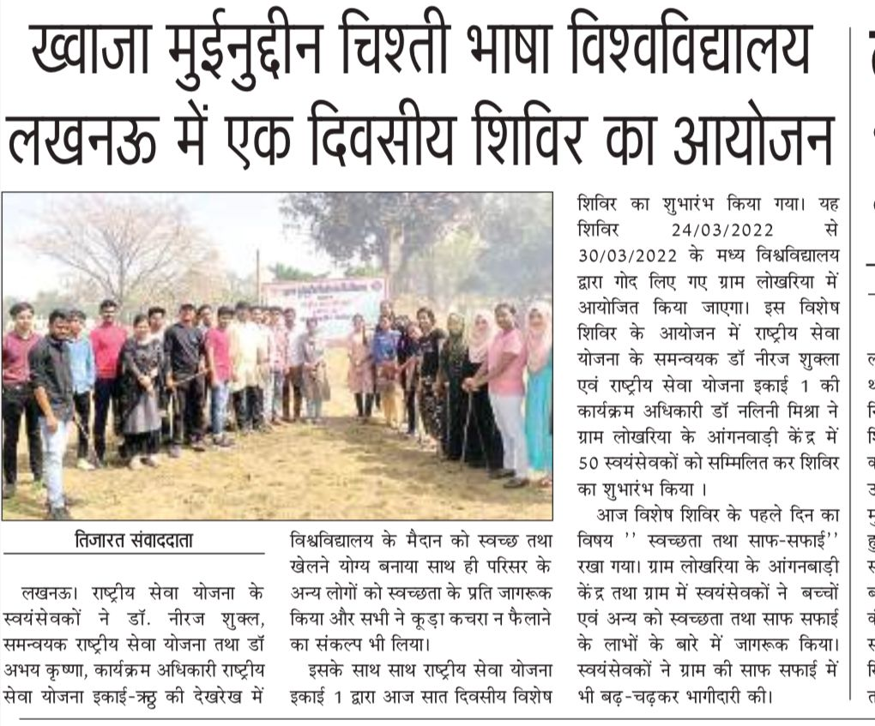
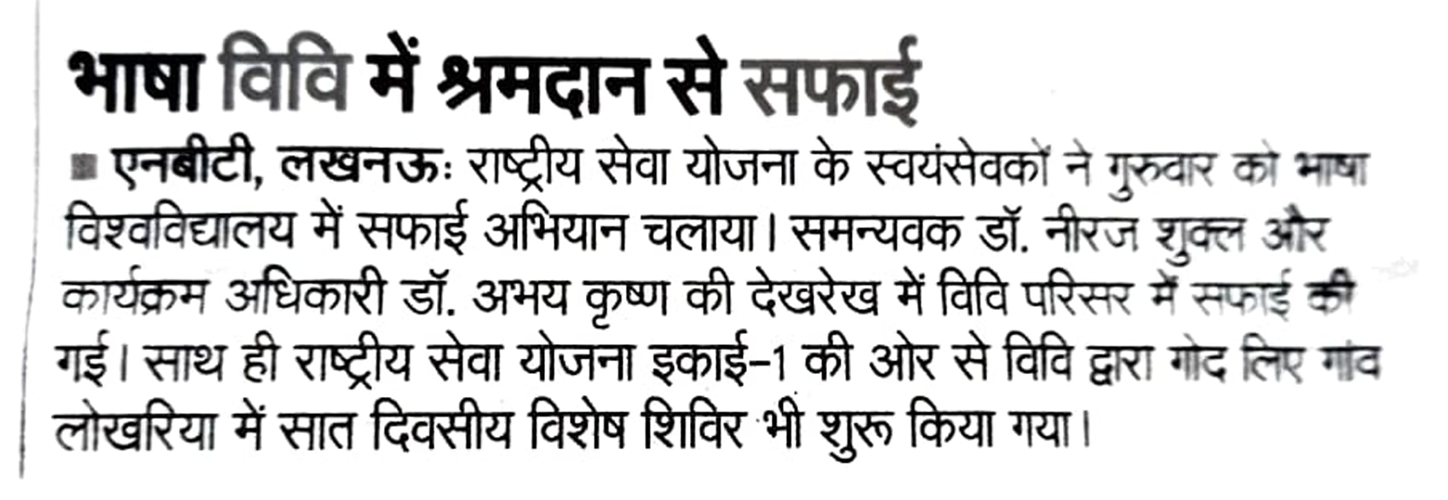

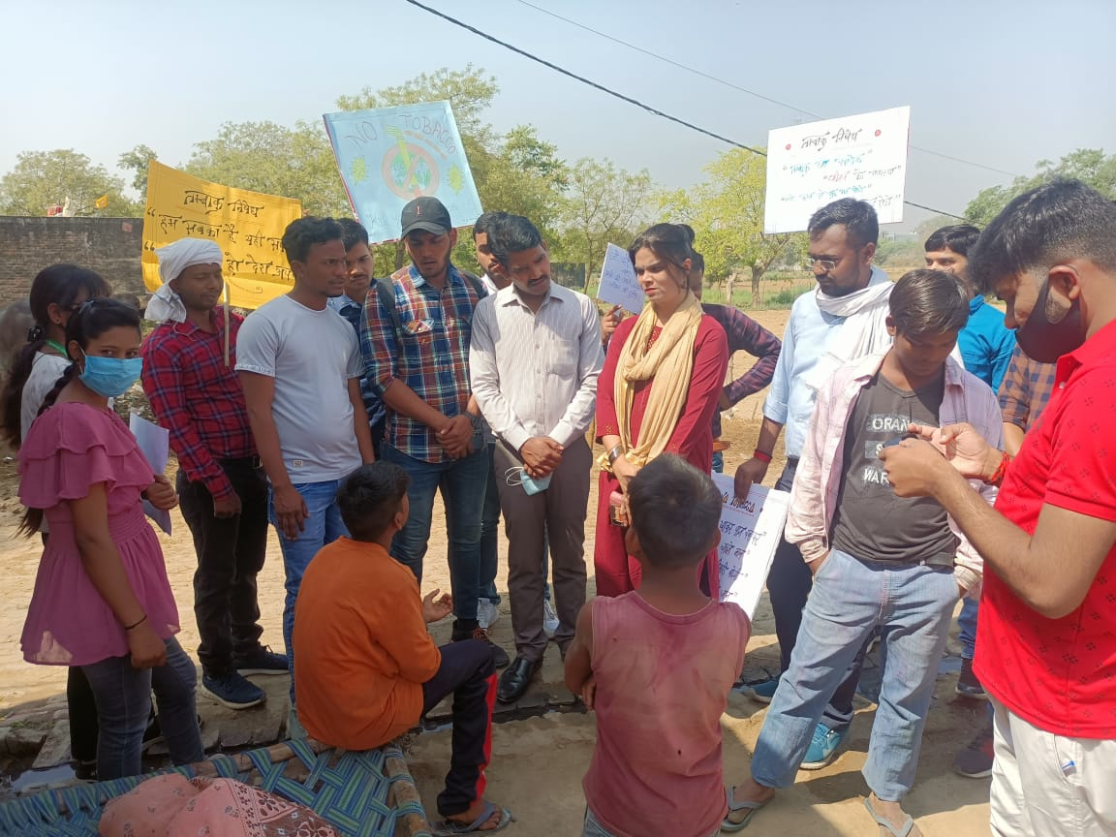

Day 2 (25/03/2022): Awareness about Cleanliness and Hygiene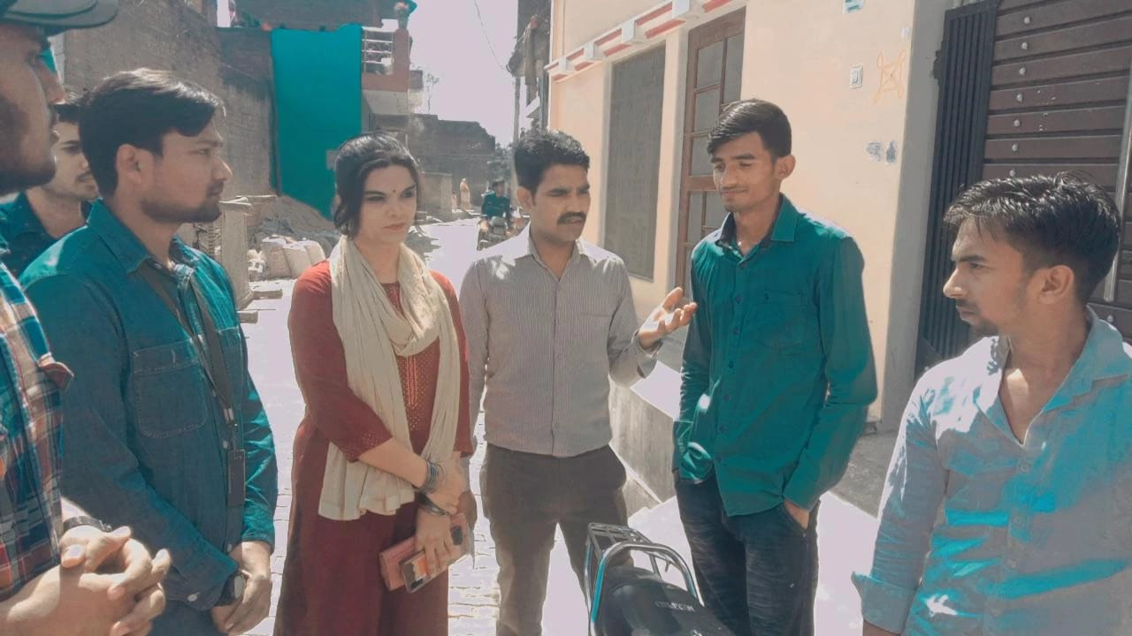 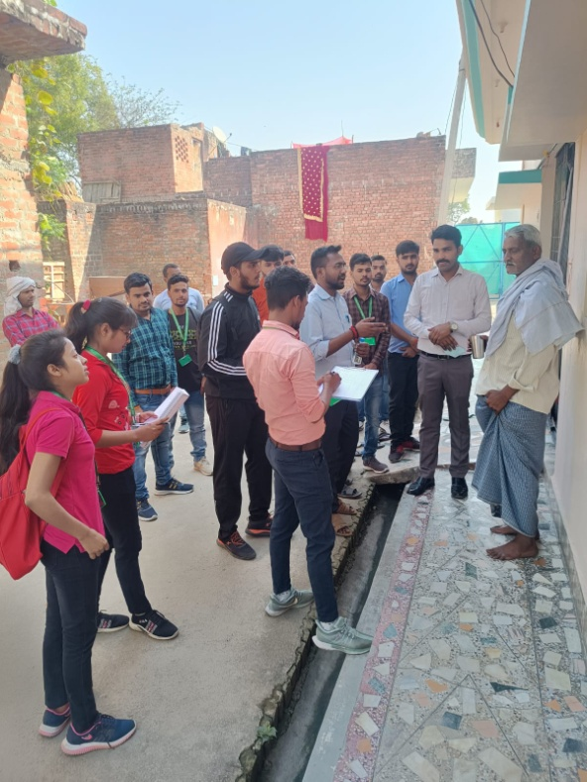
Day 3 (26/03/2022): Awareness about Beti bachao Beti Padhao

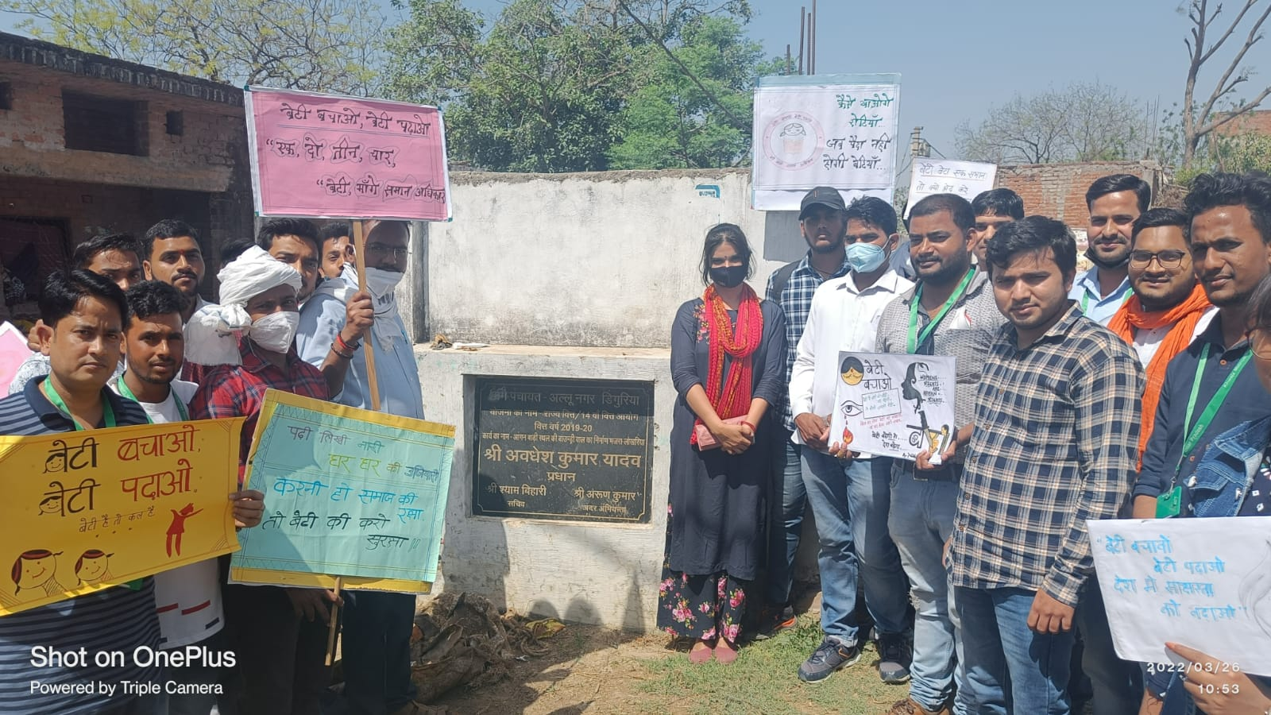

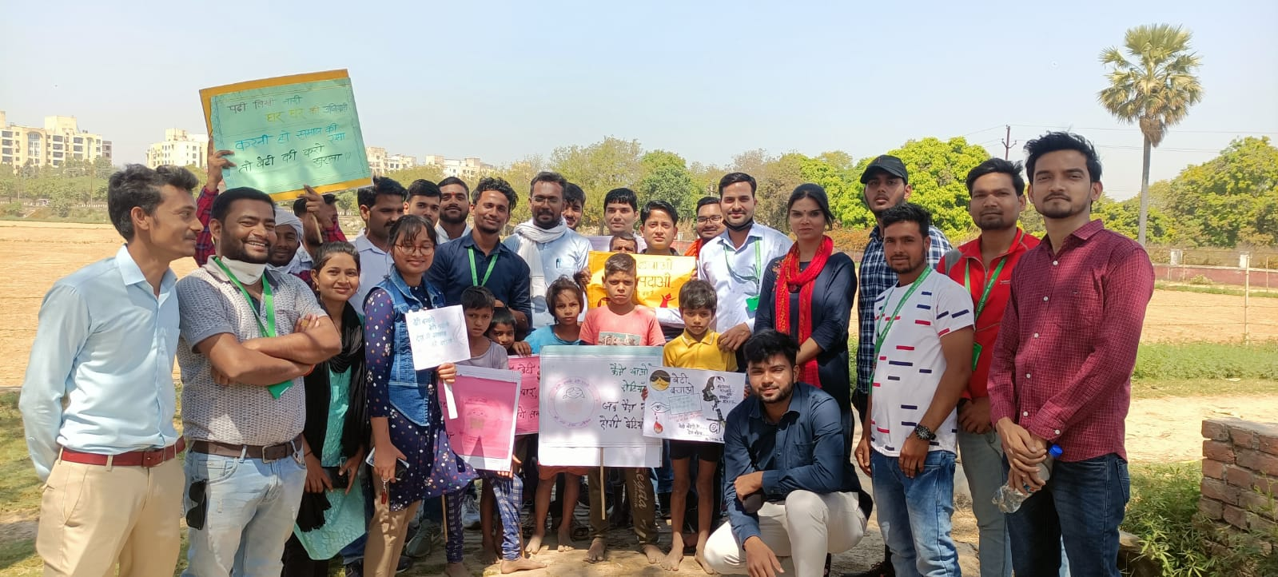

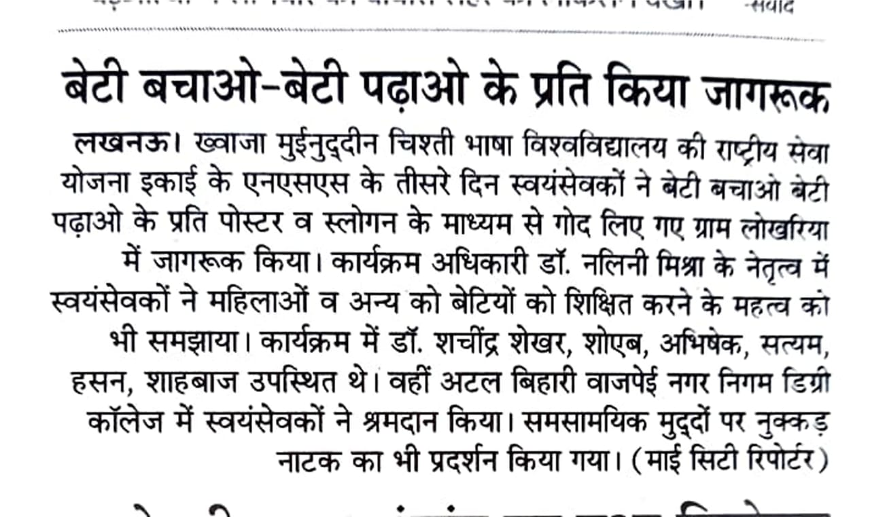

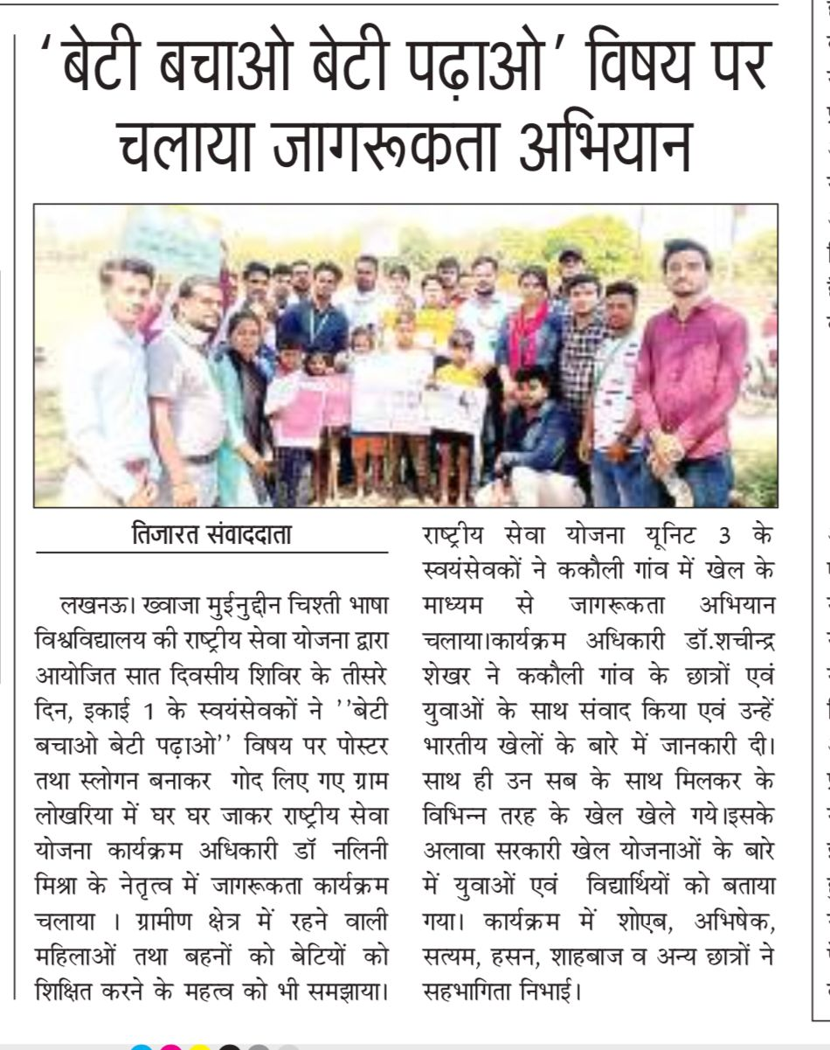
Day 4 (27/03/2022): Awareness about Covid Prevention and Covid Vaccination
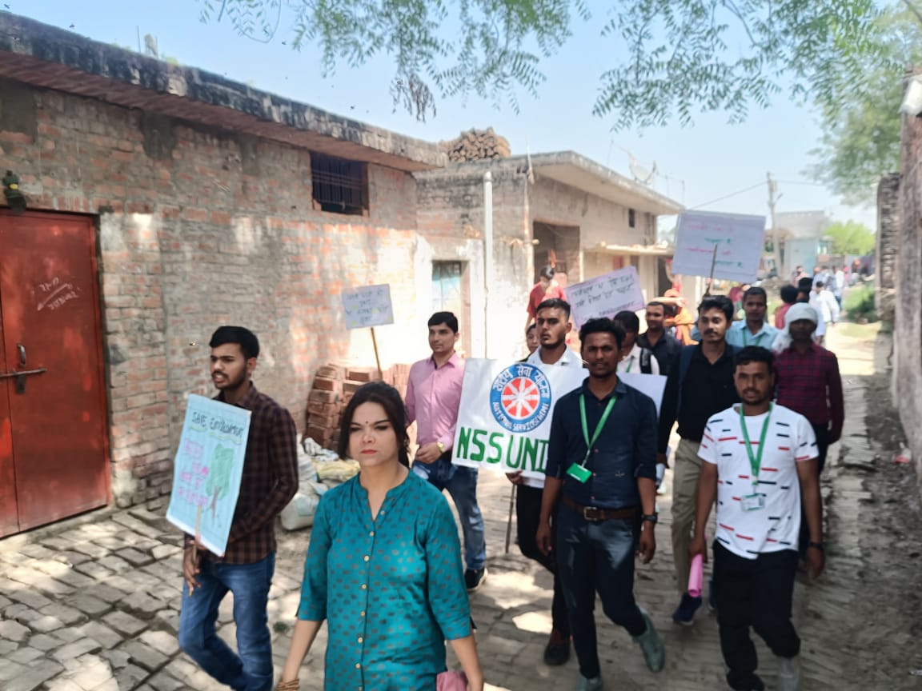

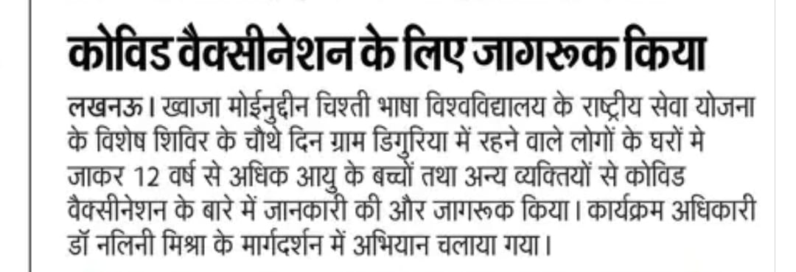
Day 5 (28/03/2022): Awareness about Impact of Environment on Life
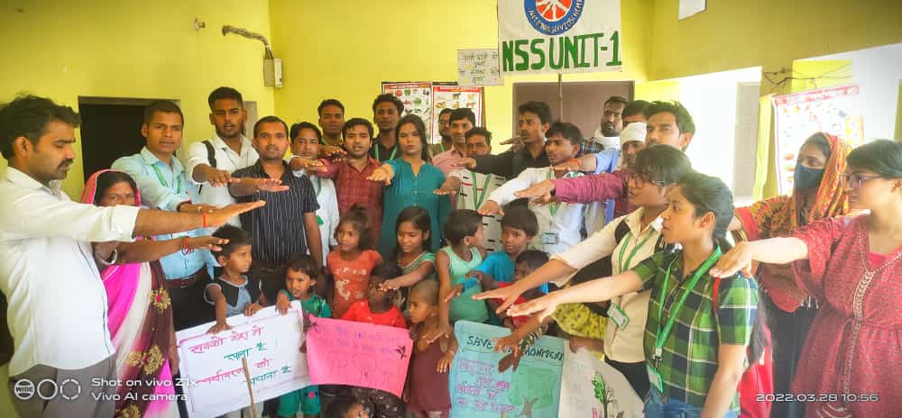
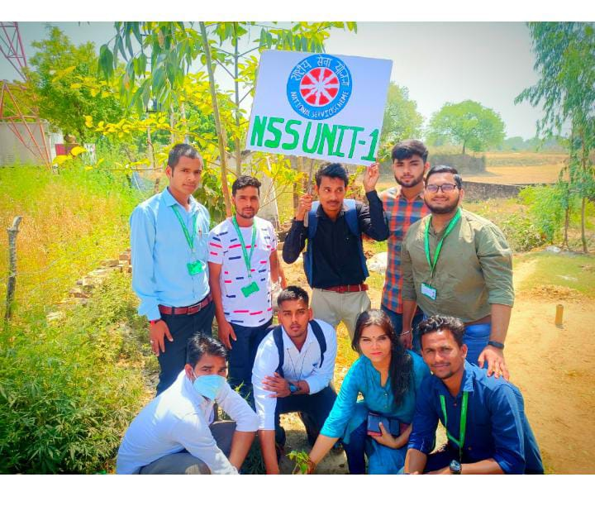
Day 6 (29/03/2022): Awareness about Road Safety and Traffic Awareness
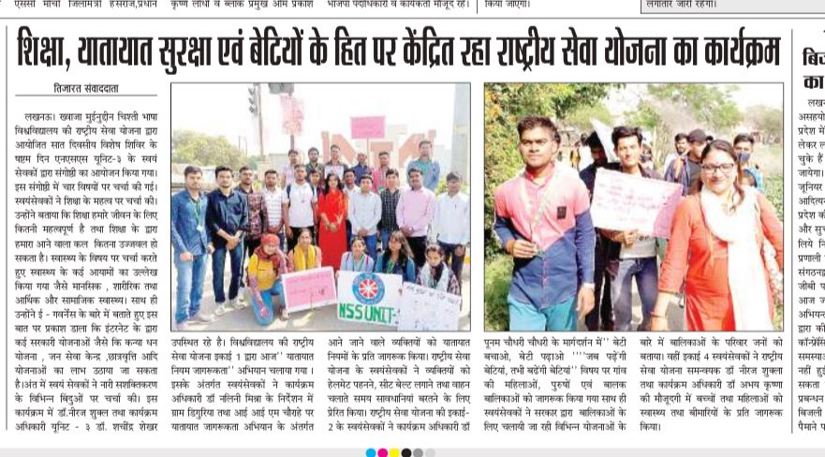
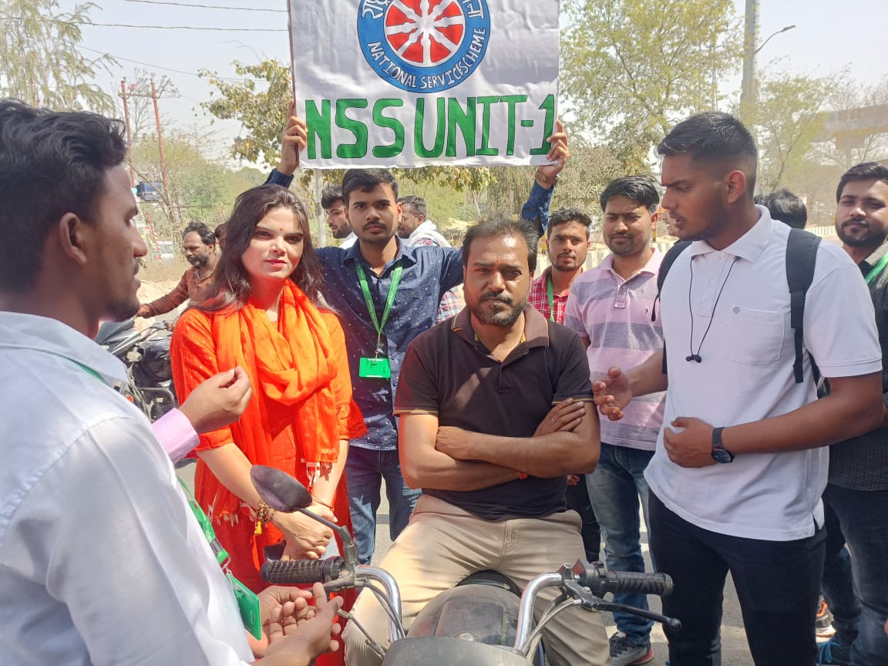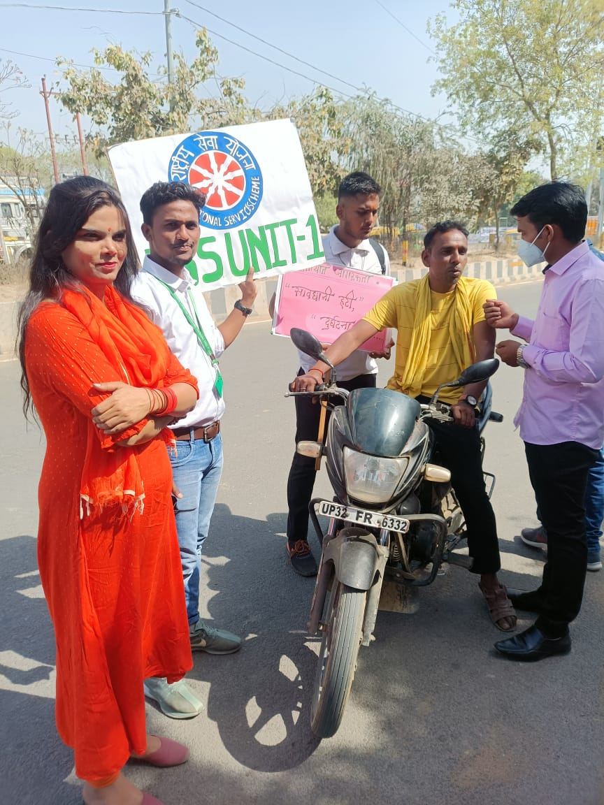
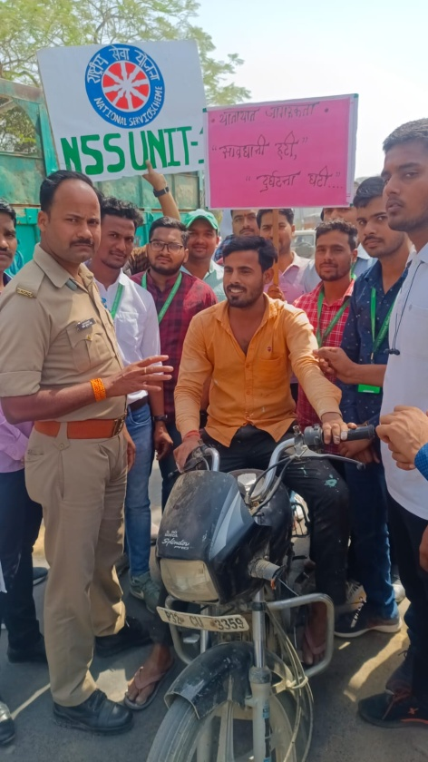
Day 7 (30/03/2022): Communication with elders
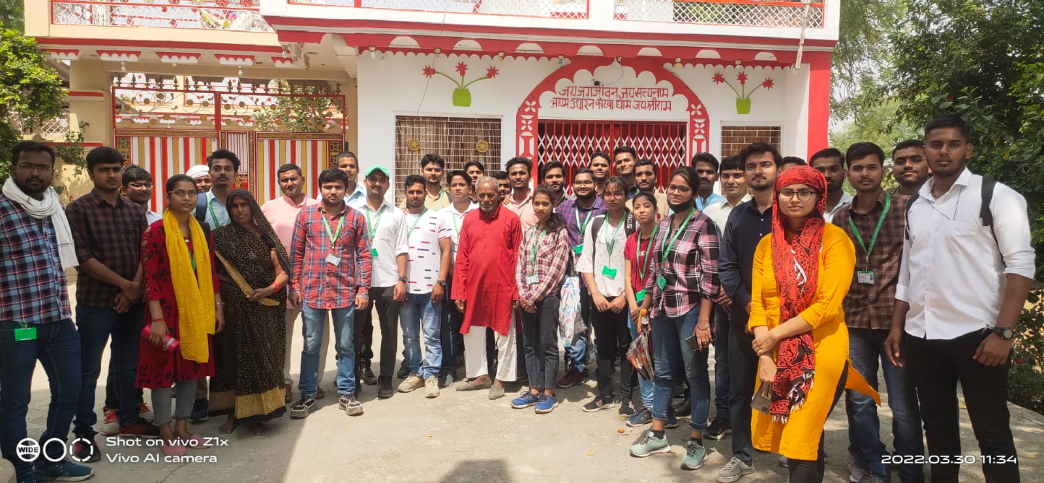
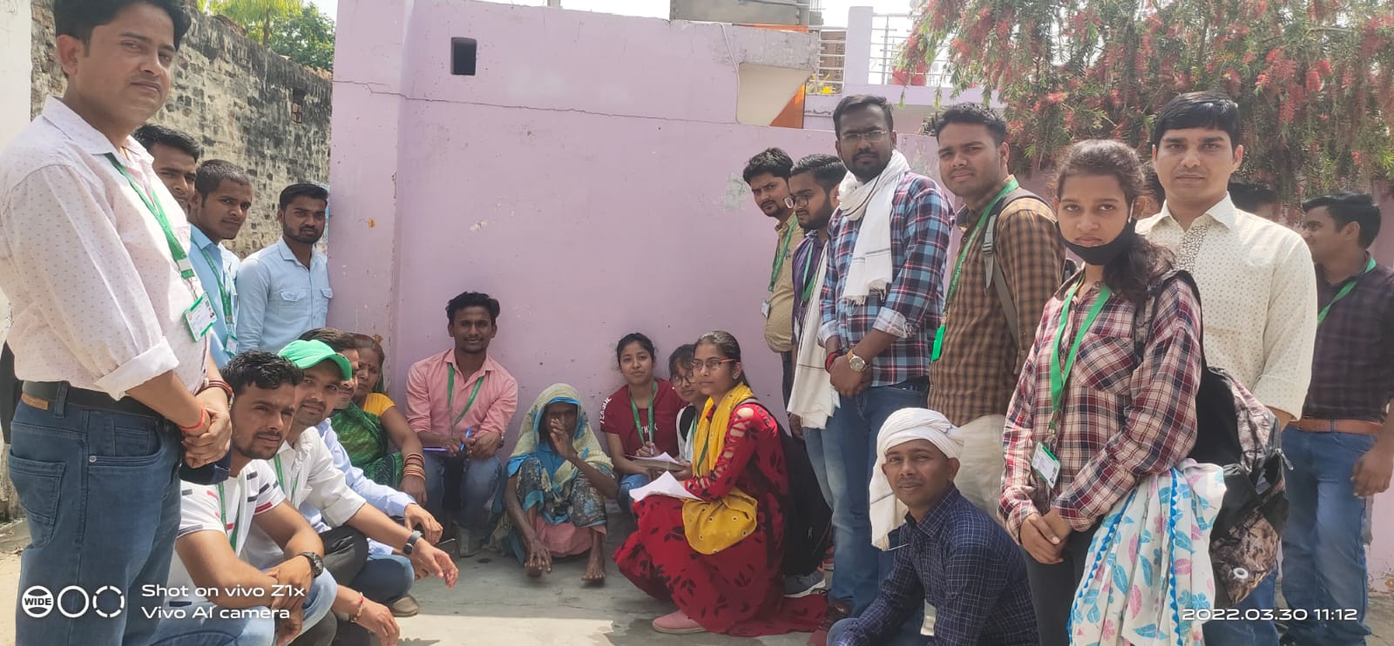

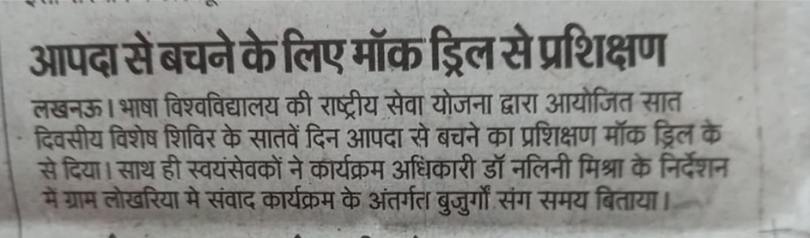
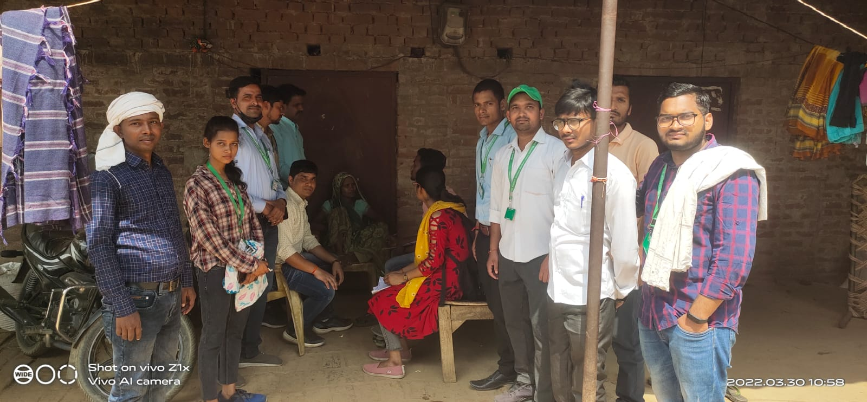
- Poster Activity was organized on the theme “Traffic Rules and Life” in the University campus in which the students participated with great zeal and enthusiasm.
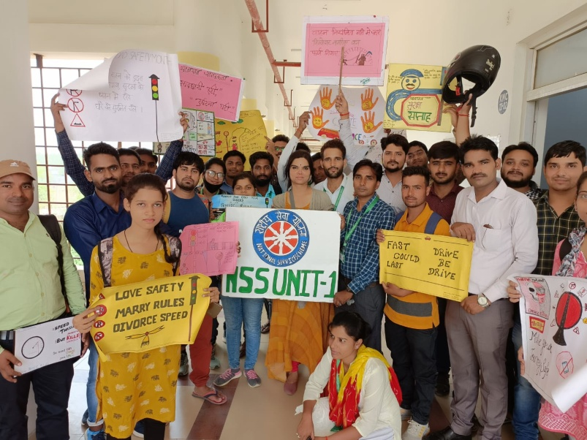

- A Road Safety Awareness Workshop was organized 30th May, 2022 in which R.T.O., (Lucknow) and A.C.P. (Traffic) were the Special Guests and the Chief Guests. There was lecture session followed by practical workshop for learning the traffic rules given by Traffic Trainers, RTO.
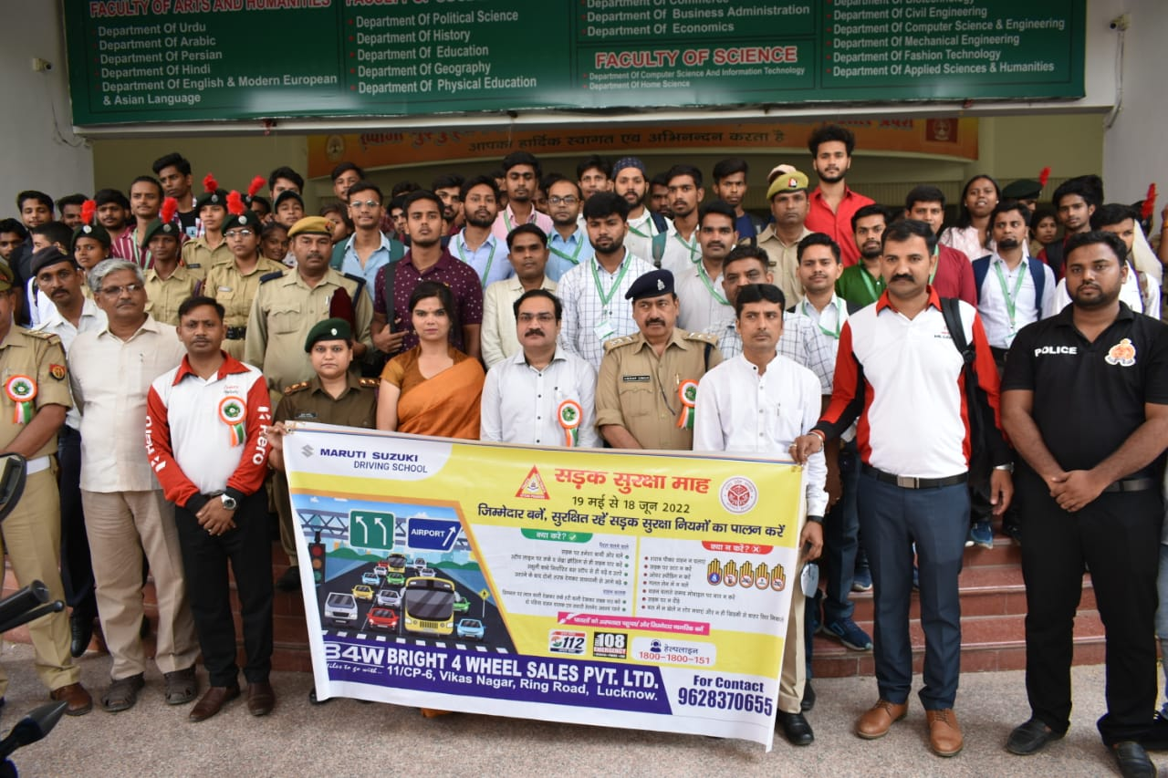
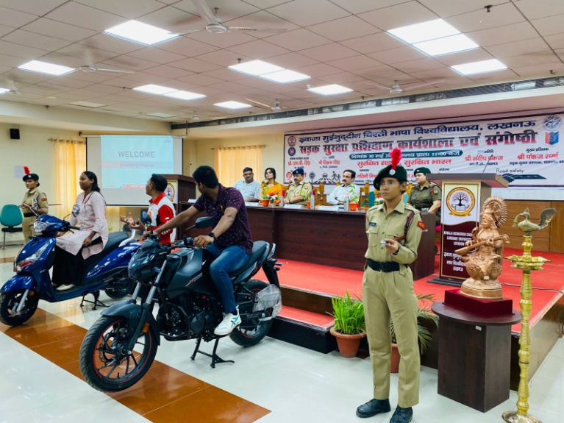

- Regular plantation drives and other social issues related activities are done both inside and outside campus by NSS Unit I.