KMC LANGUAGE STATE GOVERNMENT UNIVERSITY
REPORT OF ANEMIA TESTING DONE ON 03 FEBRUARY 2021
SNO. | RANGE HAEMOGLOBIN | Frequency  Of girls | Percentage | Anaemic
1. | Normal Range (11.5-16.5) g/dl | 95 | 60%
2. | Anaemia (10-11.4) g/dl | 46 | 30% | 40%
3. | Severe Anaemia Below 10 g/dl | 17 | 10%

On 3rd February 2021 158 girls gave their blood samples for anaemia testing. 60% girls were under normal range that is 11.5 to 14.5. 40% had low haemoglobin and among them 10% have been detected to have severe anaemia that is below 10 g/dl. The anaemic girls will be further sent to KGMU for serum, B12, Folate estimation and medication. The university had conducted Anaemia testing last year in 2020 24th January and counselled parents to take medical help for anaemic girls. But majority girls reported no further follow up by family. Thus this time university had moved ahead to further arrange for follow up, medication and diet counselling for the detected Anaemic girls. Thus these girls will be given follow up by KGMU Doctors.

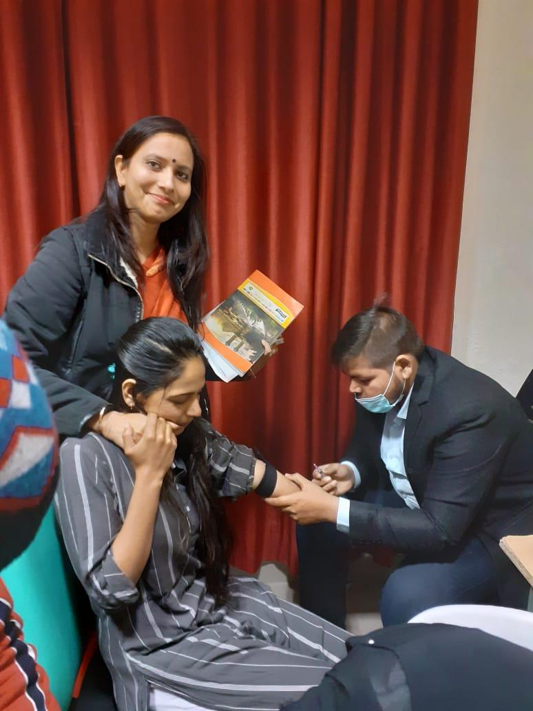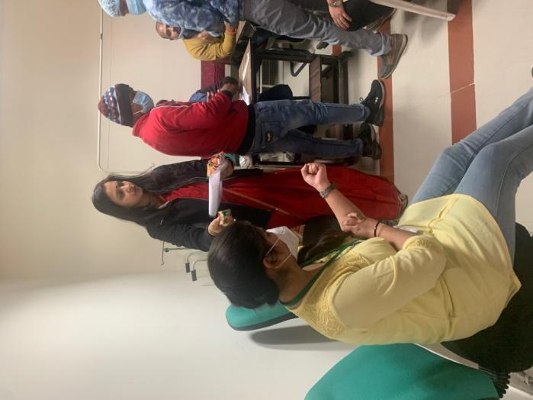

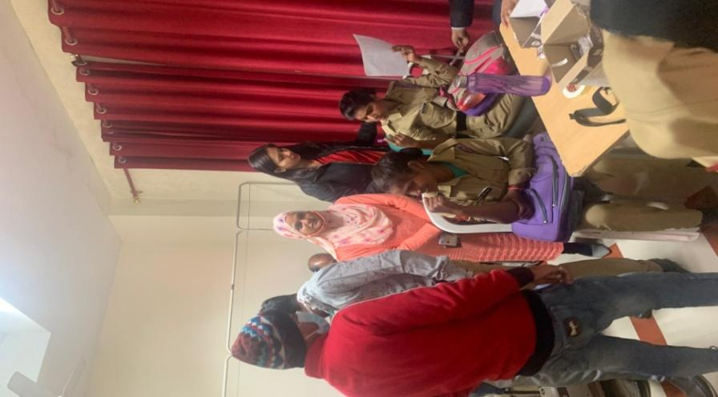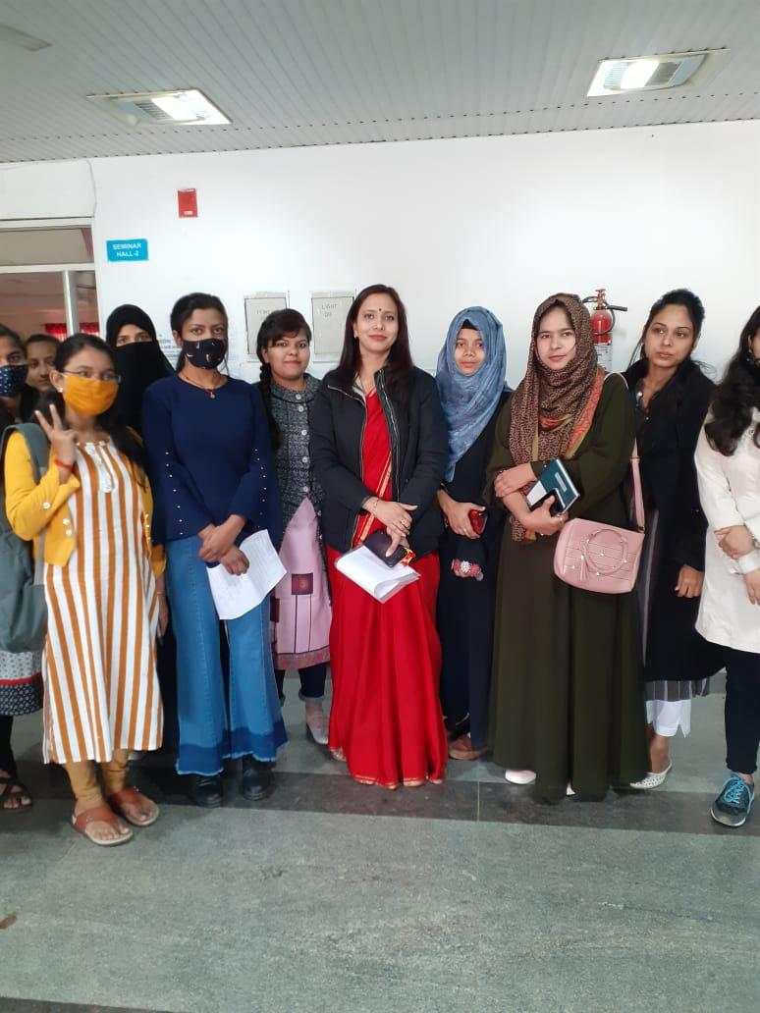

Anemia testing for girl students
24 January 2020
Honorable Governor of U.P. wished that all educational institutes should do Anemia testing for girl students as prevalence of anemia among adolescent girls is 56%. Thus the university successfully organized a workshop on “Anemia Awareness Among Adolescent Girls” on the occasion of National Girl Child Day 24 January 2020. Dr. Priyanka Suryavanshi Assistant Professor Home Science organized a drive for anemia testing with the help of KGMU blood testing for CBC Count & Hemoglobin was done and Home Science students and faculty did BMI Checkup and Nutritional Counseling. It was decided that this good step would be repeated every year for students. 70% of girls were found to be anaemic.
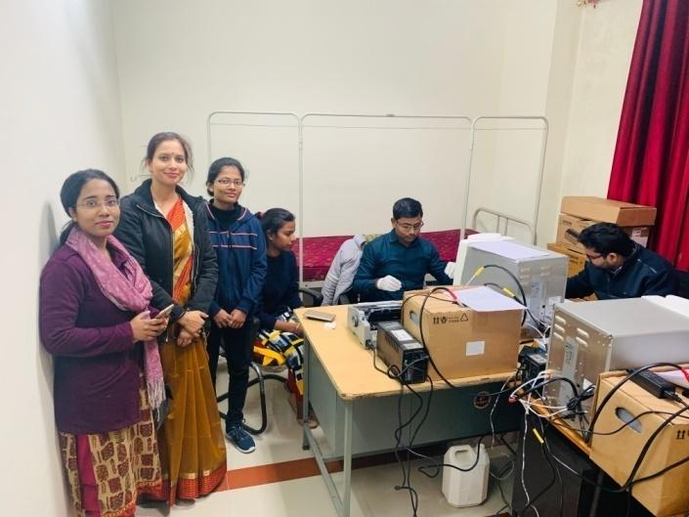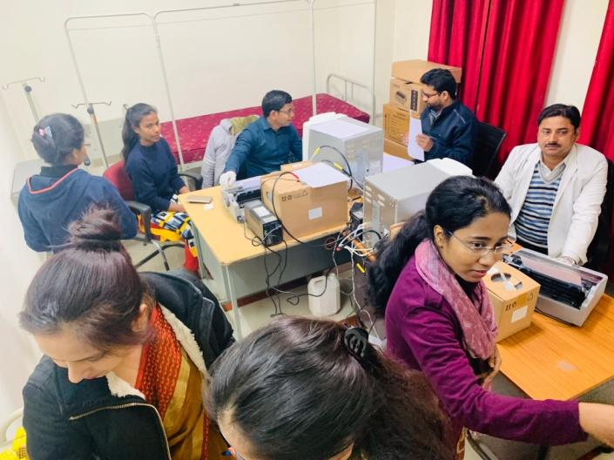
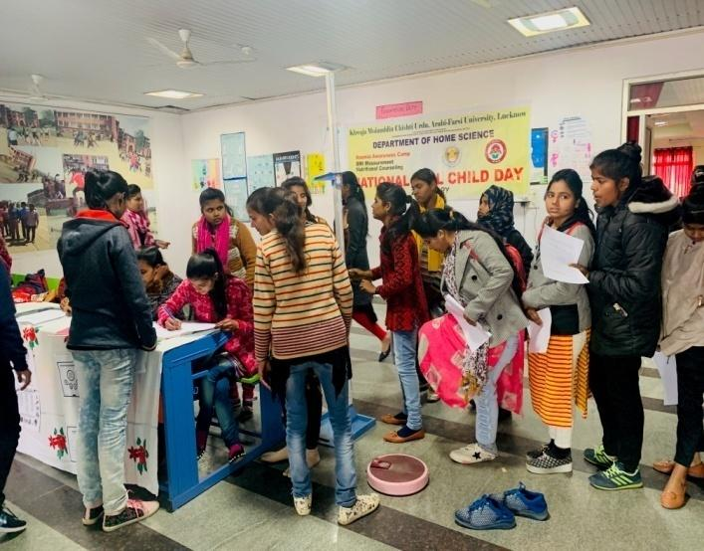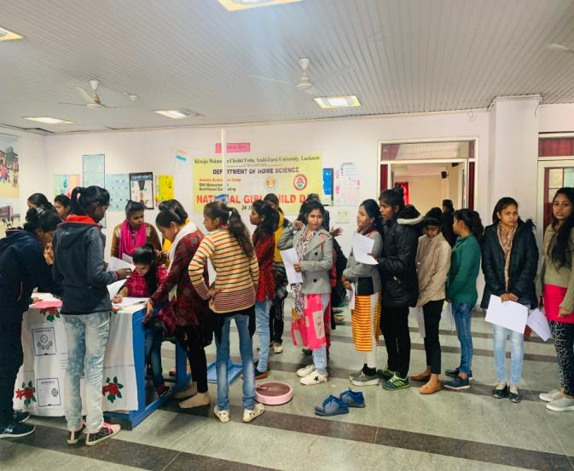

NATIONAL GIRL CHILD DAY
