DAY-1 (8TH MARCH 2021)
3 DAYS TRAINING PROGRAMME (08 -10 MARCH, 2021) THEME: ''MAHILA SHASHKITKARAN KI DISHA MEIN EK KADAM''
AT RAJ BHAVAN PARISAR LUCKNOW in the mahila samridhi mahotsav held by NAARM.
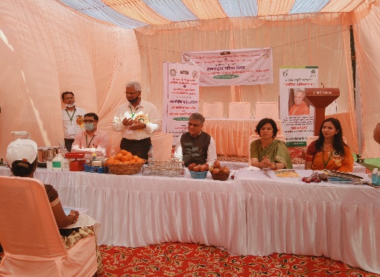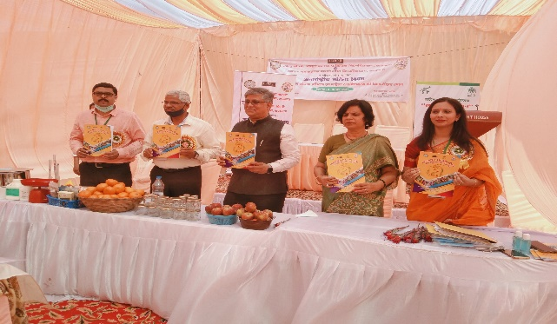
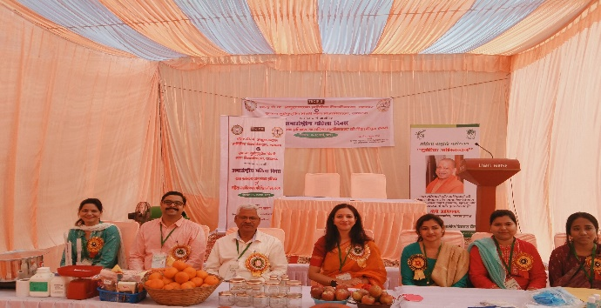
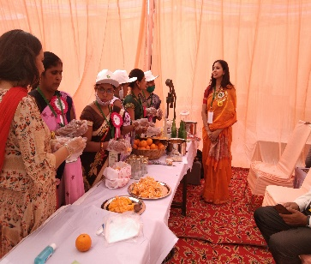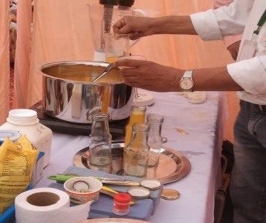

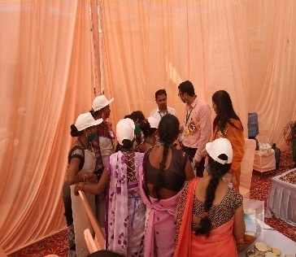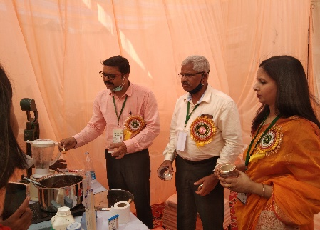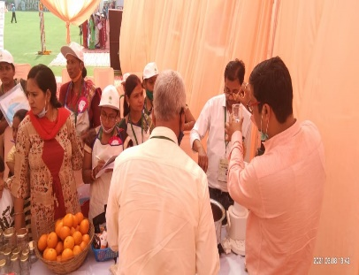

DAY-2 (9TH MARCH 2021)
3 DAYS TRAINING PROGRAMME (08 -10 MARCH, 2021) THEME: ''MAHILA SHASHKITKARAN KI DISHA MEIN EK KADAM''
AT RAJ BHAVAN PARISAR LUCKNOW in the mahila samridhi mahotsav held by NAARM.
LEARNING THE PROCESS OF TOMATO KETCHEP, SAUCE &TOMATO PUREE
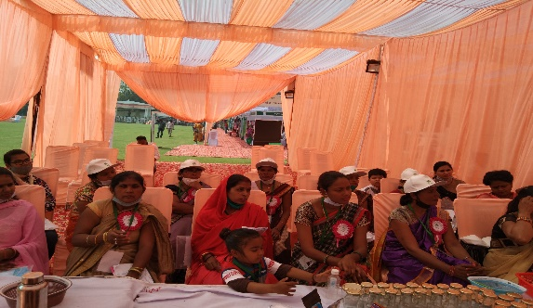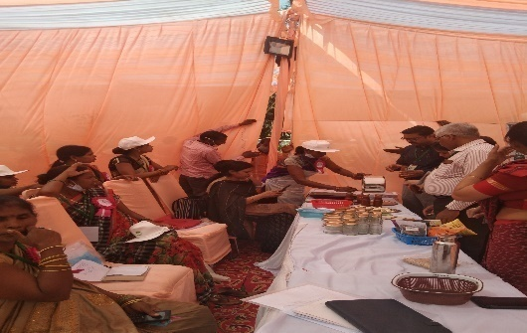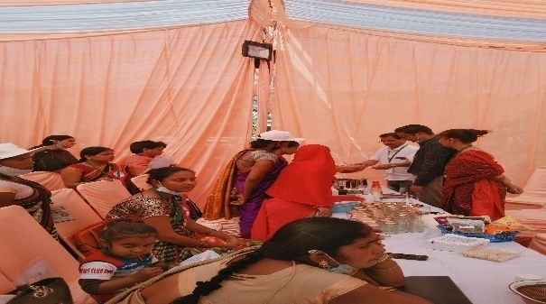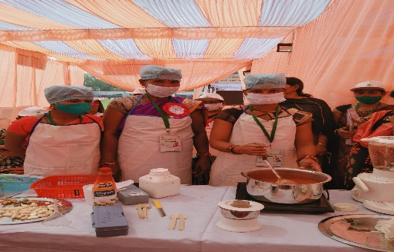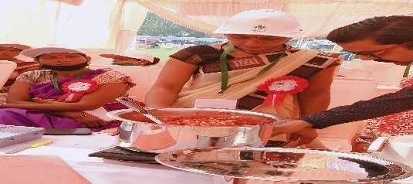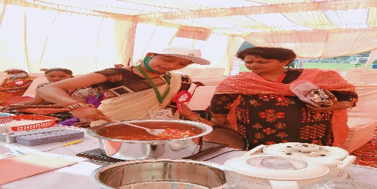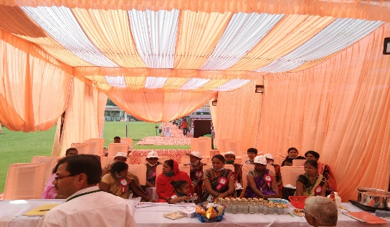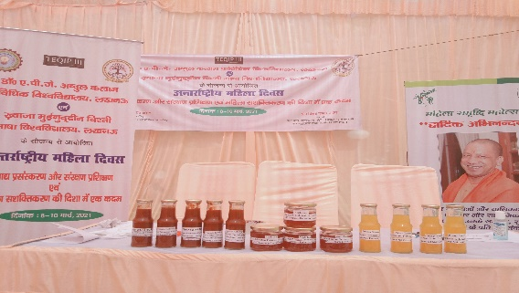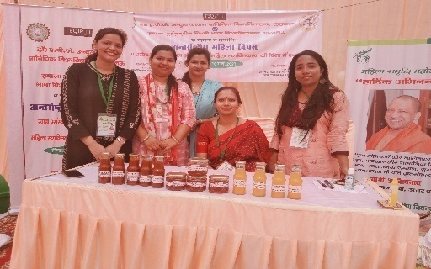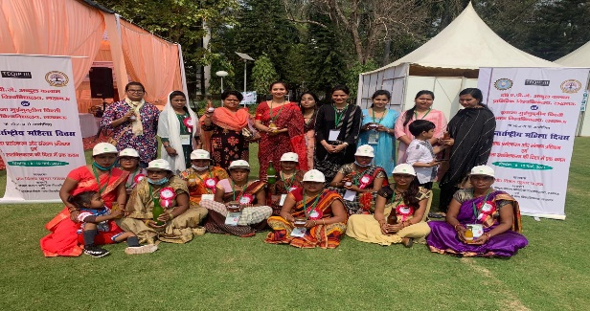
DAY-3( 10TH MARCH)
3 DAYS TRAINING PROGRAMME (08 -10 MARCH, 2021) THEME: ''MAHILA SHASHKITKARAN KI DISHA MEIN EK KADAM''
AT RAJ BHAVAN PARISAR LUCKNOW in the mahila samridhi mahotsav held by NAARM.
LEARNING THE PROCESS OF MIX VEGETABLE PICKLE TUTTI FRUITTI FROM RAW PAPAYA
VALIDICTORY SESSION & CERTIFICATE DISTRIBUTIONS
