LIST OF INTERNATIONAL & NATIONAL DAYS CELEBERATED IN UNIVERSITY

- National festivals 15th August and 26th January are celebrated with great zeal and energy. Faculty and students keep their views as speeches, singing, plays and Rangoli are the various ways of expression of devotion and love for nation that university family shows.
https://youtu.be/zz1eQh9XZyY

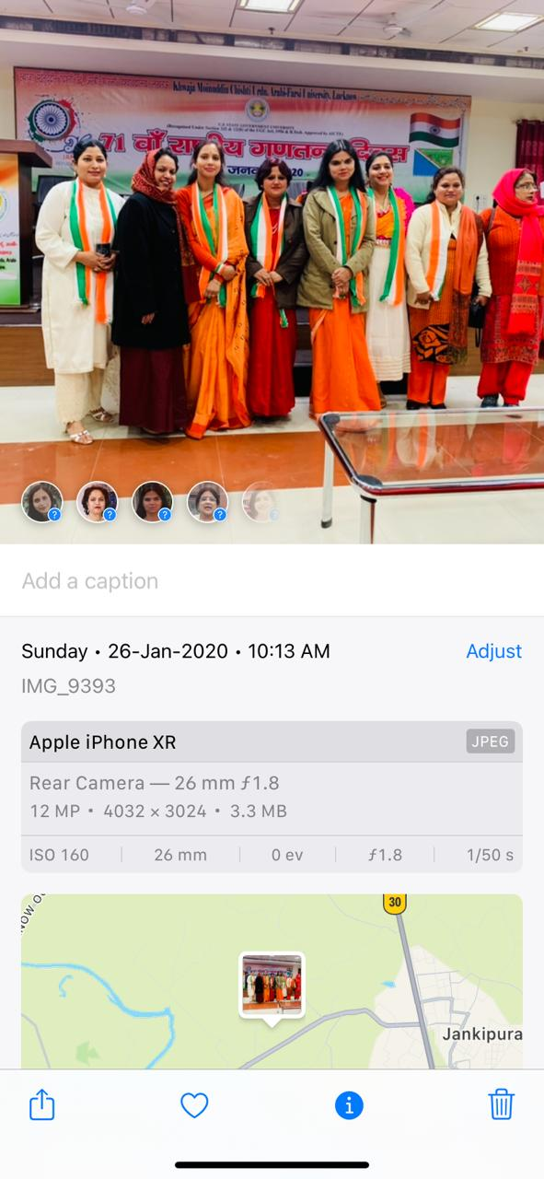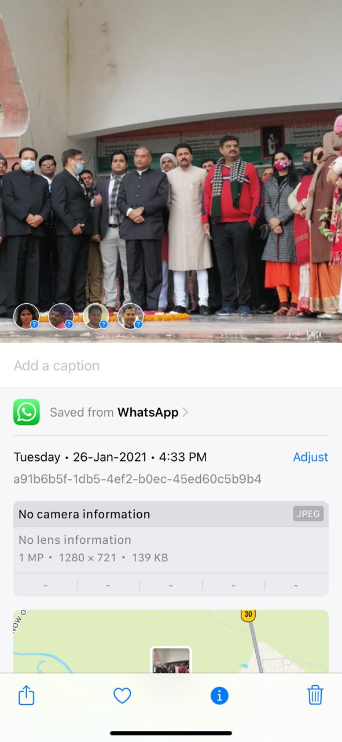
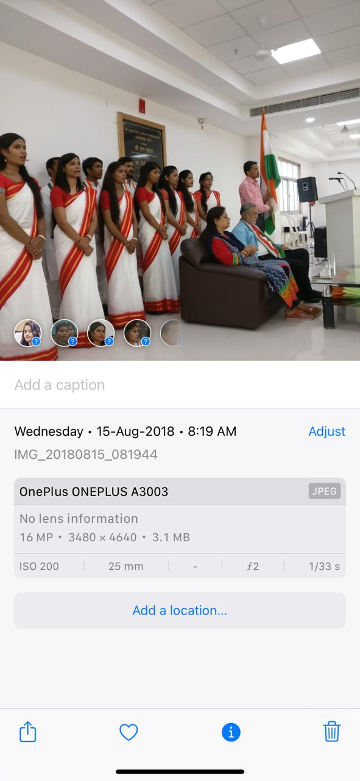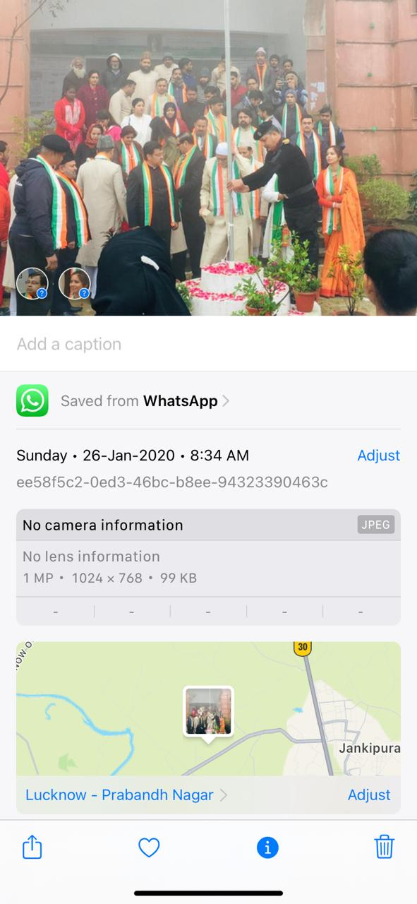

- Sardar Vallabh Bhai Patel Jayanti was celebrated on 3 October 2018. Speech Competition on “Sardar Vallabh Bhai Patel ke vicharon ki prasingta vartaman parivesh me” and poster competition on “Unity” were organised. The whole university students, teachers and non teaching staff along with Honorable Vice Chancelor participated in Unity of Run as symbolic representation of our countries Unity.

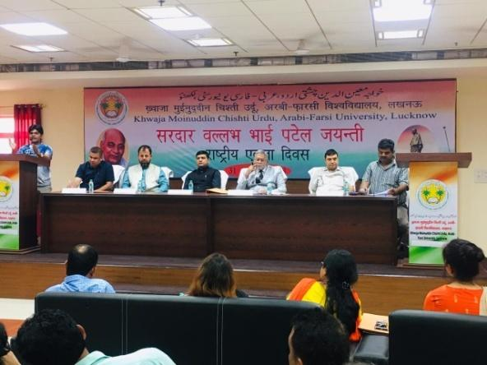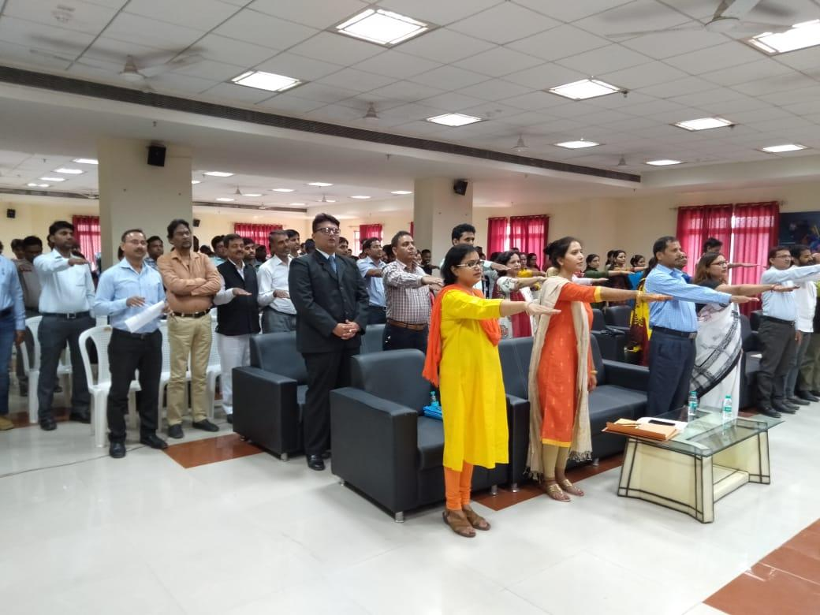

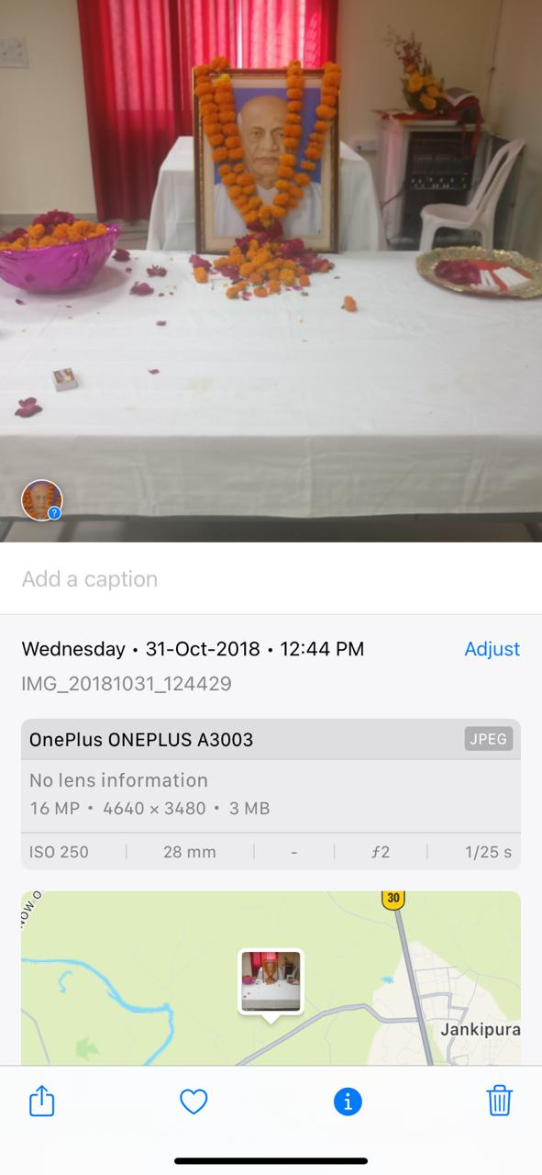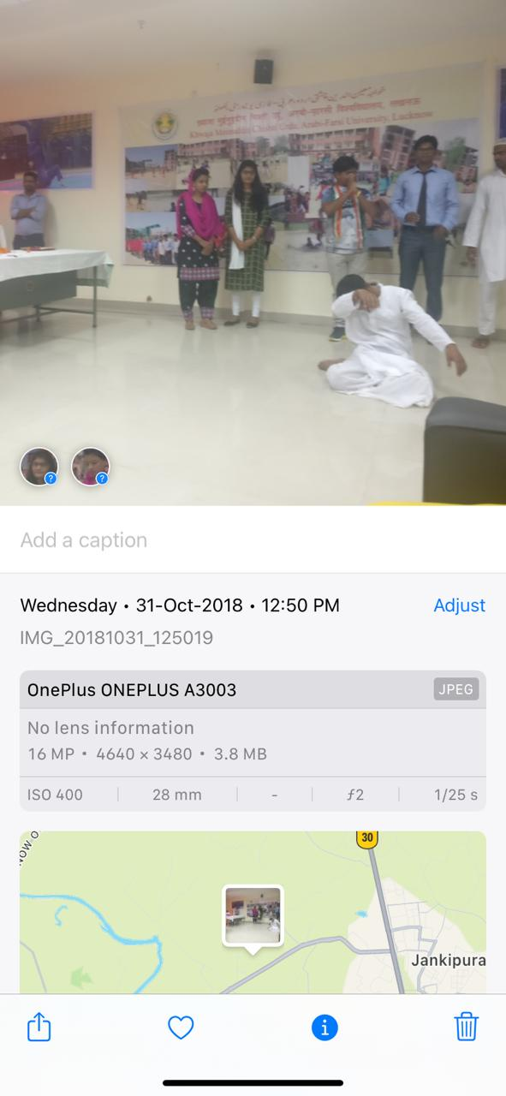

- Maharshi Valmiki Jayanti was celebrated on 24/10/18 and after garland ceremony a speech competition was organized.

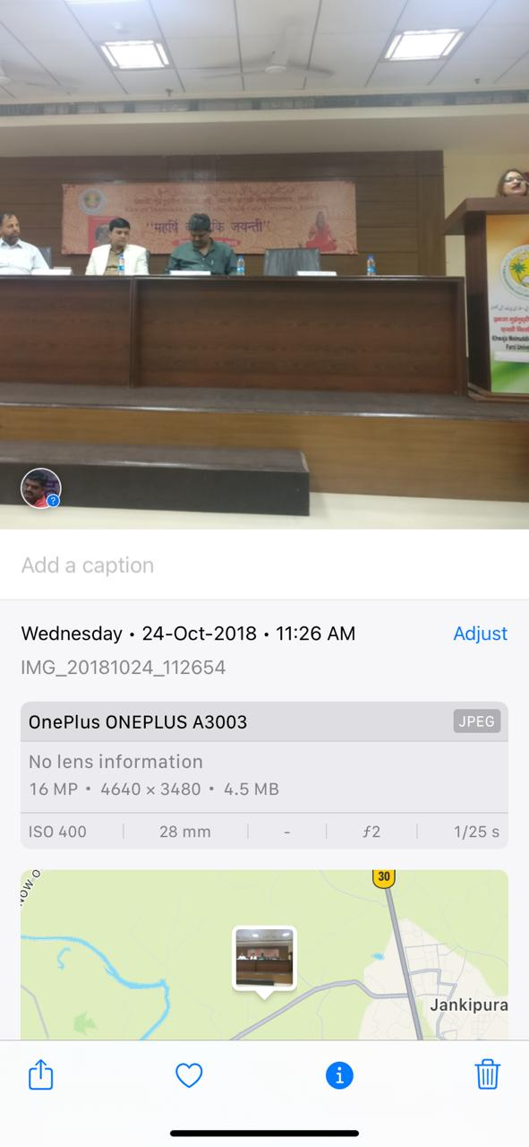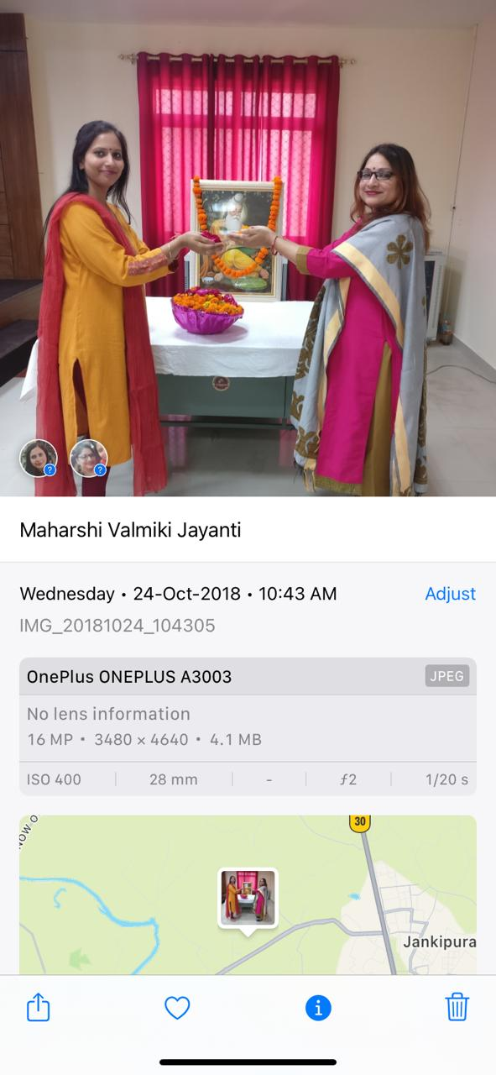

- Rashtriya Shiksha Divas was celebrated on the occasion of Maulana Abul Kalam Azad Jayanti on 11/11/2018. Speech and slogan competitions on importance of education were organized for this event.

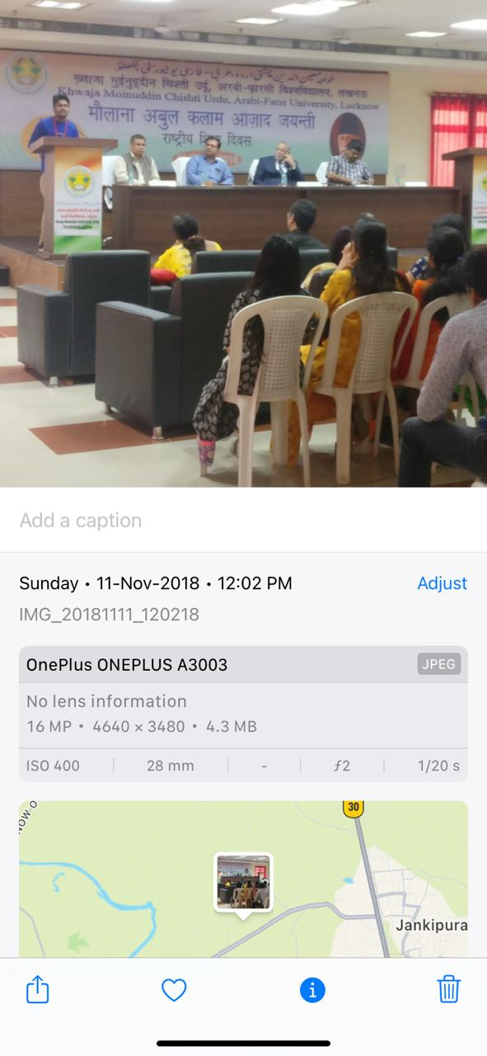

- Atal Bihari Vajpayee Jayanti was organised on 25 December 2018 and Poetry Recitation Comptetion was organised. The winners of the event and respected dignitaries in the event were given different books written by Atal Bihari Vajpayee as a token of remembrance.

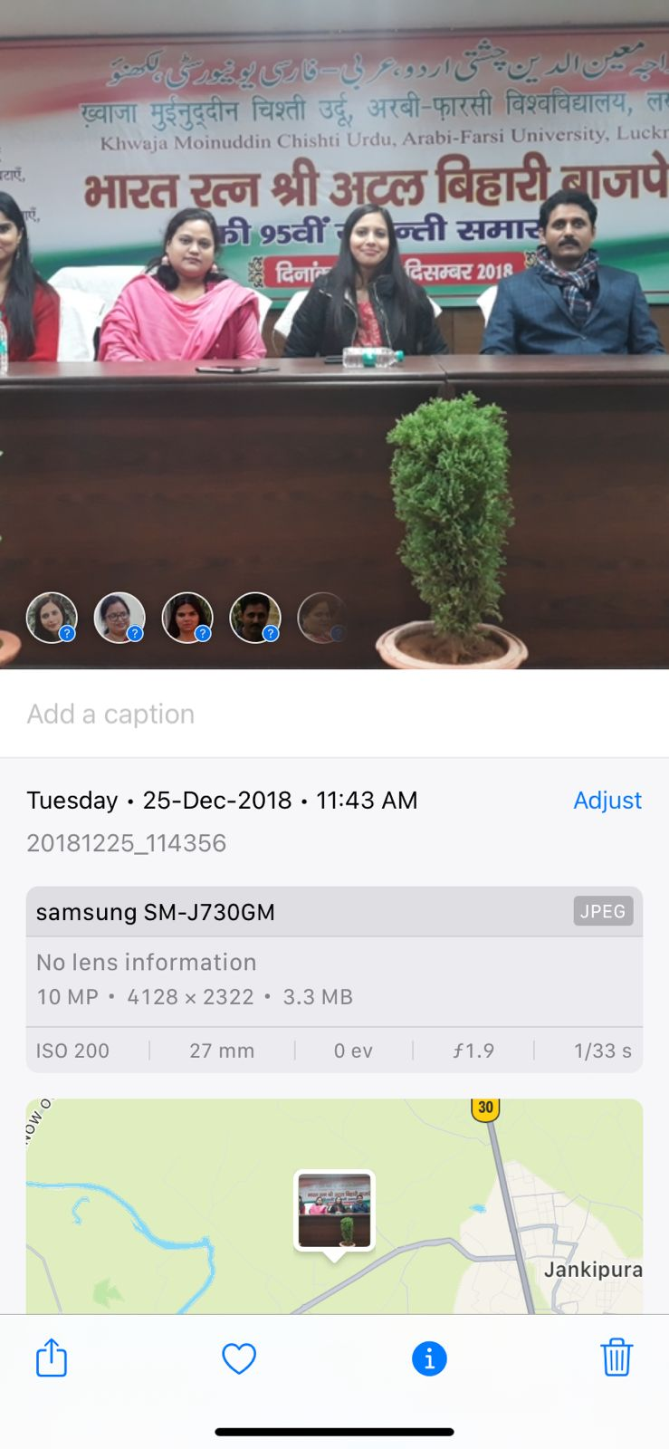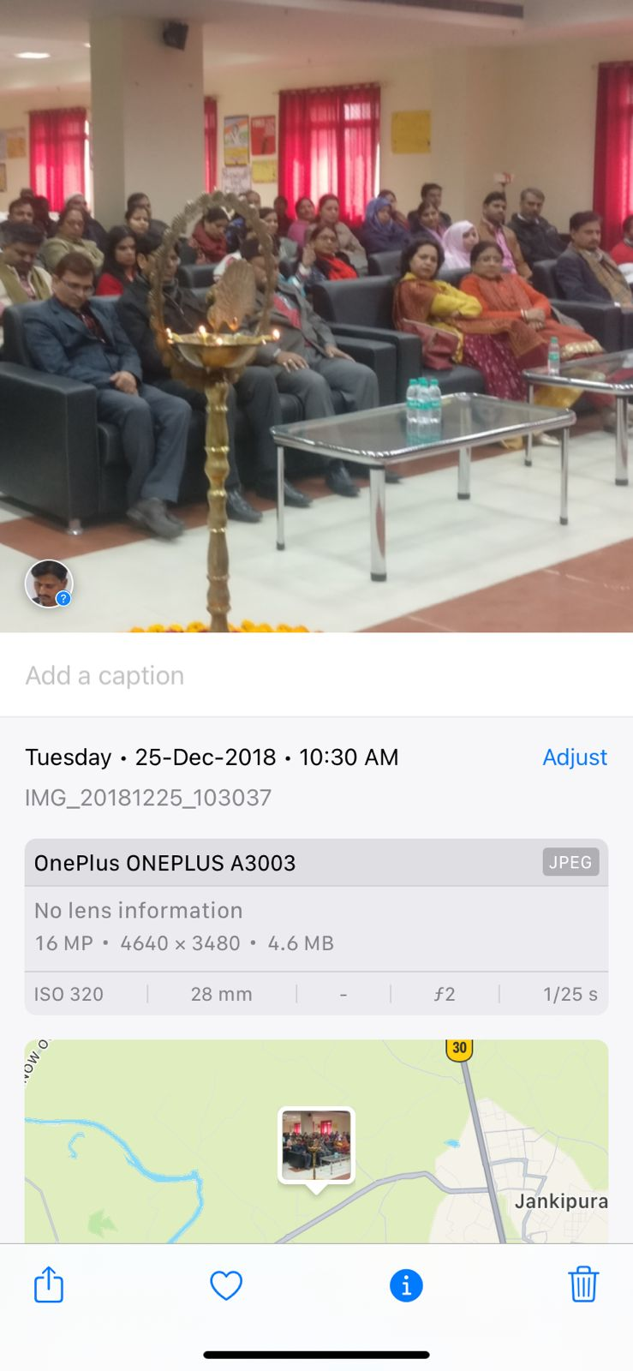

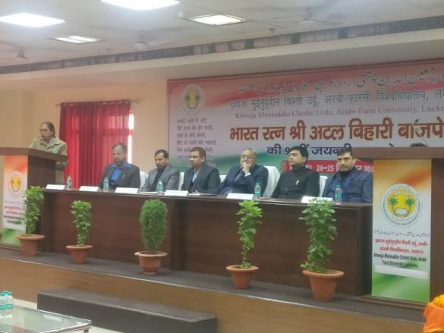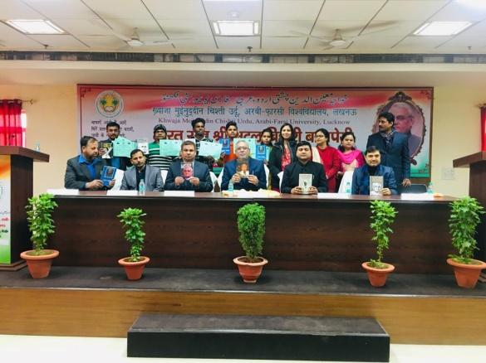

- Yuva Kumbh programme was organised from 22 December to 23 December 2018 in which students kept their views on “VICHAR EK NAYE BHARAT KA”. Students presented their views on their role and efforts for India development.

- Vishva Hindi Diwas was organised on 10.01.2019 where Sri Manish Shukla, Nideshak, Hindi Sansthan Uttar Pradesh kept his views on Hindi language and its arena. A short film on “Hindi Sanskriti ki dharohar” was shown to all students.

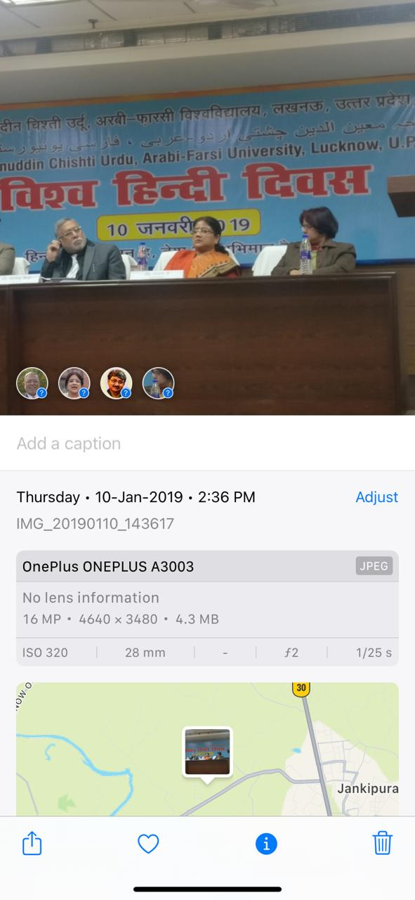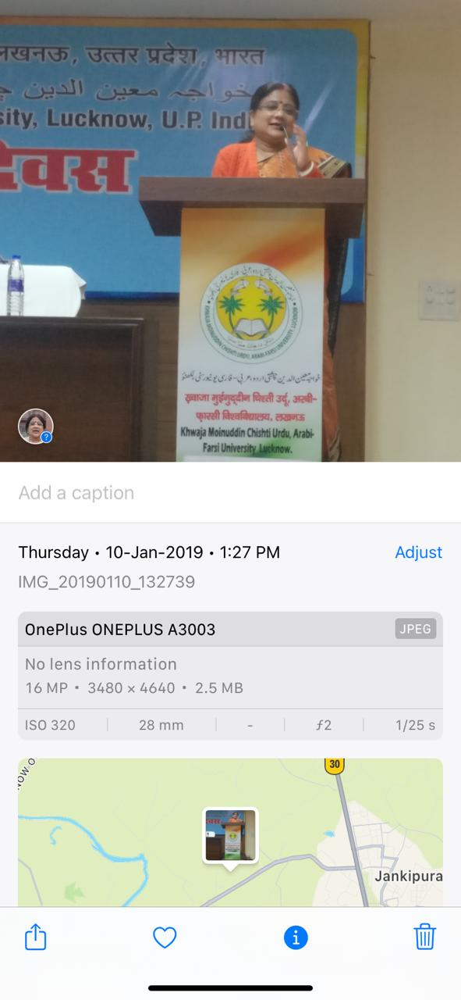

- A programme was organised on 28/01/2019 where all students were encouraged and motivated to watch and listen address by Honorable Prime Minister on “ayojit pariksha par charcha”. As it was beneficial for all students to understand examination stress reasons and their solutions.

- Blood donation camp: on 31st January 2019 University with the help of Lions Club organised Blood donation camp and free health check-up for students and staff and donors.
- On 17/04/19 sweep programme for motivating voters to vote, helping elderly voters and promoting every voter should vote was organised in which different NSS units with their students did rally and awareness programmes.
- World environment day was celebrated on June 5th 2019. Plantation drive was carried out in university and essay competition was organised on “air pollution” to make students aware.
- 31st July was celebrated as Jagrukta Abhiyan “KAVACH” under this whole july moth was organised as balika suraksha jagrukta with the famous slogan of” BETI BACHAO BETI PADHAO” and NSS Units participated in this awareness campaign by performing plays and nukad natak etc. and making girls aware about 1090 help line for women and girls.
- Under Celeberation of Mahatama Gandhi 150th Jayanti 2019 different events were organised by cultural committee and NSS team during the year. Gandhi ji’s Bhajan & Patriotic Songs Competition was organized on 26th January 2019. Projection of Gandhi Movie “The making of Mahatma” was done on death anniversary that is 30th January 2019 for university students and staff. Swatchta Pakhwada was celebrated from 1August to 15 August and different activities were conducted in nearby villages of University.

- Debate Competition on “Social Media: Vardan Ya Abhishap” organised by University & All India Hemvati Nandan Bahuguna Smriti Samiti on 14 September 2018. Students took part and represented university in it. The first round was organised in university and the winners later represented it at inter university level.

- National festivals 15th 2019 August was celebrated with great zeal and energy. Faculty and students keep their views as speeches, singing, plays and Rangoli are the various ways of expression of devotion and love for nation that university family shows.

- Seva Saptah DAAN UTSAV 14.09.2019 to 20.09.19
Daan Campaign was organised by cultural committee for donating clothes, toys and story books for orphanage children at “Drishti Sansthan”, Janki puram Extension, Sector 6. After collection of these items they were donated and an interacting activity was planned by students and teachers at the orphanage on 20/09/19.

- GANGA YATRA PROGRAMME WAS CELEBERATED FROM 27/01/2020 to 31/01/2020. Competitions were held in University campus during Ganga Yatra from 27/01/2020 to 31/01/2020. Poster competition on the topic: “water is life”, craft out of waste plastic competition and projection of documentary on environment conservation was done. NSS Students carried out awareness programmes in nearby villages for water conservation and cleaning of rivers.
- One day seminar and workshop was organised on “Indian Constitution and Fundamental duties” on 26/November/2019.
- A rally for unity and poster competition on “ Fundamental rights and duties” was organised on 26/nov/19 as awareness drive for Indian Constitution.

- A Quiz competition on Indian Constitution and Fundamental Rights was organised on 11/January/2020 with a purpose of making students aware about fundamental duties and rights.
- FIT INDIA ABHIYAN was acknowledged by organising a special programme on 29/08/2019. A cyclothon was organised to urge energy and enthusiasm among faculty and students to send the message of being healthy and conserving environment.
- Awareness rally and counselling of villagers for making the society T.B. free. Survey to identify children suffering from T.B. in villages near to university was done. All the faculty was allotted villages in groups and they conducted the survey on14/September/19.
- 150th Mahatma Gandhi Celebration on 2nd October 2019 with various programmes as collage competition on “Journey of Mahatma”, singing competition on Gandhi jee bhajan and patriotic songs were done to spread the message of gandhijee of peace and harmony.
- OCTOBER 2 Exhibition of handmade cotton bags with embroidery and block printing by home science students to spread message “Stop Plastic Use, To Save Environment”. The collected money was used to purchase stationary for government school children invited at convocation to see and observe higher education institute so that they get motivated to aspire for that.
- Padhe lucknow badhe lucknow: Inculcation of reading habit in students by reading for one hour every first working day of month.
The books of struggle for freedom, freedom fighters, Indian constitution and Indian heritage were encouraged to be read. Library was open for reading in case student doesn’t carry book with him. Thus this practice would inculcate reading habit and also aware students about their nation.

- UNIVERSITY CONVERTED TO QUARENTINE CENTER FOR COVID 19 PATEINTS.

